

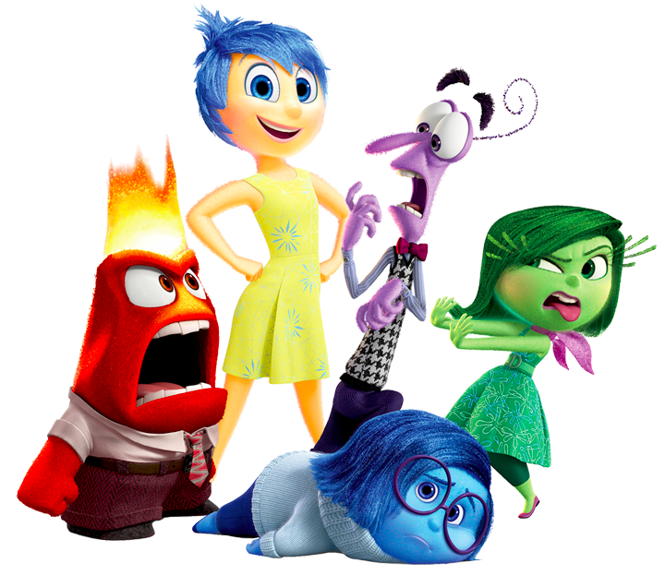

Inside Out (2015)

A Text Analytics Study

Steven Lin

Xiang Li

Ang Yu

## **Abstract**

This project involves analyzing dialogue text. Dialogue text is common on forums, chat, or phone transcripts. For this project, however, the focus was analyzing a movie script. Specifically, we selected the movie Inside Out by Pixar Animation Studios and provide some insights in this report.

Appropriate text analytics methods to answer the questions were selected, implemented and interpreted. In this project we report raw facts and conduct an extensive analysis, present visualizations of the analysis, and provide interesting conclusions and interpretations from the results. The results of the text analytics showed that meaningful information and insights can be extracted from text. It was very interesting to see the connection between the results and the expectations from our prior knowledge of the movie.

From the Name Entity Recognition, the results also match the exploratory results. The main characters were detected, as well as locations (e.g. personality islands) and organizations (e.g. bus company). The temporal time detection were also detected that most time references are for the present and past day.

The sentiment analysis of each character matched the personality definition they represent. For example, Joy has one of the most positive mood while Disgust the most negative mood. In addition, the sentiment corresponds to turning points in the movie. For instance, when Riley moves to San Francisco there is a drop in the positive sentiment, which drops further to scenes where there is drama and struggles (e.g. dinner argument and trying to escape from long-term memory). The sentiment becomes more positive in the hockey rink due to cheering and end of the movie when Joy is back.

Topic analysis (LDA) shows that the topics detected can reflect the personality of characters, the moods in the scenes and themes in each location. Document similarity shows following features would lead to a high document similarity: characters with similar personality, two locations involving same scenes and characters and two scenes happening at same locations with same characters.

Hierarchical clustering with ward distance shows good performance for characters, with the analysis resulting in separate groups of emotions, physical world characters and supporting characters. An interesting highlight from the dialogue act analysis is that “happy characters”, such as, Bing Bong and Joy, express more greeting and acceptance compared to other characters, such as Angelo.

## **Table of Contents**

1. Introduction 1

1.1 Movie Background 1

1.2 Text Analytics 2

2. Data and Methodology 3

2.1 Data 3

3. Results 6

3.1 Exploratory Analysis 6

3.2 Word Frequency 10

3.3 Named Entities 11

3.4 Temporal Reference 13

3.5 Sentiment 14

3.6 LDA 18

3.6.1 Characters VS. Topics 18

3.6.2 Locations VS. Topics 20

3.6.2 Scene VS. Topics 22

3.7 Document similarity 23

3.8 Clustering 25

3.9 Dialogue Act Types 29

4. Conclusions 31

4.1 Summary 31

4.2 Future Work 32

Appendix 33

A. Movie Synopsis (IMBD) 33

B. Data Processing Notes 38

C. Hierarchical Clustering 42

D. Python Code 48

E. References 96

# 1. Introduction

## 1.1 Movie Background

The movie Inside Out is a 3D animation movie produced by Pixar Animation Studios and released by Walt Disney Pictures in 2015. The film was directed by Pete Docter and co-written by Pete Docter and Ronnie Del Carmen. The movie has been well received, with ratings of 8.4/10.0 (IMDb), 98% (Rotten Tomatoes) and 94% (Metacritic), and has been a commercial success having accumulated over $851 million in worldwide box office revenue (Wikipedia).

The movie tells the story of 12-year-old Riley as she moves with her Mom and Dad from Minnesota to San Francisco. Riley experiences emotional struggles during this abrupt transition and period of adaptation to a new city, where she relies and is guided by her emotions to navigate through this new chapter in her life.

The main characters of the movie are her emotions: Joy, Fear, Anger, Disgust and Sadness (Figure 1.1.1). They live inside Riley’s mind (Headquarters) and control Riley’s behaviors. The core memories, such as friendship, hockey, family and honesty, power Riley’s personality, which are represented by islands (e.g. friendship island). When Riley moves to San Francisco, emotional chaos sweeps Headquarters. As a result, Joy and Sadness find themselves outside Headquarters, in Long-Term memory.

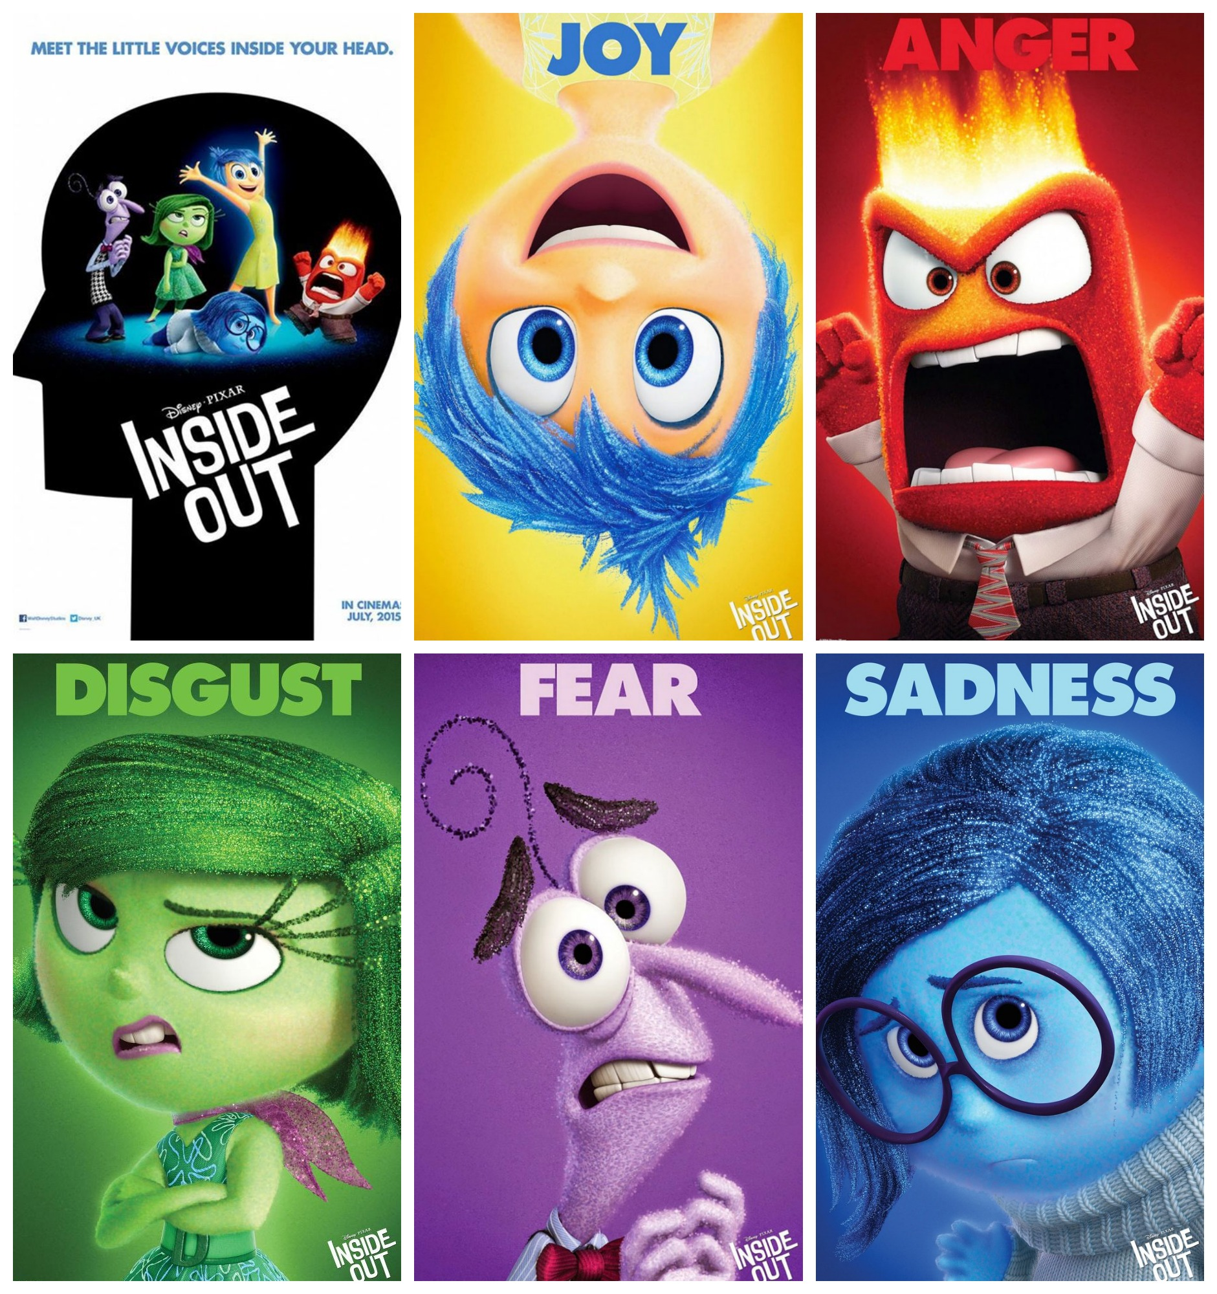

Figure 1.1.1 - Main Characters

The main storyline is about Joy and Sadness trying to get back to Headquarters to prevent a disaster in Riley’s life and a complete emotional breakdown. During the time Joy is outside Headquarters with Riley’s core memories, the islands of personality are shut down. This results in Riley going through a tough period without her personality, which translates into fights with her parents and friends, anger in hockey tryouts and booking a bus ticket to Minnesota behind her parents back. These events in turn cause her islands of personality to crumble down.On their quest to go back to Headquarters, Joy and Sadness navigate through Long-Term memory with the help of Bing Bong (Riley’s childhood imaginary friend), visiting various places in Riley’s mind and meeting other interesting characters along the way in this adventure. For a more detailed movie synopsis please refer to Appendix A.

## 1.2 Text Analytics

This project involves analyzing dialogue text. Dialogue text is common on forums, chat, or phone transcripts. For this project, however, the focus was analyzing a movie script. Specifically, we selected the movie Inside Out by Pixar Animation Studios and provide some insights in this report.

Appropriate text analytics methods to answer the questions were selected, implemented and interpreted. In this project we report raw facts and conduct an extensive analysis, present visualizations of the analysis, and provide interesting conclusions and interpretations from the results.The tools of choice were Python 2.7 for data processing and text mining, Stanford Corenlp (Python Wrapper) for Natural Language Processing, and Tableau 9.2 for visualization.

The movie Inside Out is very unique since the main characters are emotions. In addition, the movie takes place in both the physical world and mind world. Therefore, the movie provides a rich data source for interesting text analytics applications and opportunity to see what and how we can learn from textual data that is so prevalent in our lives.

Some questions that we seek to answer through text analytics are:

* Can we learn anything from the movie by looking at word frequencies in script?
* What are the Named Entities (e.g., people, places, organizations) that appear?
* What are the temporal references?
* What is the mood of each speaker (e.g., the average sentiment of the words they utter)?
* What are the topics of the movie?
* What are the most similar and dissimilar characters, locations and scenes?
* Can we cluster characters, locations and scenes?
* Can we classify utterances of characters by dialogue act types (e.g. greeting, question)?
* Do our results depend on time (e.g., by scene)? Do they vary by location or character?
* Are there any difference among the different text analytics methods used?

# 2. Data and Methodology

## 2.1 Data

The movie script was released by the Walt Disney Studios and can be found in the link: <http://www.waltdisneystudiosawards.com/downloads/inside-out-screenplay.pdf>

The format of the file is PDF. A sample of the movie script is shown below in Figure 2.1.1. From this figure, we can see the basic structure of the data. The location is stated in upper case on the left, and is usually followed by a description. Following the location or description, the utterances (the term “quotes” will be used for future sections) by character appear with the character name being upper case in the center, and the quotes off center following the character name. As one can see from this script, there are a lot of special cases that don’t follow exactly this structure (e.g. when characters speak at the same time). In addition, one of the challenges is standardizing the character names and locations as the script provide extra information.

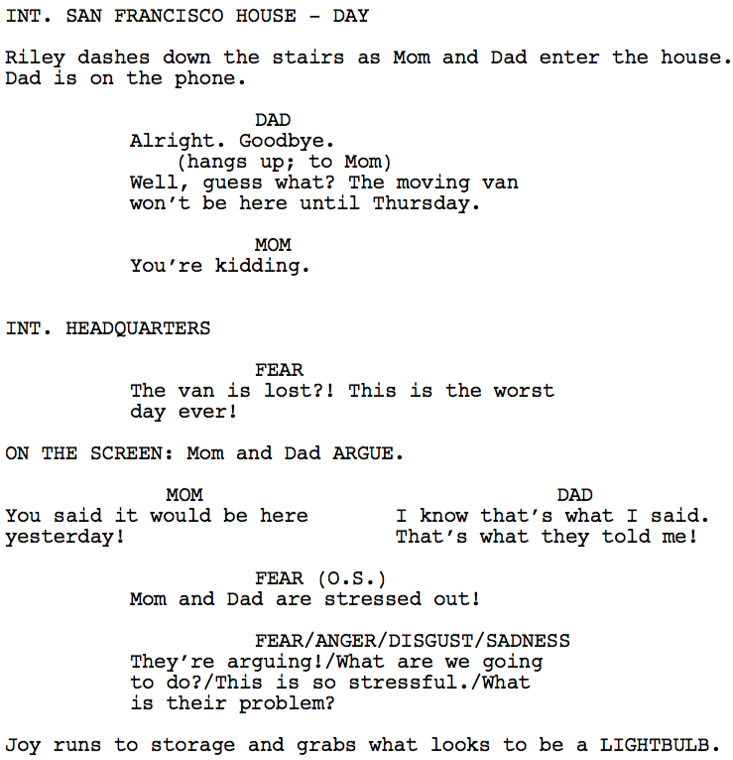

Figure 2.1.1 - Sample Movie Script (PDF)

As a result, we decided to use the HTML version and web scraping techniques to extract the data and format it to prepare for analysis. This part was the most time consuming part of the project and also served as a source of ideas for text analysis. Figure 2.1.2 shows a sample movie script in HTML format, and Figure 2.1.3 shows the pre-processed text. Tags and margin information was used to provide structure to the data. For full details of the pre-processing step, please refer to Appendix C.

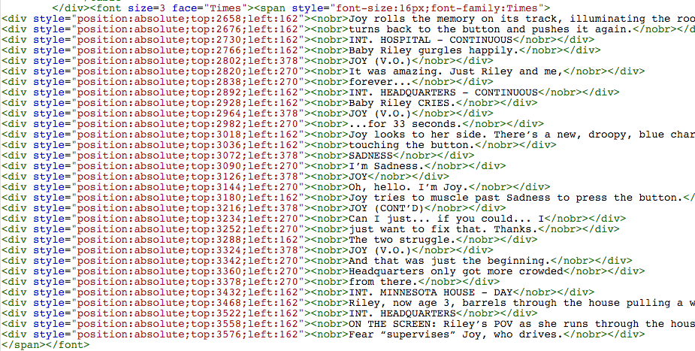

Figure 2.1.2 - Sample Movie Script (HTML)

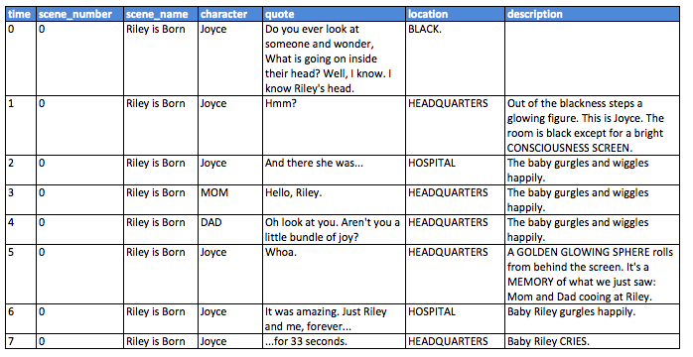

Figure 2.1.3 - Sample Movie Processed Data

2.2 Methodology

Several machine learning and text analytics methods were used to analyze the movie script. The methods applied to each section of the project are summarized below in Table 2.2.1.

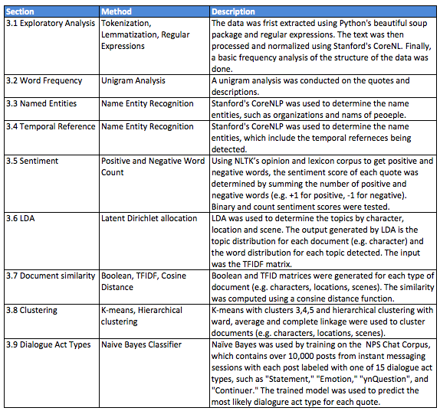

Table 2.2.1 - Text Analytics Methods Applied in each section

Because the character names are emotions (Joy, Sadness, Fear, Anger and Disgust), they were replaced by common names (Joyce, Felipe, Angelo and Diane) for the text analysis to avoid issues with the parsing and name entity recognition, and biases with the sentiment analysis (e.g. Sadness mentions Joy most of the time).

# 3. Results

## 3.1 Exploratory Analysis

We started an exploratory analysis with distributions of characters, locations and scenes by quotes since data is uniquely defined by quote index (time index). Figure 3.1.1 represents the top 10 characters by quotes. Joy is one of main characters that drives the stories in the movie. Joy got the most speaking time (324 quotes) and follows by Sadness (130 quotes) and Fear (104 quotes). Surprisingly, Bing Bong is the fourth character who spoke the most since he is not one of the main characters. Bing Bong was Riley’s childhood imaginary friend living in Long-term memory , and he helped Joy and Sadness to go back to Headquarter.

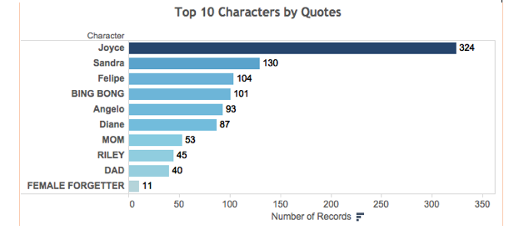

Figure 3.1.1 - Top 10 Characters by Quotes

Figure 3.1.2 shows locations by quotes. The most numbers of quotes happened at Headquarters (40.77%). The result meets our expectation since there were lots of events that happened at Headquarters across the movie. Moreover, Joy and Sadness accidentally fell into location Long-term memory. More than a half of movie was about how they were trying to get back to Headquarter from Long-term memory. Therefore, Long-term memory is the second major location in terms of quotes.

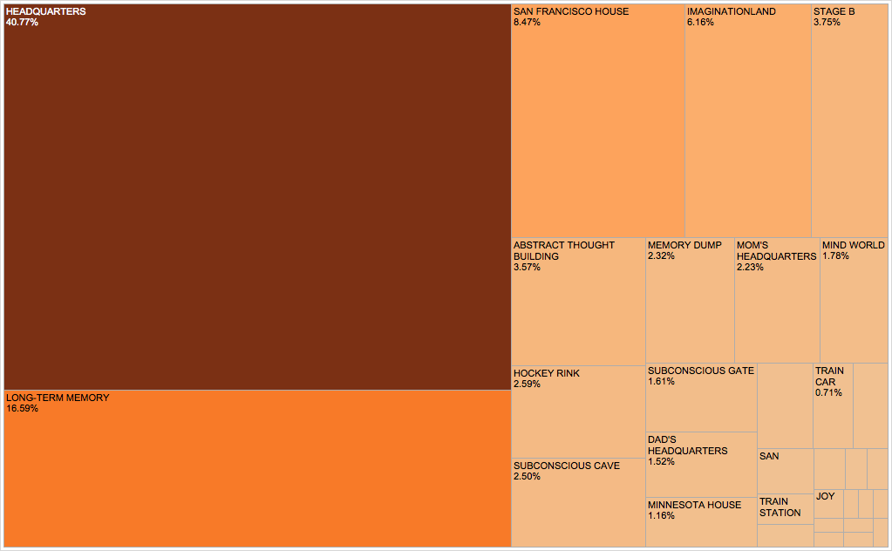

Figure 3.1.2 - Location by Quotes Treemaps

A distribution of scenes ordered by number of quotes is shown in Figure 3.1.3. Moving to San Francisco is a major scene included the most quotes, since most of dramas were developed about how Riley was struggle after moved to San Francisco. According to the result from Figure 3.1.2, Bing Bong is one of characters who spoke the most. Correspondingly, Meeting Bing Bong becomes the second scenes with the most frequencies.

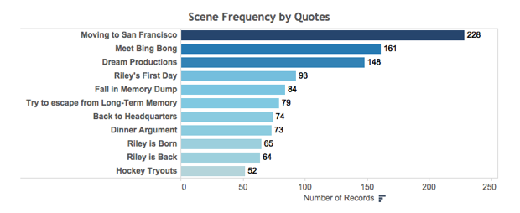

Figure 3.1.3 - Scene Frequency by Quotes

Then, we looked at a distribution of quotes by characters and time index (quote index) in Figure 3.1.4. Quotes of the five emotions are across the whole movie. Joy, Sadness and Fear are the top 3 characters with the most quotes shown by Figure 3.1.1, so their quotes frequency distributions are denser than others. One highlight is that Bing Bong appeared in a certain time range shown by a yellow region in the figure. Another highlight is that Mom’s and Dad’s emotions first time showed up together in the conversation on the San Francisco dining table.

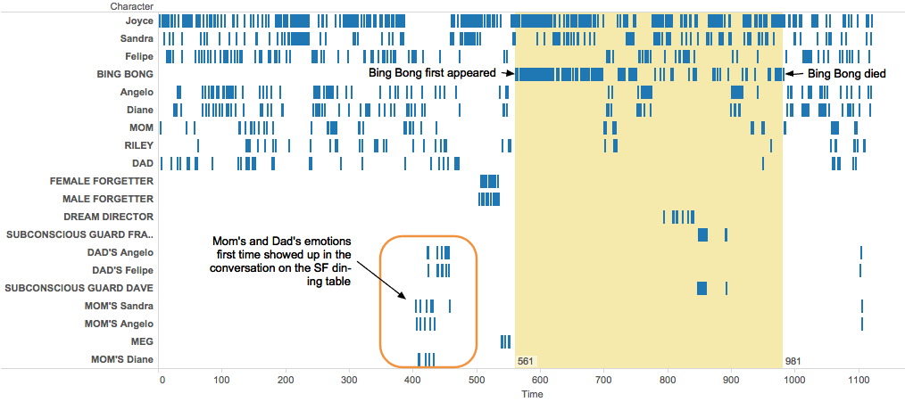

Figure 3.1.4 - Quote Frequency by Character and Time Index

Figure 3.1.5 indicates a distribution of quotes by location and time index (quote index). Headquarter, Long-term Memory and San Francisco House are the top 3 locations with the most quotes shown by Figure 3.1.2, so their quotes frequency distributions are denser than others. 3 areas, which are circled out, indicated interesting insights.

The orange circle shows Imaginaryland first time appeared after Long-term memory in terms of quotes frequency. The reason is Joy and Sadness fell into Long-term Memory and met Bing Bong; then, Bing Bong first time took them to Imaginaryland. The green circle indicates Minnesota House appeared only at the very beginning of the movie and then Riley's family moved into San Francisco House. The red circle indicates a location order between Train Car and Dream Productions by time index: characters got off the train to produce a dream for Riley and went back to the train.

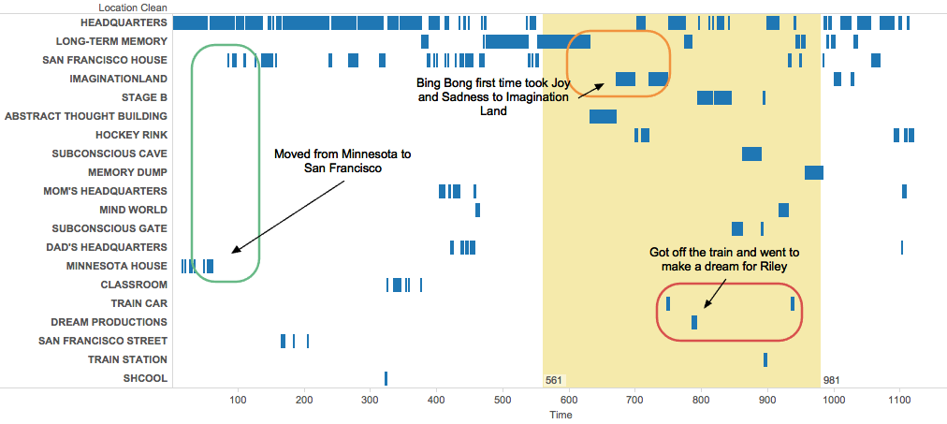

Figure 3.1.5 - Quote Frequency by Location and Time Index

Figure 3.1.6 shows how characters who spoke at least twenty times performed in each of top 4 locations. An average of number of utterance by characters is 32.04 quotes. Emotions who are main characters had much more quotes in the major location Headquarter. Joy spoke the most in Headquarter and Long-term Memory, and Bing Bong spoke the most in Imaginationland. Comparing to the other three locations of a Riley's mind world, or inside, San Francisco House is a location of a physical world, or outside. Therefore, mom, dad and Riley having more quotes than emotions shown in the graph meets the expectation.

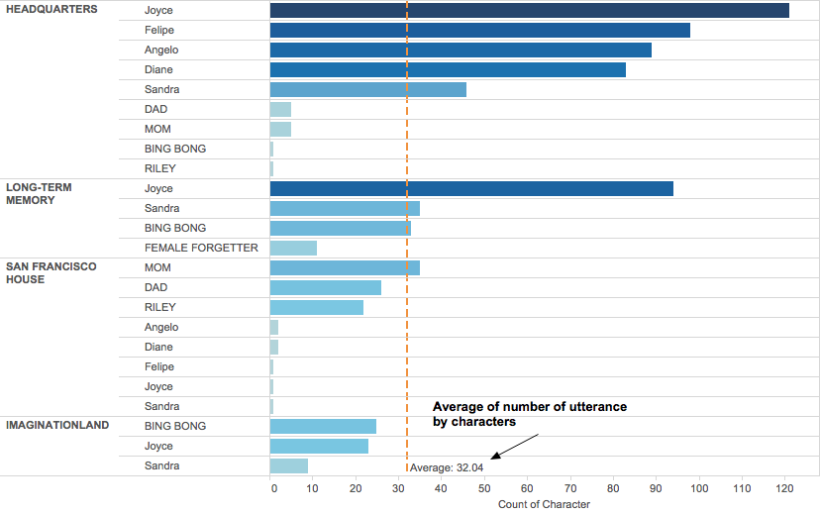

Figure 3.1.6 - Top 4 Locations by Quotes and Characters that Speak more than 20 Times

## 3.2 Word Frequency

Figure 3.2.1 shows a unigram word cloud from quotes and descriptions of the script, it provides basic messages about characters, locations and events. For example, Riley, Joyce are the two main characters and followed by Sadness and Bing Bong. ‘Memory’ word shows up since character emotions created, and stored memories in order to control Riley’s emotion.

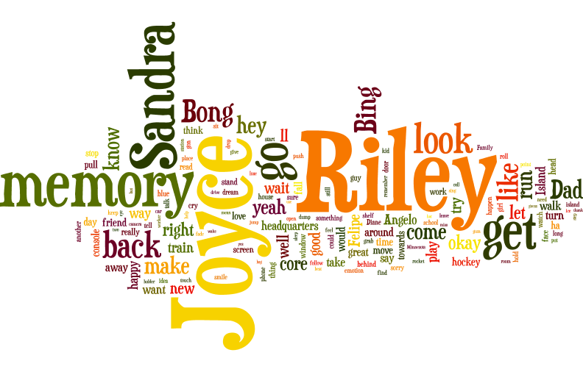

Figure 3.2.1 - Unigram Word Cloud

## 3.3 Named Entities

Figure 3.3.1 represents person entities frequency from quotes and descriptions generated by Stanford CoreNLP. All character names in the script are successfully captured (colored in orange), and CoreNLP mostly successfully detects right person entities.

**PERSON**

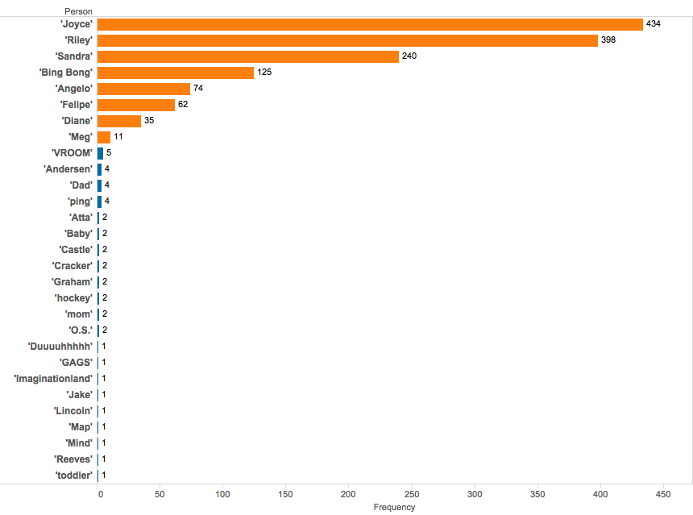Figure 3.3.1 - Person Frequency

**LOCATION**

Location in the previous analysis (Figure 3.1.2) represents the location where an event happens, while locations in the NER are based on locations extracted from the dialogue or a description of a dialogue. Thus, there will be overlap between the locations but also differences. For example, events never happened in Canada, but there was a reference made in the dialogue.

Figure 3.3.2 represents location entities frequency from quotes and descriptions generated by Stanford CoreNLP. CoreNLP mostly successfully detects right person entities. For example, Family, Goofball, Friendship and Hockey Island are personality islands in Riley’s mind world. Locations in orange are same as locations where an event happens in Figure 3.1.2.

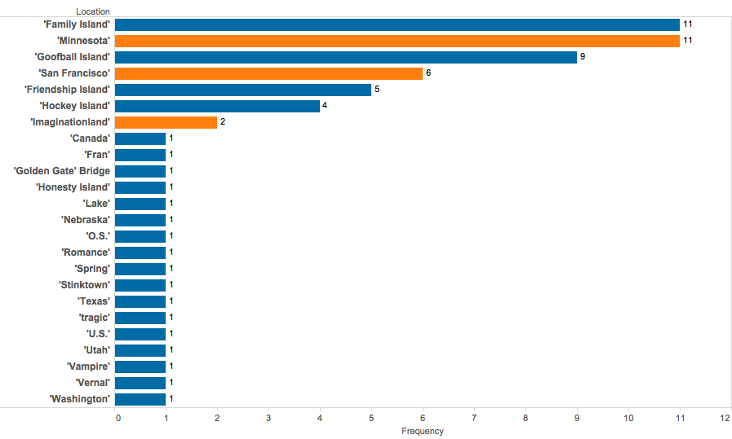

Figure 3.3.2 - Location Frequency

Figure 3.3.3 represents organization entities frequency from quotes and descriptions generated by Stanford CoreNLP. CoreNLP mostly successfully detects right person entities. For example, ‘Dogs’ is the hockey team Riley joined at Minnesota.

**ORGANIZATION**

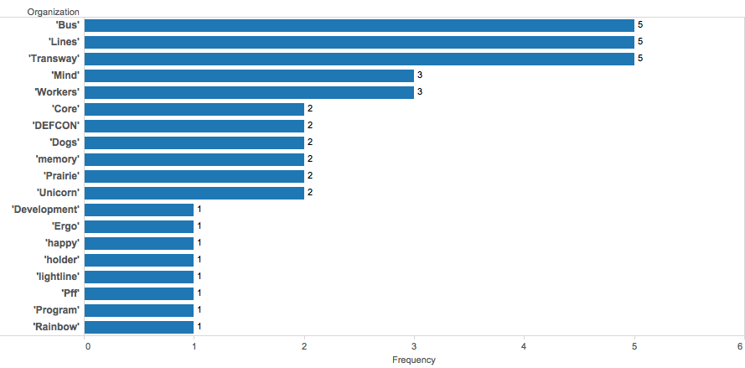

Figure 3.3.3 - Organization Frequency

## 3.4 Temporal Reference

Temporal ferences are captured by CoreNLP. The movie does not contains actual dates but only relative dates. There is not a clear initial time reference to convert relative dates/time into absolute dates/time. Figure 3.4.1 and 3.4.2 show temporal reference frequency of date and time with corresponding lemmas. In the Date Frequency plot, PRESENT_REF counts the most by word ‘now’ and ‘right’. In the Time Frequency plot, TMO counts the most by word ‘morning’.

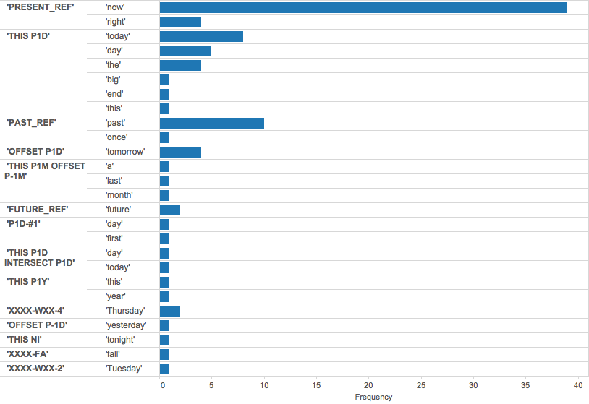

Figure 3.4.1 - Date Frequency

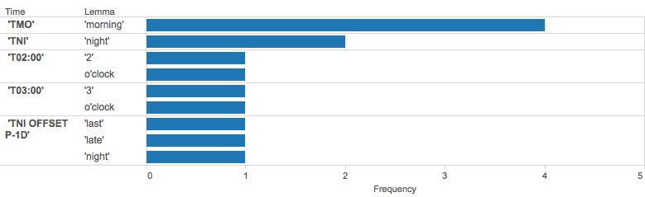

Figure 3.4.2 - Time Frequency

## 3.5 Sentiment

We visualized the sentiment result by nine main characters. Figure 3.5.1 contains two plots: average binary sentiment and average count sentiment. (see section 2.2) The results of the two different methods are similar: same orders of characters by an average of sentiment. Mon and Joy are the top two positive characters and Sadness and Disgust are only negative characters of these main characters. Count sentiment gives more weights on sentiment scores (counts of positive, negative words), so it has a larger range of average of sentiment compared to binary sentiment. Therefore, we selected count sentiment method for further sentiment visualizations.

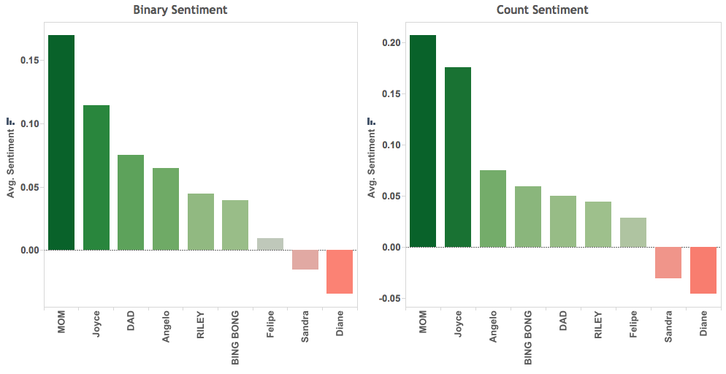

Figure 3.5.1 - Binary and Count Sentiment by Characters

In the movie, Joy and Sadness were always together. It is interesting to compare the sentiment scores between them. In Figure 3.5.2, Joy has more positive scores than negative ones; in contrast, Sadness has more negative scores than positive ones. The result matches the definition of personalty for these two characters.

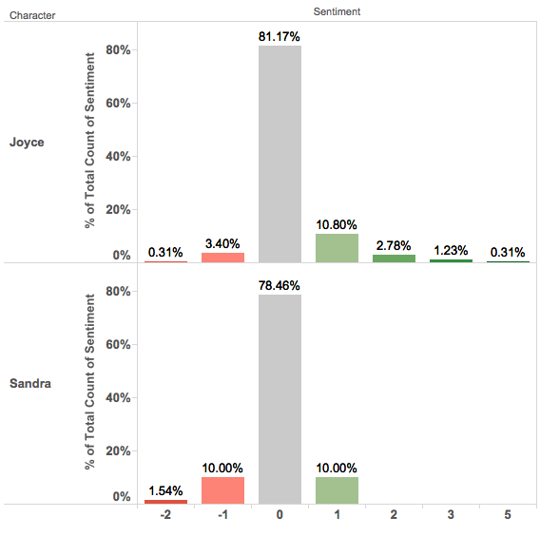

Figure 3.5.2 - Sentiment Index by 2 Characters

Then, we tried to analyze how the does sentiment of the movie change along time. Figure 3.5.3 shows average of sentiment scores by each scene. The average sentiment scores dropped from ‘Riley is Born’ to ‘Moving to San Francisco’; it indicated Riley was disappointed about San Francisco and sad about leaving happy life at Minnesota. Joy and Sadness fell into Long-term Memory and Riley’s emotions were not controlled by Joy, and the sentiment score sharply dropped to negative level until they met Bing Bong. Bing Bong has a positive sentiment from the result in Figure 3.5.1, so the sentiment scores increased in the scene ‘Meet Bing Bong’. Scene ‘Hockey Tryouts’ heats the highest sentiment scores since there were a lot of encouragements. The scene ‘Back to Headquarter’ heats the lowest negative sentiment scores, which was the most important turning point of the movie. At the end, the scene ‘Riley is back’ shows an average positive sentiment score.

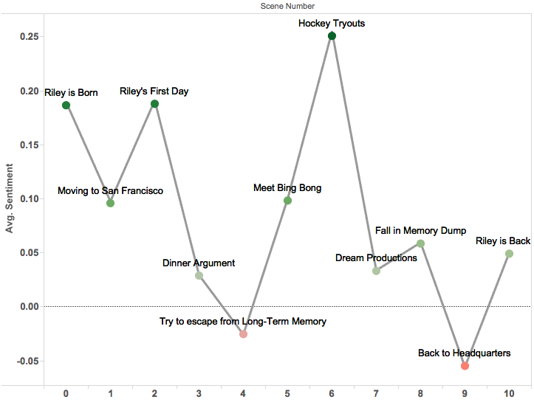

Figure 3.5.3 - Sentiment by Scene Order

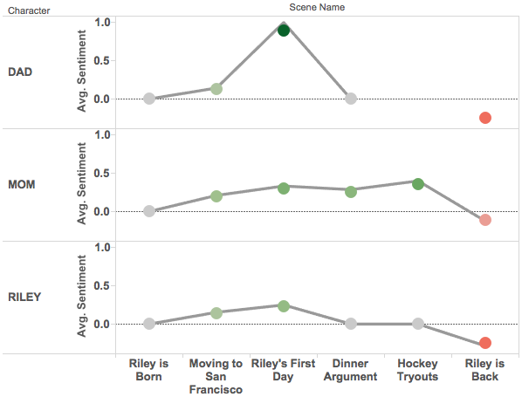

Figure 3.5.4 - Sentiment by 3 Main Characters and Scene

Besides the movie sentiment by scenes, character sentiment by scenes shown in Figure 3.5.4 and Figure 3.5.5. Similar findings as the movie sentiment can be shawn here. For example, in Figure 3.5.4, dad and mom were positive in ‘Riley’s First Day’ and ‘Hockey Tryouts’ since they tried to encourage Riley.

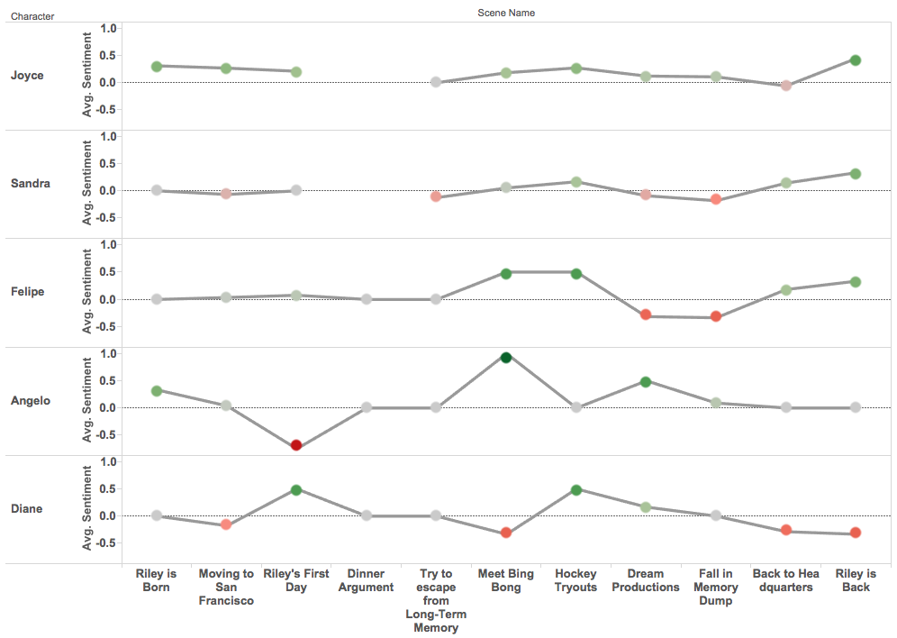

Figure 3.5.5 - Sentiment by 4 Main Characters and Scene

In Figure 3.5.5, Joy and Sadness didn’t show any sentiment scores in scene ‘Dinner Argument’ since they didn’t appear there. Sentiment scores of Angry has more fluctuations along scenes; it indicates Angry would like to enlarge his emotions.

## 3.6 LDA

### 3.6.1 Characters VS. Topics

We visualized the topic Distribution by top 10 Characters in Figure 3.6.1. Most of characters have different topic distributions, however, topic 12 is related to all top 10 characters. Bing Bong and Sadness share the most different topic distributions.

We separately plot them with Topics by bubble charts. (See Figure 3.6.2 left) We found out topic 28 is only significant in Bing Bong and topic 26 is only significant in Sadness. The right plot in Figure 3.6.2 shows top words of topic 28 and 26. Words ‘fly’ and ‘thank’ in topic 28 of Bing Bong matches his personality; similarly, word ‘worry’ in topic 26 of Sadness ‘ matches her personality.

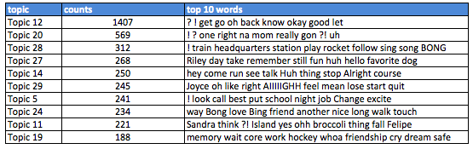

Table 3.6.1 - Top 10 words for each of the Top 10 Topics

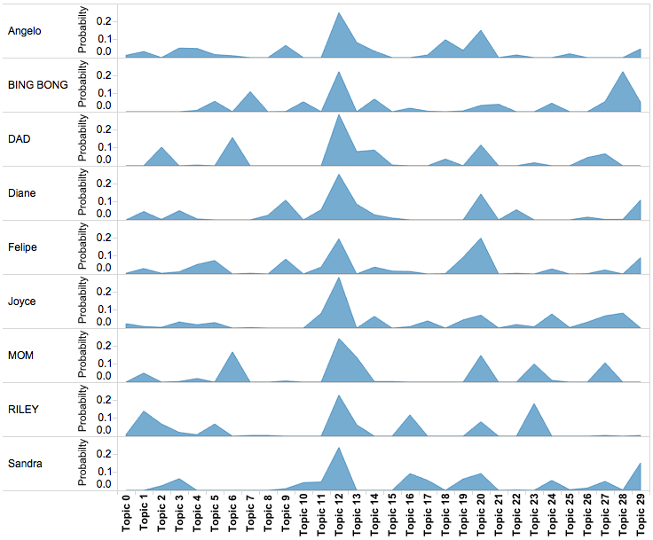

Figure 3.6.1 - Topic Distribution by Top 10 Characters

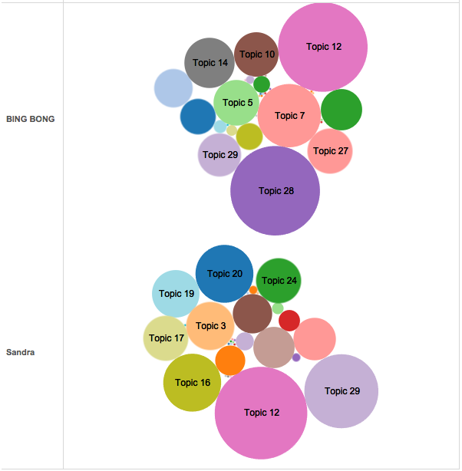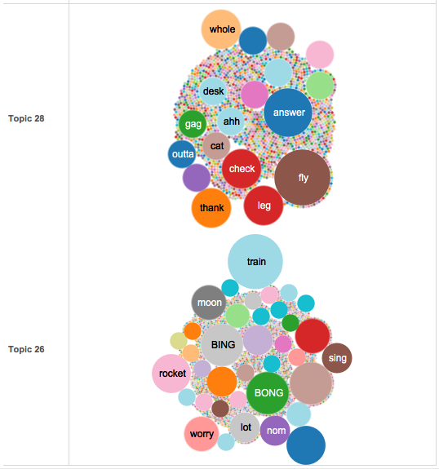

Figure 3.6.2 - Topic Frequency by Characters and Word Frequency for Selected Topics

### 3.6.2 Locations VS. Topics

Figure 3.6.2 shows topic distribution by top 5 locations. Most of locations have different topic distributions, however, topic 28 is related to all five locations. We wanted to compare differences between Minnesota and San Francisco House in terms of topics. Figure 3.6.4 is bubble charts of topic frequency by locations.

We found out topic 16 is only significant in Minnesota House and topic 17 is only significant in San Francisco. The right plot in Figure 3.6.4 shows top words of topic 16 and 17. Word ‘skate’ and ‘money’ in topic 26 are uniquely referring to Riley’s life at Minnesota. ‘ matches her personality. Moreover, words ‘worst’ and ‘introduce’ reflect the bad time at San Francisco.

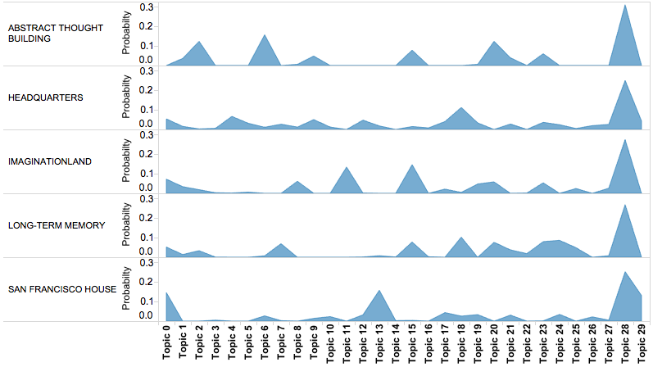

Figure 3.6.3 - Topic Distribution by Top 5 Locations

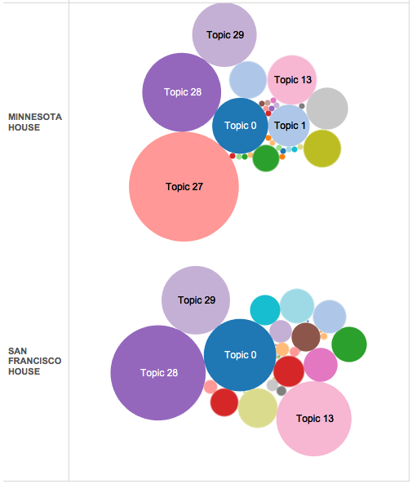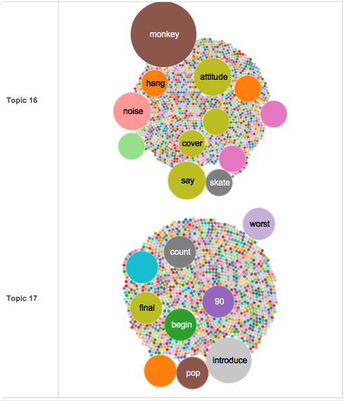

Figure 3.6.4 - Topic Frequency by Locations and Word Frequency for Selected Topics

### 3.6.2 Scene VS. Topics

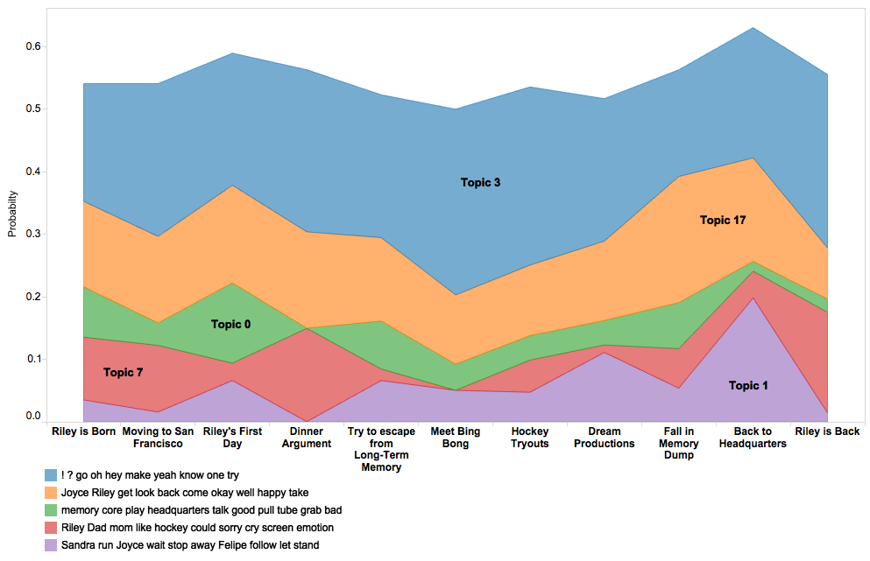

Figure 3.6.5 - Top 5 (Overall) Topics Density Plot across Scenes

Besides characters and location, we plot overall top 5 topics across scenes in Figure 3.6.5. Topic 3 and topic 17 are comparably more related to each scene than other topics. Based on the features (keywords) of topics, the distributions of some topic are fluctuated across scenes. For example, topic 7, which includes keywords ‘Riley’, ‘Dad’, ‘mom’, shows relevance in scene ‘Riley is Born’, ‘Dinner Argument’ and ‘Riley is Back’ instead of ‘Meet Bing Bong’.

## 3.7 Document similarity

We analyzed the document similarity by applying both tfidf and boolean similarity methods. In Figure 3.7.1, the left plot is a tfidf similarity heatmap and the right plot is a boolean similarity heatmap across top characters; they show very similar results by both methods.

Fear and Disgust have a high similarity since their personalities match. A same conclusion can be drawn on a high similarity between Joy and Bing Bong. The reason that Joy and Sadness have a high similarity is they always appeared together in same locations and scenes.

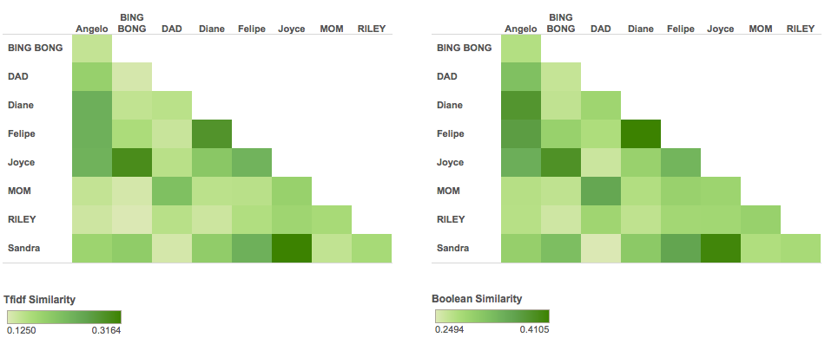

Figure 3.7.1 - Character Similarity Heatmap

In Figure 3.7.2, the left plot is a tfidf similarity heatmap and the right plot is a boolean similarity heatmap across top characters; they show very similar results by both methods. The reason that Headquarter has a high similarity with both Long-term Memory and San Francisco is these locations shared same scenes and characters. Similarly, we can conclude from the result in Figure 3.7.3: two scenes have a high similarity since they happened at same locations and includes same characters.

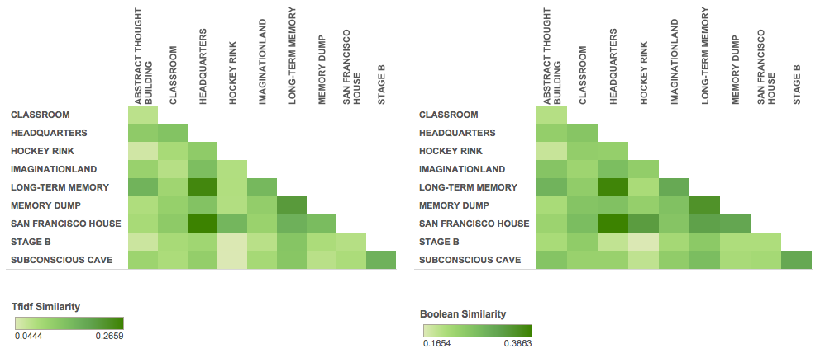

Figure 3.7.2 - Location Similarity Heatmap

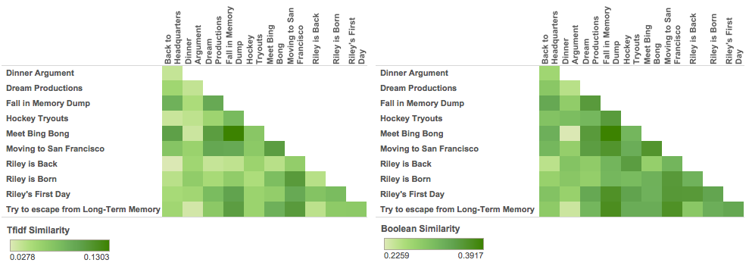

Figure 3.7.3 - Scene Similarity Heatmap

## 3.8 Clustering

Clustering based on the tfidf matrix and using k-means with different cluster size for characters, locations and scenes was conducted. The results show that the main characters are assigned to separate clusters, while the rest of characters are usually assigned to one cluster. However, due to the small size of the dataset (e.g. few characters, locations and scenes), hierarchical clustering was performed as it is more appropriate for small datasets. The algorithm merges or splits clusters recursively based on the linkage criteria (based on cosine distance in this case). In this case, ward, average and complete linkages were tested. The results show that ward distances seem to perform better than the other linkages. For the details of average and complete linkage clustering refer to Appendix C.

Figure 3.8.1, Figure 3.8.2 and Figure 3.8.3 show the dendrograms using ward linkage for characters, locations and scenes respectively. For characters, it can be seen that at a high level, 3 clusters are formed: the main characters (e.g. Riley, Mom, Dad, Bing Bong and the emotions), Mom’s emotions, and the rest of the characters. At the lower level, we can see that Mom and Dad are grouped together, which are then grouped together with Riley. Similar insights can be gained from the emotions and the rest of the characters, indicating that the clustering overall makes sense.

Regarding locations, we can see one cluster that makes sense: imagination land, memory dump, abstract thought building, long-term memory and mind world. These locations have common events happening throughout the movie. The clustering of scenes mostly indicates a time sequence in the grouping. The clustering of locations and scenes is not as well defined or clearly separated as that of the characters. One reason might be attributed to the fact that for locations and scenes, both the quotes and descriptions were used to generate the tfidf and distance metric. Another reason is that the location and scenes might not be very distinctive in the first place as they aggregate a lot of information and events.

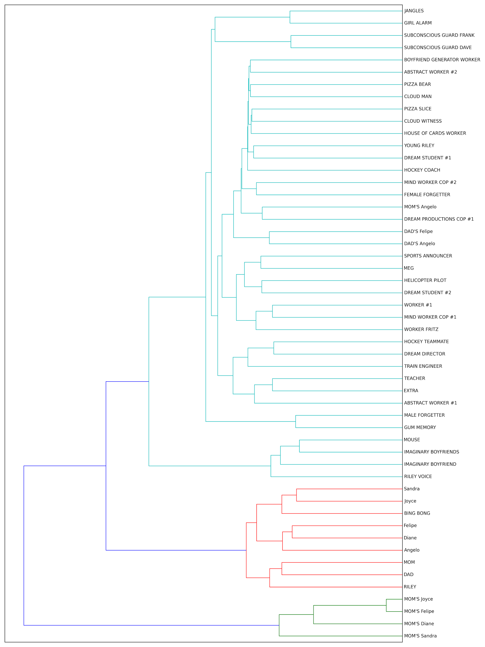

Figure 3.8.1 - Hierarchical Clustering (ward linkage) on Characters

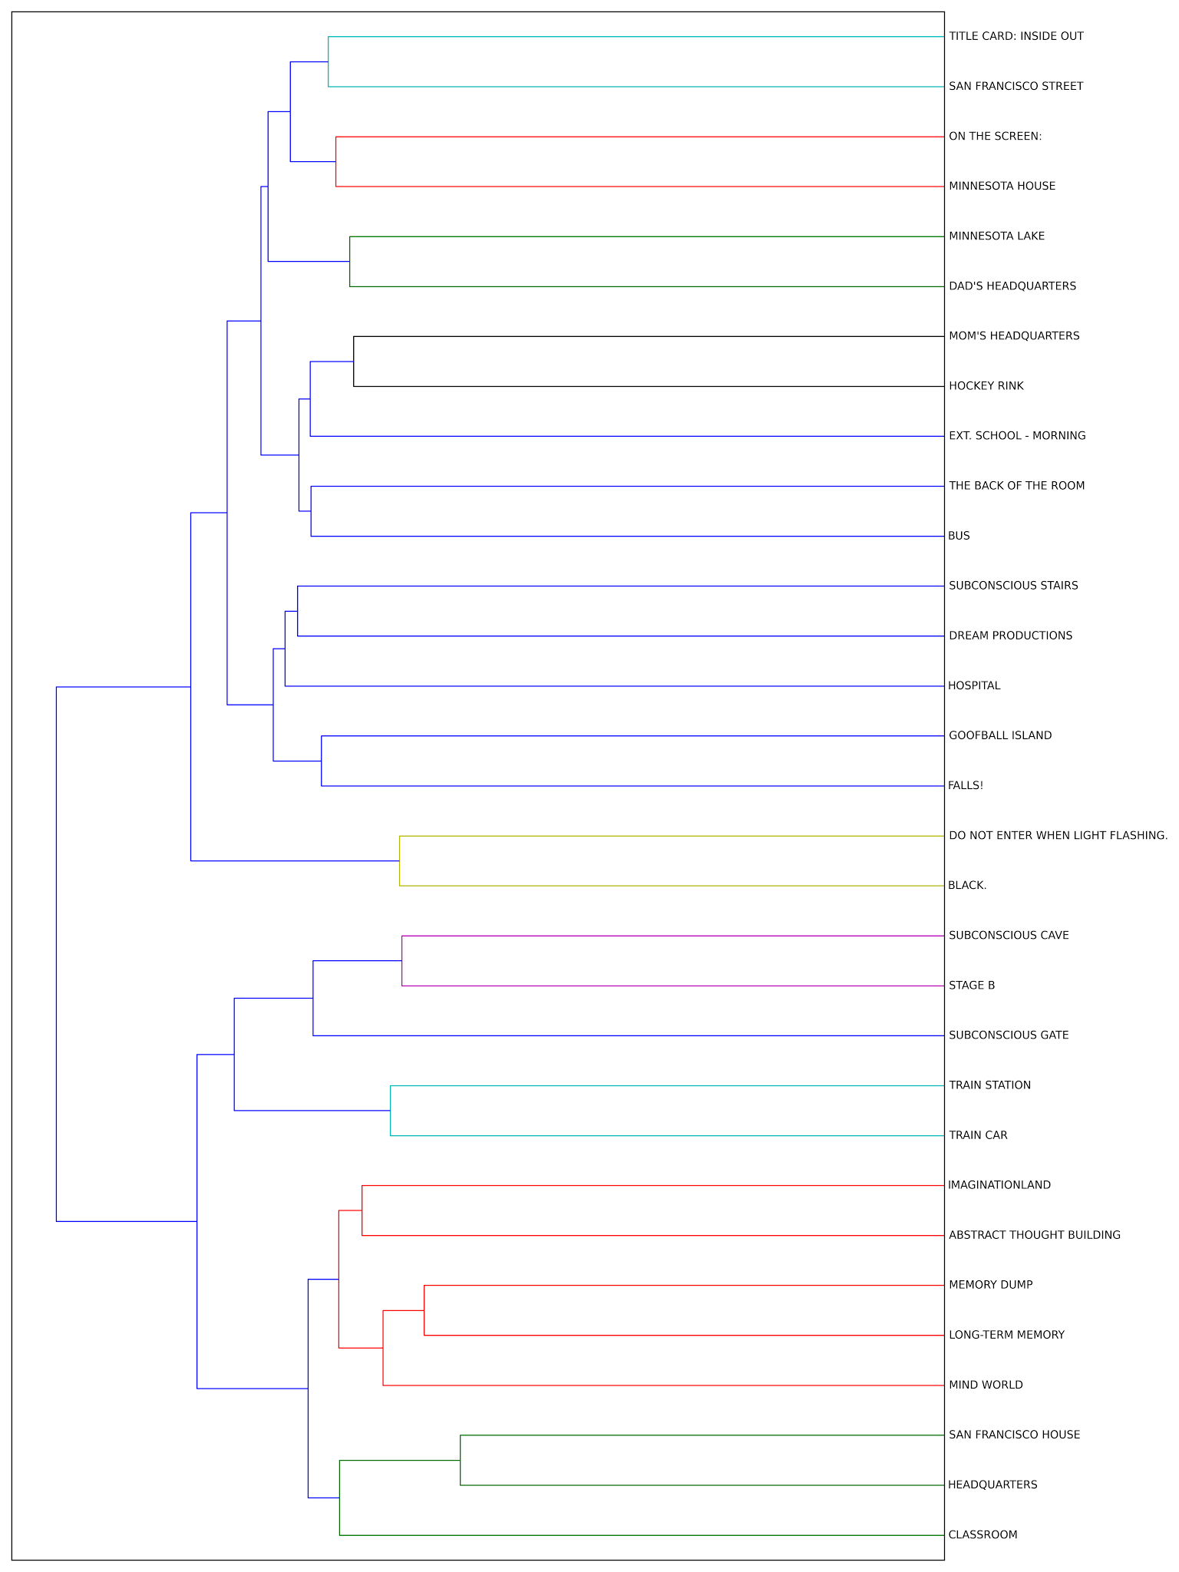

Figure 3.8.2 - Hierarchical Clustering (ward linkage) on Locations

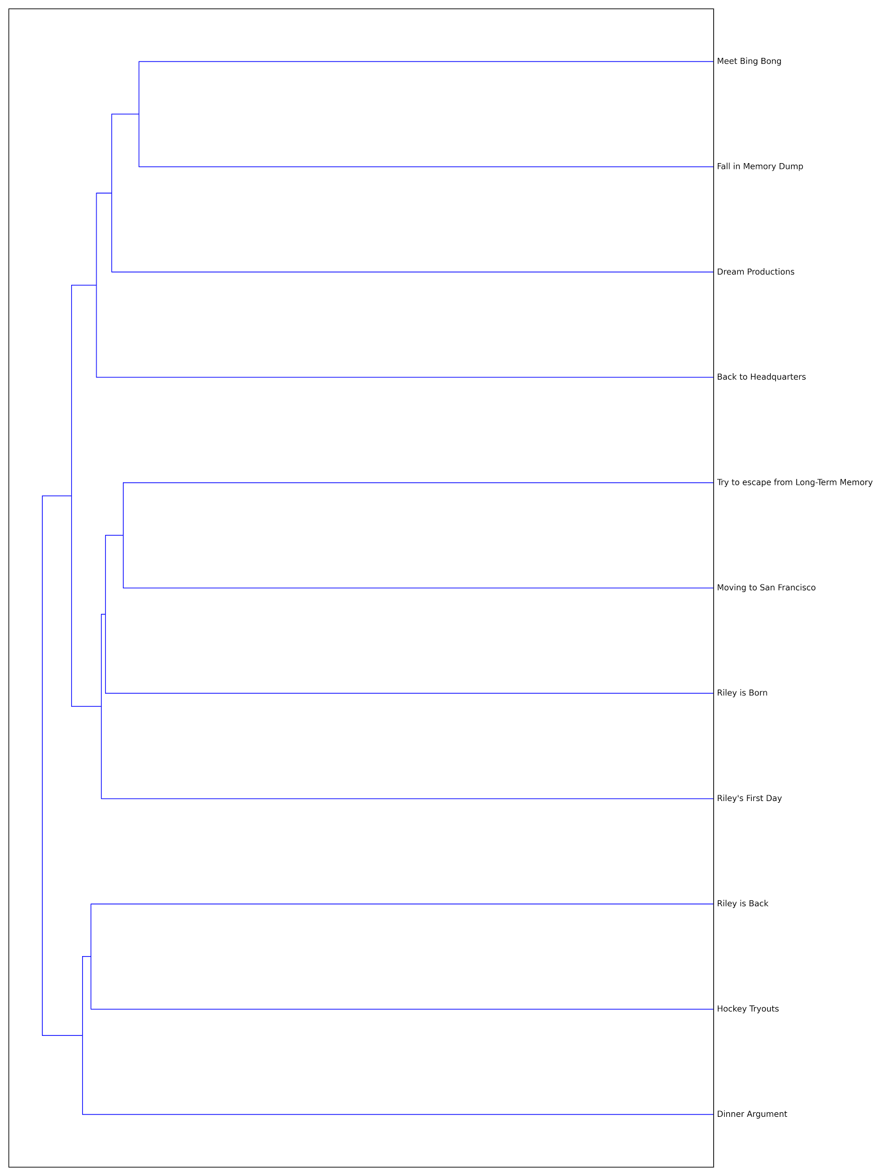

Figure 3.8.3 - Hierarchical Clustering (ward linkage) on Scenes

## 3.9 Dialogue Act Types

The classification of quotes based on the dialogue type by character, location and scene is shown below in the heatmaps found in Figure 3.9.1, Figure 3.9.2 and Figure 3.9.3 respectively. The percentage in the heatmap is at the row level (e.g. distribution of act types for each character). At the character level, the heat map indicates that Joy and Bing Bong express more greeting and acceptance compared to Angelo. Mom and Riley also seem to have more statements than emphasis compared to other characters. Similar insights can be deduced from the locations and scenes heatmap. An interesting highlight is the high number of statements and rejection dialogue acts in the hockey rink.

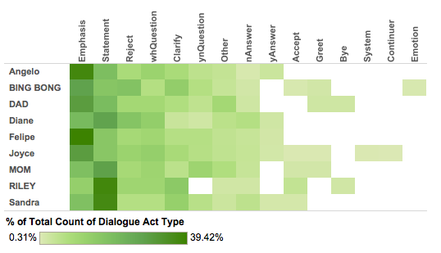

Figure 3.9.1 - Dialogue Act Type by Characters Heatmap

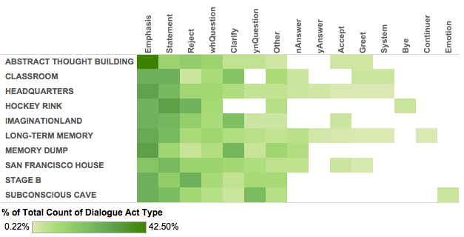

Figure 3.9.2 - Dialogue Act Type by Location Heatmap

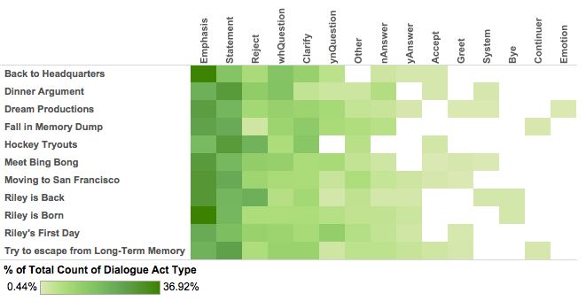

Figure 3.9.3 - Dialogue Act Type by Location Heatmap

# 4. Conclusions

## 4.1 Summary

The results of the text analytics showed that meaningful information and insights can be extracted from text. It was very interesting to see the connection between the results and the expectations from our prior knowledge of the movie.

The exploratory results showed the top characters, locations and scenes by simply counting the number of utterances (quotes). The unigram analysis matched the exploratory results, with the main characters being Riley and Joyce. In addition, the analysis highlights memory as an important theme in the movie.

From the Name Entity Recognition, the results also match the exploratory results. The main characters were detected, as well as locations (e.g. personality islands) and organizations (e.g. bus company). The temporal time detection were also detected that most time references are for the present and past day.

The sentiment analysis of each character matched the personality definition they represent. For example, Joy has one of the most positive mood while Disgust the most negative mood. In addition, the sentiment corresponds to turning points in the movie. For instance, when Riley moves to San Francisco there is a drop in the positive sentiment, which drops further to scenes where there is drama and struggles (e.g. dinner argument and trying to escape from long-term memory). The sentiment becomes more positive in the hockey rink due to cheering and end of the movie when Joy is back.

Topic analysis (LDA) shows that the topics detected can reflect the personality of characters, the moods in the scenes and themes in each location. Document similarity shows following features would lead to a high document similarity: characters with similar personality, two locations involving same scenes and characters and two scenes happening at same locations with same characters.

Hierarchical clustering with ward distance shows good performance for characters, with the analysis resulting in separate groups of emotions, physical world characters and supporting characters. An interesting highlight from the dialogue act analysis is that “happy characters”, such as, Bing Bong and Joy, express more greeting and acceptance compared to other characters, such as Angelo.

## 4.2 Future Work

An extensive analysis was done in this project using several diverse text analytics techniques. However, due to the richness of the data, we suggest to conduct further analysis.

For example, a sentiment analysis to predict the polarity based on a classification algorithm (e.g. Naive Bayes or SVM) can be done to compare the approach in this project. In order to train the classifier, a corpus with dialogue and positive/neutral/negative label is needed. A related interesting analysis can be done if labels for moods can be attached to a dialogue.

A dialogue analysis can also be done to gain more insights on the conversation in the movie. For example, interesting questions that can be answered are: Who talks (spends time) with whom? Does it change over time? Which fraction of the talk does each speaker contribute?

The results of the dialogue analysis can be combined with the results of this project to find out who or what does each speaker talk about, what is the sentiment of the speaker about each entity (i.e., what is the sentiment of the words that appear near them in the dialog?), and if the mood depends on who or what they are talking about. To conduct this analysis, coreference resolution (to identify what pronouns matches what noun) can be used when identifying who talks about what or whom since participants agree about the antecedents of pronouns in dialogues. Thus, consecutive utterances from the various dialog participants can be processed as a single unit of unit of text for the purpose of coreference resolution.

# Appendix

## A. Movie Synopsis (IMBD)

A girl named Riley ([Kaitlyn Dias](http://www.imdb.com/name/nm4609731/)) is born, and in her mind, Joy ([Amy Poehler](http://www.imdb.com/name/nm0688132/)) and Sadness ([Phyllis Smith](http://www.imdb.com/name/nm0809613/)) are created. As she grows into a young kid, the emotions Fear ([Bill Hader](http://www.imdb.com/name/nm0352778/)), Anger ([Lewis Black](http://www.imdb.com/name/nm0085400/)) and Disgust ([Mindy Kaling](http://www.imdb.com/name/nm1411676/)) form, each one coloring the memories that power the islands in her mind. Since her first memory was scoring a goal in a game with her parents, she has Hockey Island, in addition to Goofball, Family, Honesty and Friendship Islands. Each island is connected to Headquarters via lightlines, and has the appearance of a small theme park. Joy can see how the other emotions can be useful, except for Sadness, because she doesn't ever want Riley to be sad.

When Riley is 11, her father ([Kyle MacLachlan](http://www.imdb.com/name/nm0001492/)) starts a new business, and he moves the family from Minnesota to San Francisco. The room in her new home is tiny, and the moving van with all of Riley's stuff keeps getting delayed, so they don't have most of their things. Determined to keep things upbeat, Joy has Riley start a makeshift hockey game in the living room with her dad, using her stick and a wad of paper. Family Island is churning along. Then, Dad gets a business call and quickly has to leave. Sadness tries to take control, but Joy blocks her out, instead giving Riley the idea that she should ask her mom ([Diane Lane](http://www.imdb.com/name/nm0000178/)) to go get pizza.

The pizza mission quickly goes wrong, as only pizza made with broccoli (which Riley hates) is served at the local restaurant. Mom asks Riley what her favorite part of the trip was, and Joy serves up the memory of the time Dad tried to take a picture of them posing in front of a cement dinosaur, failing to realize that the car was rolling down the hill behind him, and it crashed into another dino statue. The memory makes Riley laugh, but then suddenly it turns blue after Sadness touches it. Joy is unable to restore the memory, and orders Sadness not to touch any more memories. Joy then tries to set things right by having Riley slide down a banister, causing Goofball Island to come to life. But then, Riley changes her mind and decides to just walk down the stairs. Dumbfounded, Joy investigates and finds a core memory on the floor, and Sadness standing next to the core memory holder, having caused the memory to fall out. The missing core memory caused Goofball Island to go black. When Sadness tries to touch a core memory, Joy quickly pulls her hand back, knowing that the memories can't be changed back once they're turned sad. Determined to keep Sadness from causing any more trouble, Joy takes her to a large collection of mind instruction manuals and tells her to read them.

On the first night, Riley has only a sleeping bag in her room, and she's unable to sleep. Riley's emotions realize that the move was a lot worse than Joy had said it would be. Mom comes into the room and thanks Riley for keeping a happy face through the stressful situation. When Riley finally falls asleep, Joy puts on a happy dream of Riley ice skating with her parents. The next day, Riley has her first day at her new school, and Joy gives assignments to the team, telling Sadness that she should just stand still, and not take the controls at all. When Riley arrives in class, the teacher asks her to introduce herself, and tell everyone about her life in Minnesota. Riley talks about playing on a hockey team, but once again the memory turns blue after Sadness touches it. Joy tries to take the memory out, and sees Sadness taking control of the console. Joy finally succeeds in removing the memory and pulls Sadness away from the console, but not before a new sad core memory is created. Joy tries to activate the memory dump, but Sadness stops her from erasing the memory. In the struggle, all of the core memories fall out, and a happy core memory starts to get sucked into the dump tube, and Joy grabs it and finds herself, Sadness and the core memories getting sucked away.

Joy and Sadness get dumped out in Riley's long term memory. From a distance, they can see Riley's personality islands lifeless. Knowing that Riley needs her core memories and can't be happy without Joy at the controls, they set out to make their way back to headquarters. With Fear, Anger and Disgust in charge, Riley can only snap back at her parents when they try to talk to her. Frustrated, Dad sends Riley to her room. Joy and Sadness make it to Goofball Island, where they try to walk the lightline back to headquarters, knowing that one misstep will land them in the memory dump below. When Dad comes into the room and tries to cheer Riley up, she rolls over and faces the wall, causing Goofball Island to crumble. Joy and Sadness barely escape falling into the memory dump, and the other emotions are hoping desperately that Joy will return soon.

With Goofball Island destroyed, Joy sets out for Friendship Island. The only path is through long term memory, and Sadness remembers from the manual that it's easy to get lost in there. Joy realizes that if Sadness read the manual, she would know how to get back to headquarters, so she lets Sadness lead the way. With Sadness too depressed to walk, Joy has to spend the night dragging her through long term memory, where they encounter Forgetters, who have the job of sending Riley's faded memories to the dump. One memory they vow never to get rid of is the jingle from an old gum commercial, and they send that one up to Headquarters through a recall tube at random times, causing the song to play in Riley's head. Riley is doing an online chat with an old friend, Meg ([Paris Van Dyke](http://www.imdb.com/name/nm5336046/)), who tells her that there's a new girl on her old team who plays really well with her. Anger is at the helm, and Riley abruptly ends the conversation, causing Friendship Island to crumble. Joy and Sadness plan to head to Hockey Island, but then meet up with Riley's imaginary friend, a pink elephant named Bing Bong ([Richard Kind](http://www.imdb.com/name/nm0454236/)).

Bing Bong realizes the urgency of the situation, and tries to help the pair get back to headquarters. Joy remembers the rocket ship he had that was powered by Riley's singing. Excited at the prospect of being remembered again, Bing Bong starts to dance, but then trips and cries. Joy notices his tears are actually pieces of candy. Bing Bong gives Joy a bag to hold the core memories that she's been carrying, and tells her that taking the Train of Thought will get them back to headquarters much faster than walking. Bing Bong knows a shortcut that will take them to a train station in Imagination Land, but Sadness warns her that the path isn't safe, having read about the area in the manual. Undeterred, Joy and Bing Bong head into a building, with Sadness reluctantly following. The building turns out to be abstract thought, and the three of them start to lose their body shape. In the final stage, they become straight lines, and are able to inch their way out of the building, but miss the train and decide to go through Imagination Land to reach another station.

In Imagination Land, Bing Bong is able to find his old rocket ship, and they run into Riley's imaginary boyfriend. Bing Bong leads them through Preschool World to get to the station. Riley is at the first tryout for the new hockey team, but without her core memories, she can't play well, and she quits in frustration, causing Hockey Island to crumble. Bing Bong realizes that Preschool World is being demolished, and he loses his rocket. Joy is unable to cheer him up, but Sadness consoles him by acknowledging his grief. For the first time, Joy sees that Sadness can be useful. The three catch the train back to headquarters.

Back at headquarters, Anger gets the idea to have Riley run away back to Minnesota to create more happy memories, but decides to let her sleep on it. As soon as she falls asleep, the train stops, stranding the trio. They decide to try to wake Riley up by giving her an exciting dream, and set out for Dream Productions. Joy hands Bing Bong the bag that holds the core memories, and then puts on half of a dog costume, and gives the other half to Sadness.

At Dream Productions, there is a crew producing Riley's dream, like a movie. Fear is in charge of the dream, which has Riley in class in her underwear and with her teeth falling out. Sadness has doubts that a happy dream will wake Riley, suggesting a scary dream instead, but Joy ignores her idea, and they come into the dream as a cute dog, surprising the movie crew. Bing Bong starts a party in the classroom with balloons and confetti. He dances around and causes the dog costume to rip in half, and Joy chases Sadness around, causing the dream to be half a dog chasing the other half. The scary scene nearly causes Riley to wake up, but a guard tackles Bing Bong and takes him off to the Subconscious. Joy and Sadness follow in an effort to rescue Bing Bong. They can't get in, but then stand near the doors and pretending that they are escaping from the subconscious, they are caught by the guards, and are shoved in as well. They follow Bing Bong's candy tears and find him trapped in a cage made of balloons, that is built on the side of Jangles, the birthday clown ([Josh Cooley](http://www.imdb.com/name/nm2155757/)), asleep on the floor. They're able to free Bing Bong, and they get Jangles to chase them back to Dream Productions. They tell him that there's a birthday party in Dream Productions, and he takes over the dream, startling Riley awake.

Joy and Sadness are able to catch the train to headquarters. Anger is furious that he can't even get a good night's sleep with Fear at the controls, and he decides to follow through with his plan to have Riley run away. Joy acknowledges that Sadness had the right idea to scare Riley awake. Bing Bong finds a box of Riley's memories, and Sadness fixates on one where Riley is celebrating with her teammates. Joy thinks that Sadness has finally come around to her own way of thinking, until Sadness reveals that the memory is actually of the time when Riley missed the winning shot, costing her team the game.

Riley sneaks downstairs and grabs her mom's credit card from the purse. At first, it seems that her mom will see her with the credit card in her hand, but mom is too involved in her conversation to notice. Honesty Island collapses, sending the train crashing into a cliff. The three escape just before the train falls into the memory dump. Riley shoves her clothes into her backpack and leaves the house. Family Island starts to crumble, exposing a memory recall tube. Joy and Sadness realize that they could be sucked up and sent back to headquarters. Riley heads out for the bus station, causing Family Island to quake.

Joy and Sadness make it to a tube, but there isn't enough room for both of them, and Joy decides to go back alone. The quake causes the tube to break apart, and Sadness watches helplessly as Bing Bong tries to save her, and they both fall into the abyss. Joy realizes that she's in the memory dump, and tries to climb out. Bing Bong finds her and tells her there's no point. Joy finds the sad core memory that never got stored at headquarters. Dejected, Joy goes through Riley's core memories, finally coming across the one where Riley had missed her shot in the hockey game. Joy realizes that she had misinterpreted what looked like a celebration, and that Sadness was right: it was actually the team and Riley's parents consoling her, and Sadness was the cause.

With renewed determination, Joy finds Bing Bong's rocket ship, and sings its broom engines to life. They try several times, with the ship coming closer and closer to escaping. Bing Bong realizes they won't make it out with his weight, so he jumps out and falls back down to the dump, and Joy safely gets out, only to realize that Bing Bong is still in the dump, far below. He cheers her on, and then begins to fade out of existence. Joy sets out to get back to headquarters and save Riley.

Riley's parents realize that she isn't home and call her cell phone. With Anger at the helm, she ignores the call and continues to the bus station. Joy is able to follow a trail of memories that Sadness has touched. Riley is standing in line for the bus, and Family Island starts to disappear. Dissuaded, Anger tries to remove his idea. Joy finds Sadness, but Sadness decides Riley would be better off without her. She hops onto a cloud and flies away. Joy finds the Imaginary Boyfriend Generator. Anger can't dislodge his idea, and the console turns black. Riley is unable to have any feeling.

Joy creates a stack of imaginary boyfriends, and forms them into a tower, one standing on top of another. She then climbs to the top, and jumps onto a trampoline, which launches her high enough to catch Sadness in midair. Together, they're propelled back to headquarters, where they crash into the window. Disgust is able to cause Anger to erupt in flames, and then uses him to cut a hole in the glass for Joy and Sadness to be pulled back in. Meanwhile, the bus closes its doors and starts to leave the station. Back at headquarters, everyone looks to Joy to save the situation, but she lets Sadness take control. Sadness is able to remove the idea, and Riley gets off the bus and walks home.

Riley walks into her house, and her parents run up and hug her. Joy lets Sadness hold the core memories, which turn blue with her touch. With Sadness at the controls, Riley is finally able to cry and honestly say that she misses her old life. Her parents comfort her, and they all talk about the things they miss. Joy hands Sadness the sad core memory she found, and she takes Joy's hand and they both touch the control button. Riley cries and smiles at the same time. Together, Joy and Sadness make a new core memory with both of their touches.

Riley's headquarters gets an upgrade with a new button for puberty. All of the islands are back, along with some new ones. Riley is at a hockey game, with her parents cheering her on with painted faces. Riley accidentally bumps into a boy, causing his emotions to overload. Riley's emotions have confidence that they can work together to help her lead a happy life.

Source: <http://www.imdb.com/title/tt2096673/synopsis?ref_=tt_stry_pl>

## B. Data Processing Notes

# Left:270 --> quotes

# Left:162 --> scene location (uppercase) and description

# Note: some of the tags 162 (description and location) are quotes when

# multiple people speak at the same time

# Left:378 --> character name

# Left:309 --> description of quotes (in parenthesis) and also inside description during quote

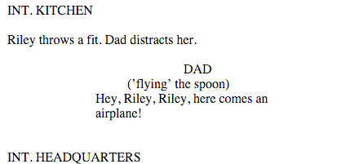

--------------------------------------------------------------------------------------------------------------------------------

# Left:500 --> quotes, this occurs when multiple characters say around the same time

# Left:629 --> character, when multiple characters say around the same time

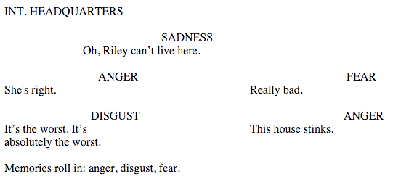

# Left:608 --> character, when multiple characters say around the same time



--------------------------------------------------------------------------------------------------------------------------------

# Left:324 --> description during a quote

# Left:309 --> description of quotes (in parenthesis) and also inside description during quote

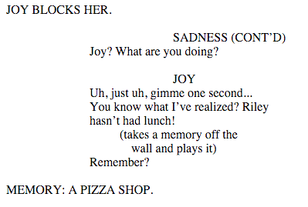

--------------------------------------------------------------------------------------------------------------------------------

# Left:857 --> asterisk on the right margin

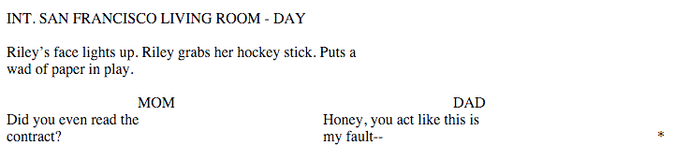

--------------------------------------------------------------------------------------------------------------------------------

# Left:302 --> character, when multiple characters say around the same time

# Left:639 --> character, when multiple characters say around the same time

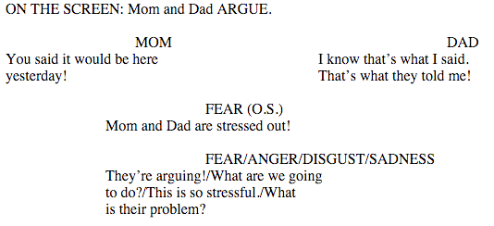

--------------------------------------------------------------------------------------------------------------------------------

# Left:633 --> character, when multiple characters say around the same time

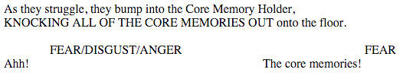

--------------------------------------------------------------------------------------------------------------------------------

# Left:618 --> character, when multiple characters say around the same time

# Left:281 --> character, when multiple characters say around the same time

# Left:291 --> character, when multiple characters say around the same time

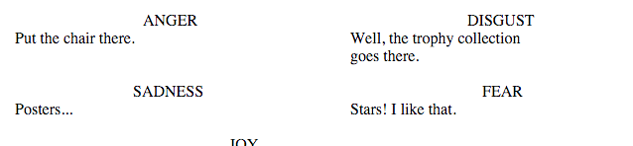

--------------------------------------------------------------------------------------------------------------------------------

# Left:693 --> CUT TO:

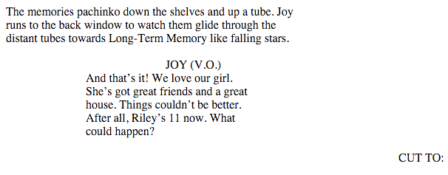

--------------------------------------------------------------------------------------------------------------------------------

# Left:222 --> character, when multiple characters say around the same time



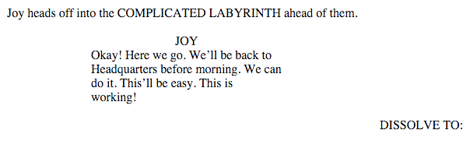

--------------------------------------------------------------------------------------------------------------------------------

# Left:296 --> character, when multiple characters say around the same time



## C. Hierarchical Clustering

C.1 Hierarchical Clustering (average linkage) on Characters

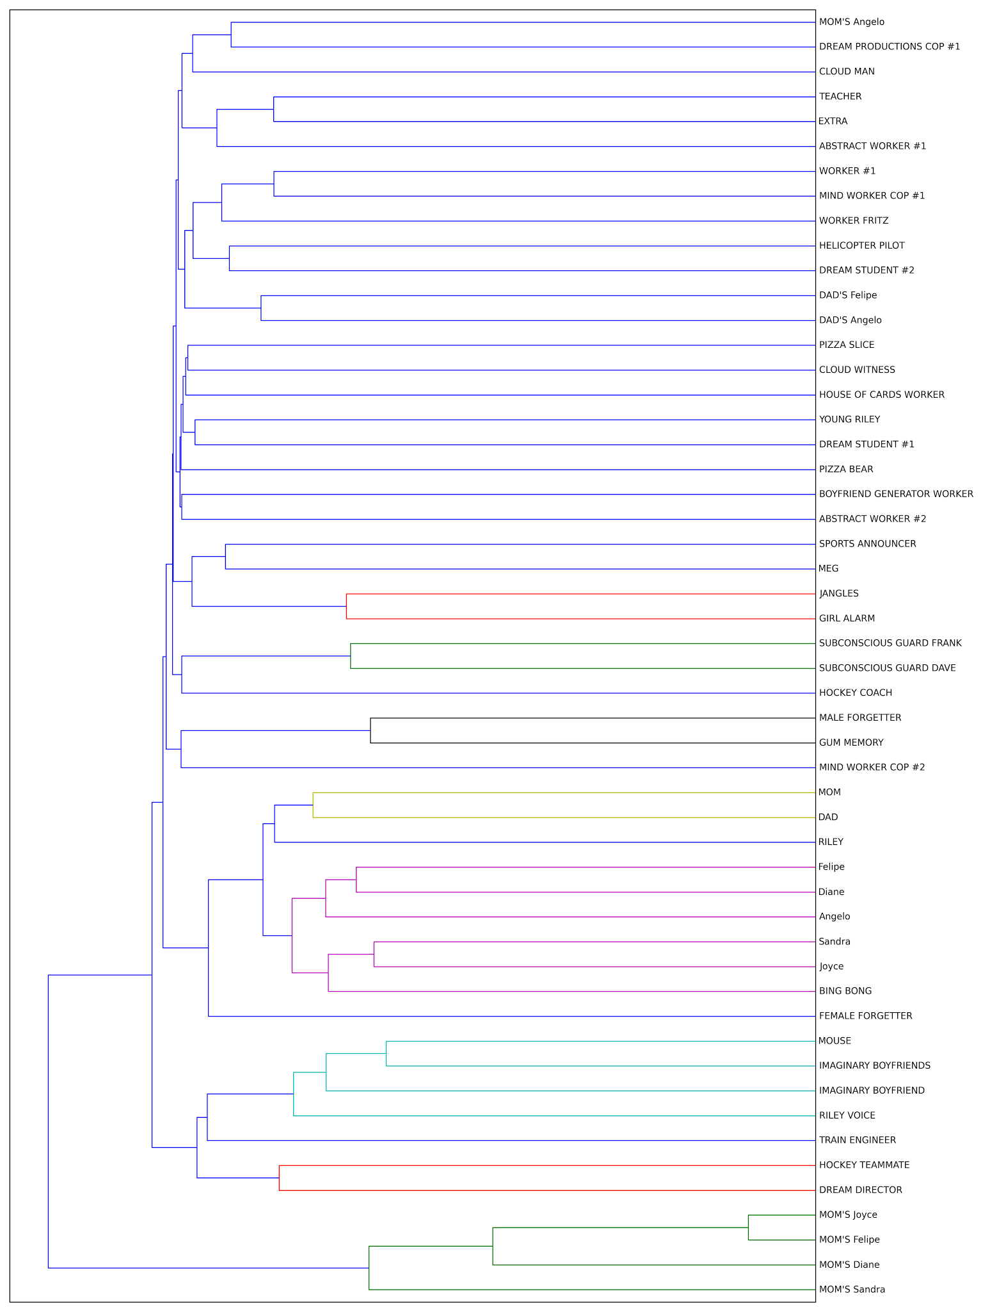

C.2 Hierarchical Clustering (complete linkage) on Characters

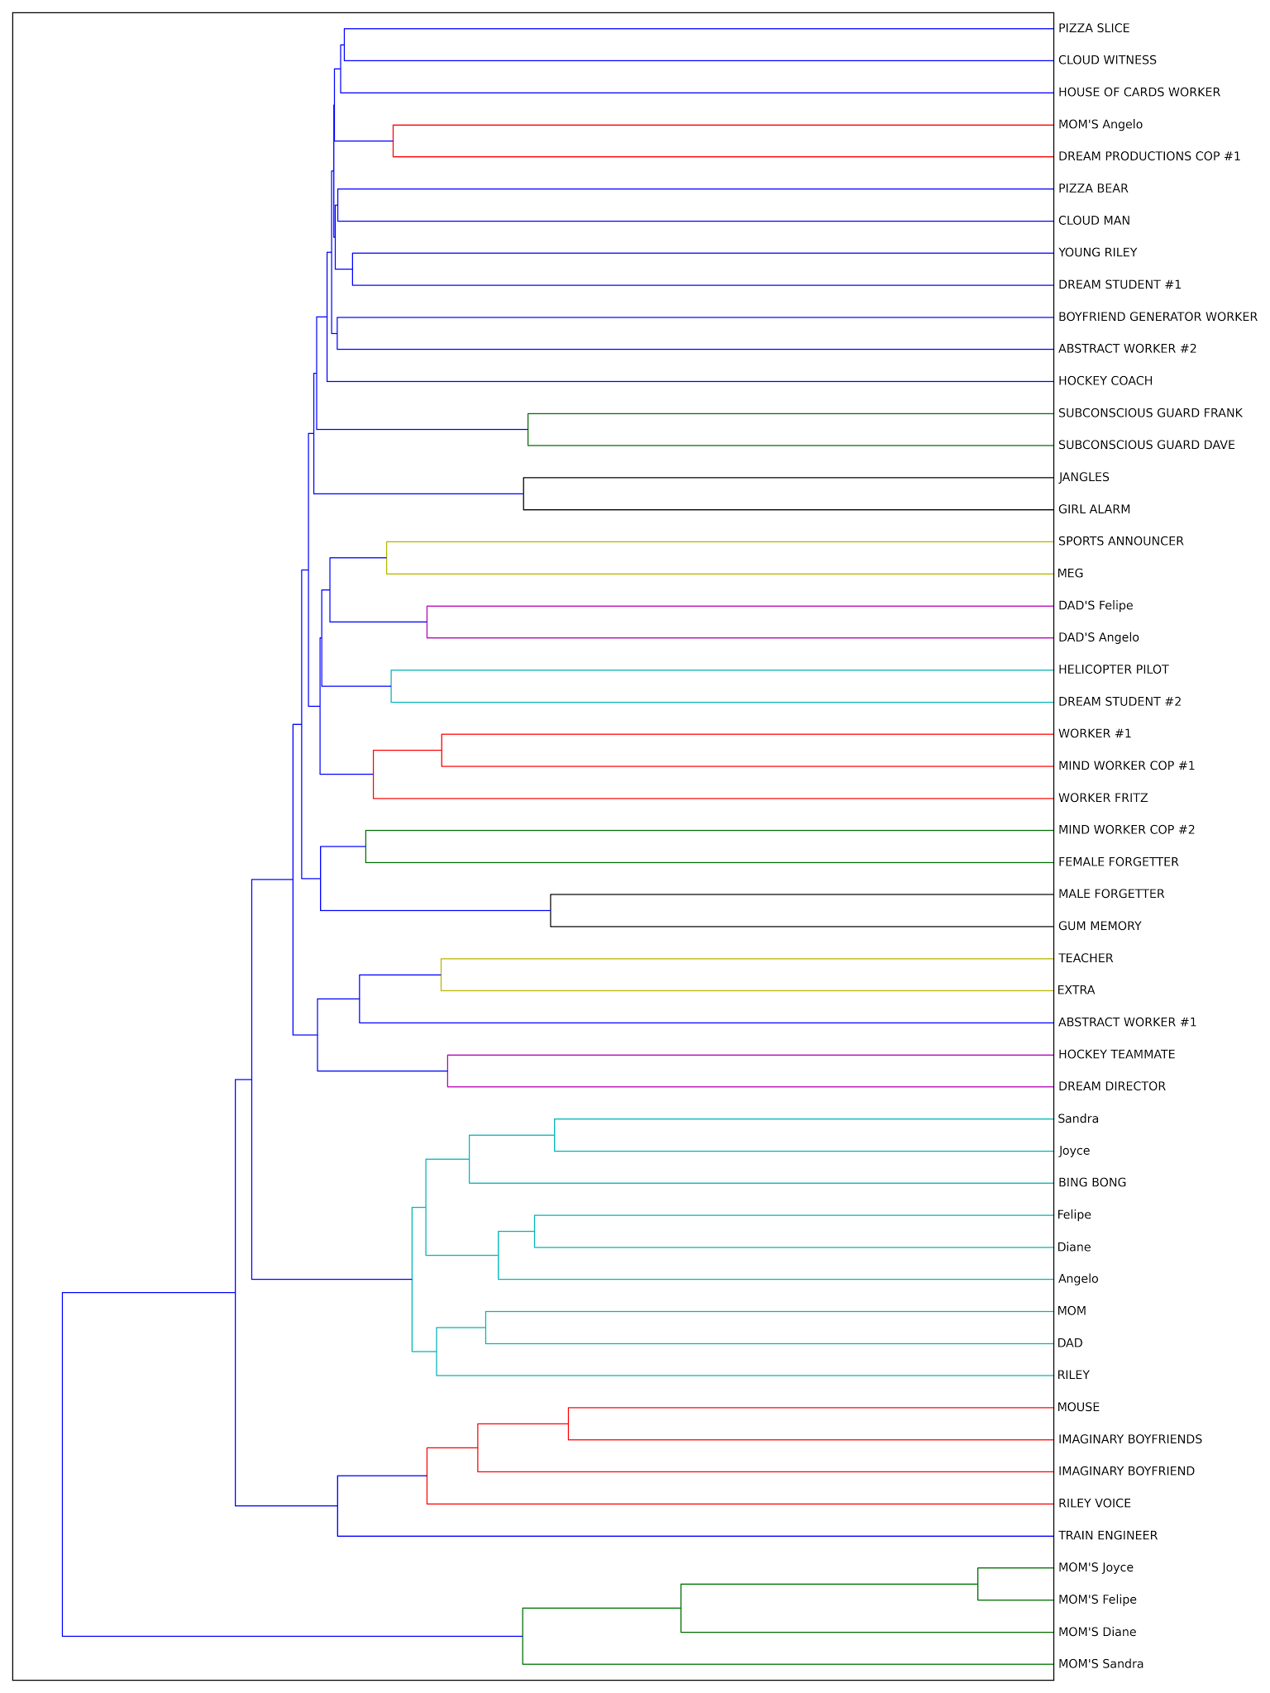

C.3 Hierarchical Clustering (average linkage) on Locations

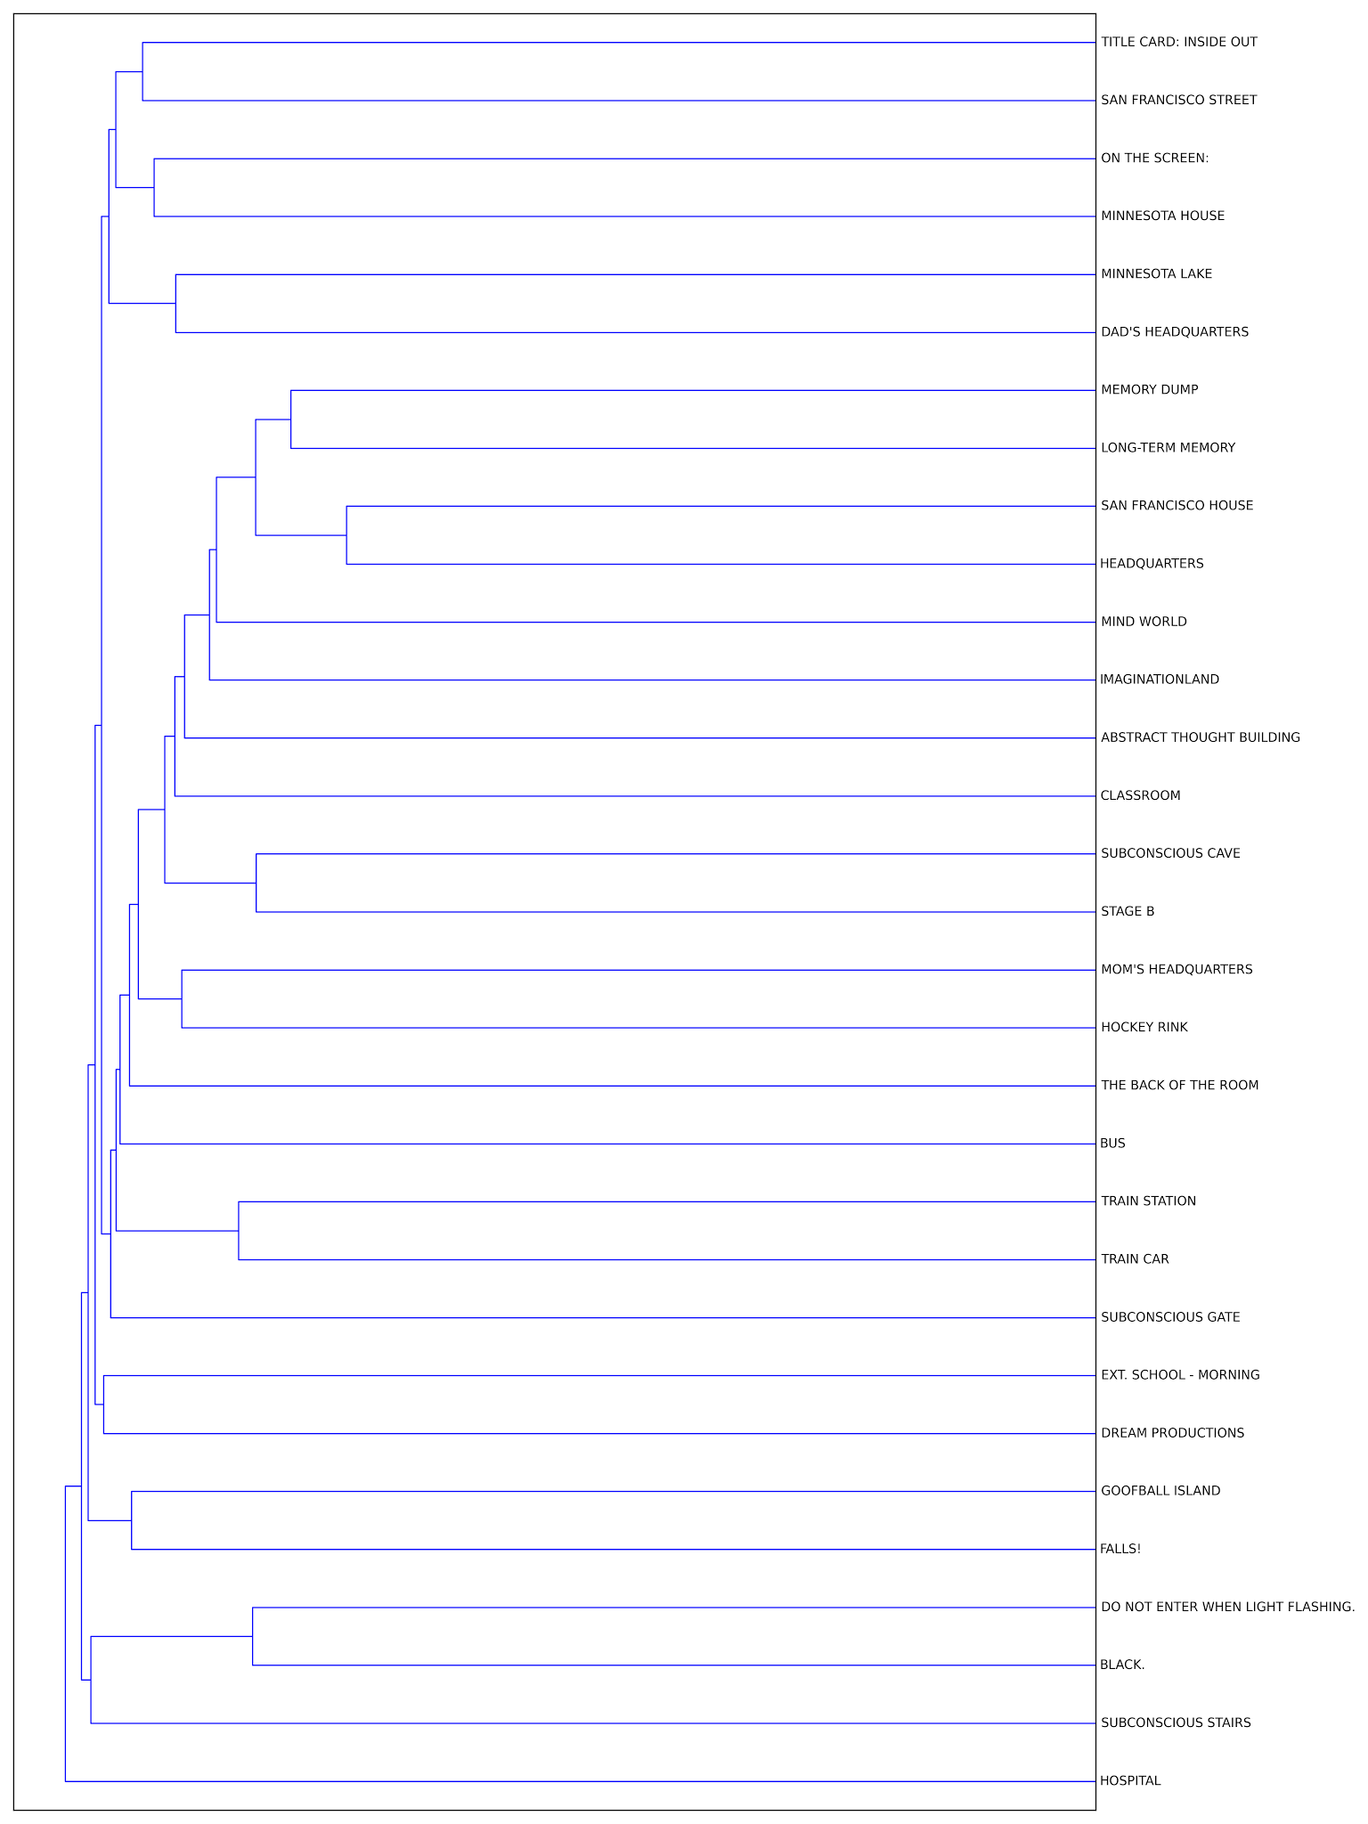

C.4 Hierarchical Clustering (complete linkage) on Locations

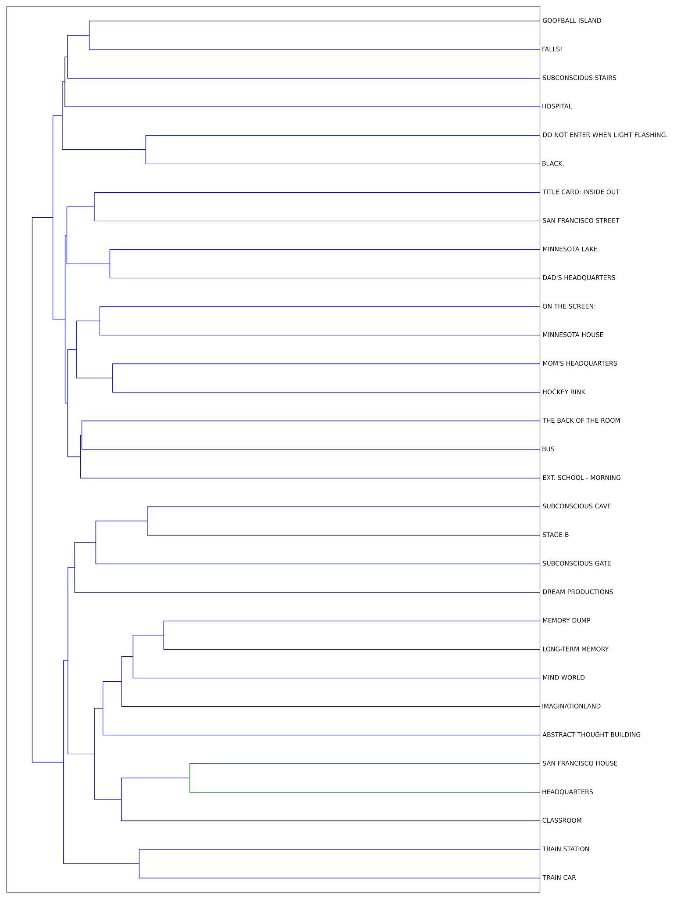

C.5 Hierarchical Clustering (average linkage) on Scenes

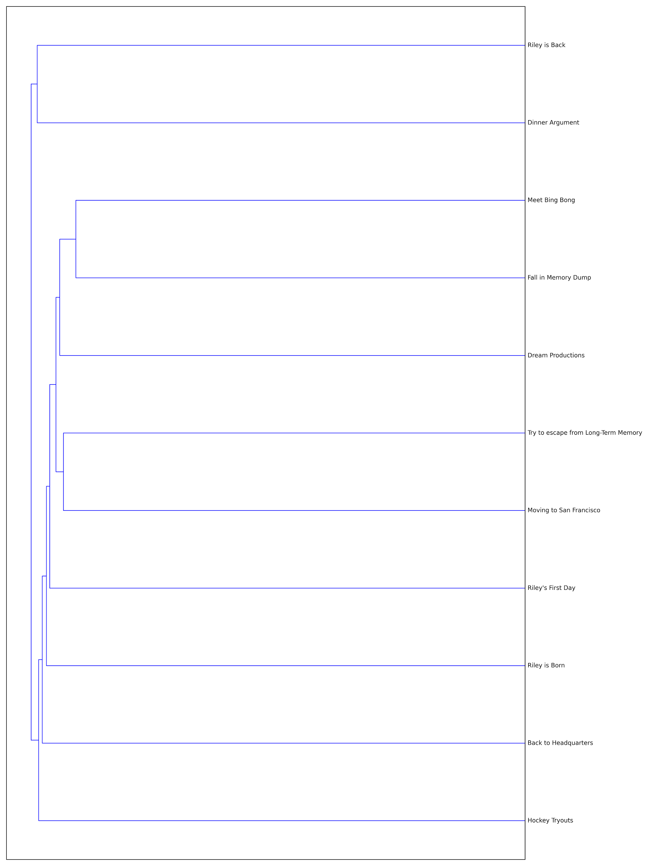

C.6 Hierarchical Clustering (complete linkage) on Scenes

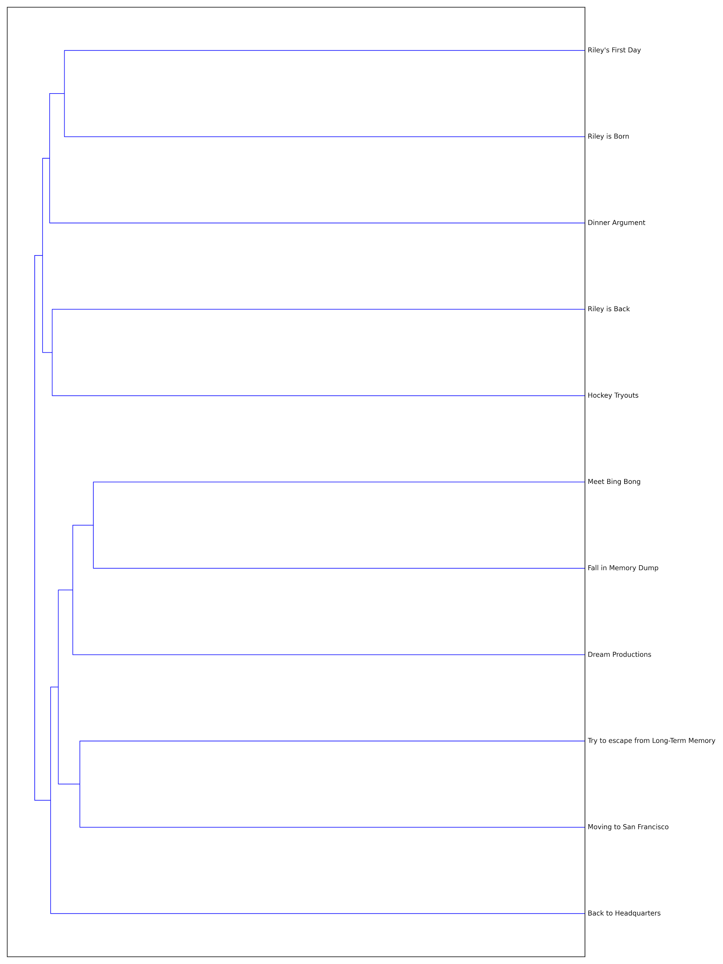

## D. Python Code

1. # -*- coding: utf-8 -*-
2. """
3. MSiA - Text Analytics - Homework 4
5. @author: Steven Lin, Xiang Li, Yu Ang
7. # References
8. http://www.crummy.com/software/BeautifulSoup/bs3/documentation.html
9. http://www.crummy.com/software/BeautifulSoup/bs4/doc/
10. http://stackoverflow.com/questions/1936466/beautifulsoup-grab-visible-webpage-text
11. http://rufuspollock.org/2006/09/25/unicode-to-ascii-mappings-for-standard-characters-from-wordprocessed-documents/
12. http://nlp.stanford.edu/software/corenlp.shtml
13. https://github.com/brendano/stanford_corenlp_pywrapper
14. http://www.nltk.org/api/nltk.classify.html
15. http://stackoverflow.com/questions/21980086/how-to-use-python-nltks-probdisti-class
16. http://www.nltk.org/book/ch06.html
17. http://streamhacker.com/2010/05/17/text-classification-sentiment-analysis-precision-recall/
18. http://www.laurentluce.com/posts/twitter-sentiment-analysis-using-python-and-nltk/
20. # References
21. # http://www.nltk.org/book/ch03.html
22. # http://stackoverflow.com/questions/952914/making-a-flat-list-out-of-list-of-lists-in-python
23. # http://stackoverflow.com/questions/7152762/how-to-redirect-print-output-to-a-file-using-python
24. # http://stackoverflow.com/questions/2225564/get-a-filtered-list-of-files-in-a-directory
25. # http://matthewrocklin.com/blog/work/2014/05/01/Fast-Data-Structures/
26. # http://pandas.pydata.org/pandas-docs/stable/dsintro.html
27. # http://pandas.pydata.org/pandas-docs/version/0.15.2/indexing.html
28. # http://pandas.pydata.org/pandas-docs/stable/generated/pandas.Series.html
29. # http://stackoverflow.com/questions/25736861/python-pandas-finding-cosine-similarity-of-two-columns
30. # http://stackoverflow.com/questions/28883303/calculating-similarity-between-rows-of-pandas-dataframe
31. # http://stackoverflow.com/questions/17627219/whats-the-fastest-way-in-python-to-calculate-cosine-similarity-given-sparse-mat
32. # http://stackoverflow.com/questions/19477264/how-to-round-numpy-values-in-savetxt
33. # http://stackoverflow.com/questions/5469286/how-to-get-the-index-of-a-maximum-element-in-a-numpy-array-along-one-axis
35. # References
36. # https://pypi.python.org/pypi/lda
37. # https://pythonhosted.org/lda/api.html
38. # http://chrisstrelioff.ws/sandbox/2014/11/13/getting_started_with_latent_dirichlet_allocation_in_python.html
40. # References
41. # http://pandas.pydata.org/pandas-docs/stable/gotchas.html
42. # http://brandonrose.org/clustering
43. # http://scikit-learn.org/stable/modules/generated/sklearn.cluster.KMeans.html#sklearn.cluster.KMeans
44. # http://docs.scipy.org/doc/scipy/reference/cluster.hierarchy.html
45. # http://scikit-learn.org/stable/modules/clustering.html
46. # http://www.rdatamining.com/docs/text-mining-with-r-of-twitter-data-analysis
48. """
50. **from** bs4 **import** BeautifulSoup
51. **import** re
52. **from** urllib2 **import** urlopen #python 2
53. **import** time
54. **from** __future__ **import** division # division results in float if both integers
55. **import** os
56. **import** json
57. **import** pandas
58. **import** copy
59. **import** numpy as np
60. **from** stanford_corenlp_pywrapper **import** CoreNLP
61. **from** nltk.corpus **import** stopwords
62. **import** nltk
63. **from** scipy.spatial.distance **import** cosine
64. **import** math
65. **from** sklearn.metrics **import** pairwise_distances
66. **import** sys
67. **import** numpy as np
68. **import** lda
69. **import** lda.datasets
70. **import** time
71. **from** sklearn.cluster **import** KMeans
72. **from** sklearn.externals **import** joblib
73. **import** matplotlib.pyplot as plt
74. **from** sklearn.metrics.pairwise **import** cosine_similarity
75. **from** scipy.cluster.hierarchy **import** ward, dendrogram
76. **import** scipy
78. path = '/Users/Steven/Documents/Academics/3_Graduate School/2014-2015_NU/MSIA_490_Text_Mining/hw/hw4'
79. in_file_name = 'inside_out.html'
80. out_file_name = 'inside_out.csv'
81. os.chdir(path)
82. os.listdir('.') # see if file is in directory

85. ##############################################################################
86. #%% Function replace utf-8 â€œ and â€™ character to ascii equivalent " and '
88. **def** processString(unicodeS):
89. """ Convert â€™ to ' and remove â€œ, strip leading and trailing whitespace
91. Args:
92. unicdeS
94. Returns:
95. str: in ascii
97. """
98. out = unicodeS.replace( u'\u2018', u"'""'")
99. out = out.replace( u'\u2019', u"'")
100. out = out.replace( u'\u201c', '')
101. out = out.replace( u'\u201d', '')
102. out = out.replace('"','')
103. **return** out.encode('ascii').strip()

106. #%% Data processing by div tag ###############################################
108. #url = 'http://webcache.googleusercontent.com/search?q=cache:zmFBXLVh38EJ:gointothestory.blcklst.com/wp-content/uploads/2015/11/Inside-Out.pdf+&cd=1&hl=en&ct=clnk&gl=us'
109. #html = urlopen(url)
110. bsObj = BeautifulSoup(open(in_file_name))
112. all_tags = bsObj.findAll("div")
113. len(all_tags) # 4817
115. # tag1: header, tag2: header, tag3: tags objects combined since there is not a closing "div" tag
116. # either use tag3:
117. len(all_tags[2].findAll("div")) # 4814
119. # or tag4 onwwards
120. len(all_tags[3:]) # 4814
122. all_tags = all_tags[3:]
124. # also ignore cover tags (e.g. Authors, phone number, etc)
125. all_tags = all_tags[10:]
127. # divs to ignore:
128. #   2 divs in cover page
129. #   2 divs in header: INSIDE OUT, and page number
130. #   1 div for Page Number
132. # page number div tags have tag <b> and also attribute style with left:0
133. **print**(all_tags[0].prettify())
134. len([tag **for** tag **in** all_tags **if** tag.b !=None]) # 129 pages (excluding cover)
136. # headers have atttribute style with left:108 or left:810
137. **print**(all_tags[65].prettify())
138. **print**(all_tags[66].prettify())
139. pattern_head = re.compile(r'left:108|left:810')
140. len([tag **for** tag **in** all_tags **if** pattern_head.search(tag["style"])!=None]) #256, or 128 each (since second page has no header info)
142. # remove these div tags
143. margin_ignore = [0, 108, 810]
144. pattern_ignore = re.compile(r"{}".format("|".join(["left:" + str(i) **for** i **in** margin_ignore])))
146. tags1 = [tag **for** tag **in** all_tags **if** pattern_ignore.search(tag["style"]) == None]
147. len(tags1) #4419

150. # Alternative: process by span tag (page) #####################################
151. # tag span: attribute style="font-size:19px" is the header of page
152. # 130 pages, but first 2 pages don't have header (128 headers)
153. # finds all the page headers
154. ps = bsObj.findAll("span",style=re.compile('font-size:19px'))
155. len(ps) # 128
157. # get pages (represented by span tag), by ignoring span tags headers
158. pattern = re.compile('font-size:19px')
159. pages = bsObj.findAll("span", style=**lambda** tag: pattern.search(tag)==None)
161. # ignore cover
162. pages = pages[1:]
163. len(pages) #129
165. # do some testing
166. pages[0].attrs
167. pages[0].name
168. pages[0].div
169. pages[0]["style"]
170. pages[0].text
171. pages[0].findAll("nobr")
172. pages[0].contents # direct children
173. # generators
174. **for** x **in** pages[0].children:
175. **print** x
176. **for** x **in** pages[0].descendants:
177. **print** x
178. **for** x **in** pages[0].children:
179. **print** x.string
180. **for** x **in** pages[0].strings:
181. **print** x
182. **for** x **in** pages[0].stripped_strings :
183. **print** x
184. pages[0].parent
185. **print**(pages[0].prettify())
187. # count number of divs
188. tags = [tag **for** page **in** pages **for** tag **in** page.findAll("div")]
189. len(tags) #4419 # this number matches data processing by div in previous section
191. tags2 = copy.copy(tags)

194. #%% Find Structure #############################################################
196. # get left margin
197. margins = [tag["style"].split(";")[2] **for** tag **in** tags]
199. series = pandas.Series(margins)
200. c = series.value_counts()
201. **print**(c)
203. # left:270    1874
204. # left:162    1302
205. # left:378    1063
206. # left:309     131
207. # left:500      14
208. # left:324       6
209. # left:857       6
210. # left:302       4
211. # left:633       3
212. # left:618       3
213. # left:281       2
214. # left:291       2
215. # left:639       2
216. # left:693       2
217. # left:222       1
218. # left:641       1
219. # left:296       1
220. # left:629       1
221. # left:608       1

224. **def** removeTag(margin, tags):
225. """ Given a margin for left, prints sample tags matching and returns tags
226. with these margins removed
228. Args:
229. margin (int): margin left
230. tags: list of div tag objects
232. Returns:
233. (list): of div tag object
235. """
236. tagsX = [tag **for** tag **in** tags **if** re.search("left:{}".format(margin), tag["style"])]
237. **print**("Number of tags matching: " + str(len(tagsX)))
238. **print**("Sample matching tags: ")
239. **print**(tagsX[0:min(len(tagsX), 10)])
241. margin_ignore2 = [margin]
242. pattern_ignore2 = re.compile(r"{}".format("|".join(["left:" + str(i) **for** i **in** margin_ignore2])))
243. tags2 = [tag **for** tag **in** tags **if** pattern_ignore2.search(tag["style"]) == None]
245. **return** tags2
247. # Left:270 --> quotes
248. tags2 = removeTag(270,tags2)
249. # Left:162 --> scene location (uppercase) and description
250. # Note: some of the tags 162 (description and location) are quotes when
251. # multiple people speak at the same time
252. tags2 = removeTag(162,tags2)
253. # Left:378 --> character name
254. tags2 = removeTag(378,tags2)
255. # Left:309 --> description of quotes (in parenthesis) and also inside description during quote
256. tags2 = removeTag(309,tags2)
257. # Left:500 --> quotes, this occurs when multiple characters say around the same time
258. tags2 = removeTag(500,tags2)
259. # Left:324 --> description during a quote
260. tags2 = removeTag(324,tags2)
261. # Left:857 --> asterisk on the right margin
262. tags2 = removeTag(857,tags2)
263. # Left:302 --> character, when multiple characters say around the same time
264. tags2 = removeTag(302,tags2)
265. # Left:633 --> character, when multiple characters say around the same time
266. tags2 = removeTag(633,tags2)
267. # Left:618 --> character, when multiple characters say around the same time
268. tags2 = removeTag(618,tags2)
269. # Left:281 --> character, when multiple characters say around the same time
270. tags2 = removeTag(281,tags2)
271. # Left:291 --> character, when multiple characters say around the same time
272. tags2 = removeTag(291,tags2)
273. # Left:639 --> character, when multiple characters say around the same time
274. tags2 = removeTag(639,tags2)
275. # Left:693 --> CUT TO:
276. tags2 = removeTag(693,tags2)
277. # Left:222 --> character, when multiple characters say around the same time
278. tags2 = removeTag(222,tags2)
279. # Left:641 --> dissolve to:
280. tags2 = removeTag(641,tags2)
281. # Left:296 --> character, when multiple characters say around the same time
282. tags2 = removeTag(296,tags2)
283. # Left:629 --> character, when multiple characters say around the same time
284. tags2 = removeTag(629,tags2)
285. # Left:608 --> character, when multiple characters say around the same time
286. tags2 = removeTag(608,tags2)
288. # quote: 270, 500 (when multiple speakers), 162 (when multiple speakers)
289. # scene location: 162 (UPPER CASE)
290. # scene description: 162 (not all upper case)
291. # description quote: 309, 324 (second level)
292. # character: 378, multiple spearkers: 222, 281, 291,296, 302, 608, 618, 629, 633, 639
294. character_margins =[378, 222, 281, 291,296, 302, 608, 618, 629, 633, 639]
296. # "position:absolute;top:1470;left:162"
297. # check that style contains 3 elements and the last one is left
298. **for** tag **in** tags:
299. **if** len(tag["style"].split(";")) !=3:
300. **print**(tag)
301. **elif** tag["style"].split(";")[-1].split(":")[0] != "left":
302. **print**(tag)
304. pattern_margin = re.compile(r'[0-9]+$')
306. **def** getMargin(tag, pattern_margin):
307. """ Returns the left margin number of a tag
309. Args:
310. tag: tag with style attribute
312. Returns
313. int: margin number
314. """
315. **return** int(pattern_margin.findall(tag["style"])[0])

318. # ignore left:693 (CUT TO) and left:857 (asterisk) and left: 641: DISSOLVE TO
319. tags = [tag **for** tag **in** tags **if** getMargin(tag, pattern_margin) **not** **in** (693, 857, 641)]
321. #%% Look at attribue top margin ###############################################
322. # get the differces in the top margin (vertical spacing) for pair of tags transitions
324. pattern_margin = re.compile(r'[0-9]+$')
326. **def** getMarginTop(tag, pattern_margin):
327. """ Returns the top margin number of a tag
329. Args:
330. tag: tag with style attribute
332. Returns
333. int: margin number
334. """
335. **return** int(pattern_margin.findall(tag["style"].split(";")[1])[0])

338. marginTop = [getMarginTop(tag, pattern_margin) **for** tag **in** tags ]
339. differences = [t-s **for** (s, t) **in** zip(marginTop, marginTop[1:])]
340. marginLeft = [getMargin(tag, pattern_margin) **for** tag **in** tags]
341. tagsTransition = [str(t) + "->" + str(s) **for** (s, t) **in** zip(marginLeft, marginLeft[1:])]
343. tagDiff = zip(tagsTransition, differences)
344. tagDiff[0:20]
346. dftagsDiff = pandas.DataFrame({"tags": tagsTransition,"diff": differences}, columns = ["tags", "diff"])
347. dftagsDiff.groupby(["tags", "diff"]).size() # some are negating, indicating out of place tags
349. #%% Create Dataset #############################################################
351. data_raw = []
352. count = 0
353. location = ""
354. description = ""
355. character = ""
356. quote = ""
357. current = ""
359. i=0
360. **while** i < len(tags) **and** tags[i].text != "THE END.":
361. margin = getMargin(tags[i],pattern_margin)
363. # location
364. **if** margin == 162 **and** tags[i].text.isupper():
366. **if** tags[i].text == "ON THE CONSCIOUSNESS SCREEN:":
367. location = tags[i-1].text
368. **if** re.search(r"CONTINUOUS$", location):
369. location = re.sub(r" - CONTINUOUS$", "", location)
371. **elif** re.search(r"CONTINUOUS$", tags[i].text):
372. #location = tags[i].text.split("-")[0].strip()
373. location = re.sub(r" - CONTINUOUS$", "", tags[i].text)
375. **elif** tags[i].text == "BEEP!":
376. location = "INT. HEADQUARTERS"
378. **else**:
379. location = tags[i].text
381. i+=1

384. # description
385. **elif** margin == 162:
387. description = ""
388. **while** margin == 162 **and** **not** tags[i].text.isupper() **and** i<len(tags):
389. description += " " + tags[i].text
390. i+=1
391. margin = getMargin(tags[i],pattern_margin)
393. # character
394. **elif** margin **in** character_margins:
395. #elif margin == 378:
396. character = tags[i].text
397. **if** tags[i+1].text[0] == "/":
398. i+=1
399. character = character + " " + tags[i].text
401. # quote
402. i+=1
403. margin = getMargin(tags[i],pattern_margin)
404. quote = ""
405. **while** (margin **in** [270, 309, 324, 500] **or**
406. (margin == 162 **and** getMarginTop(tags[i],pattern_margin)-getMarginTop(tags[i-1],pattern_margin) == 18)) **and** i<len(tags)  :
408. quote += " " + tags[i].text
409. i+=1
410. margin = getMargin(tags[i],pattern_margin)
412. **if** tags[i].text == "(MORE)":
413. i+=1
414. margin = getMargin(tags[i],pattern_margin)

417. # remove (CONT'D) (O.S) (V.O) from character name
418. clean_character = re.sub(r'\(.*','',character).strip()
420. data_raw.append({"location": processString(location),
421. "description": processString(description),
422. "character": processString(clean_character),
423. "quote": processString(quote)})
425. **else**:
426. i+=1
428. x = pandas.DataFrame(data_raw, columns = ["location", "description", "character", "quote"])
429. # x.to_csv(out_file_name, sep=",", header=True, index=True, encoding = 'utf-8')
431. #%% Clean Dataset #############################################################
433. # check character names
434. pandas.Series(x["character"]).value_counts()
435. characters = np.sort(pandas.unique(x["character"]))
436. **for** i **in** characters :
437. **print**(i)
439. # find all characters
440. # table = bsObj.findAll("div", style=re.compile('left:378'))
442. # Some of the tags are our of place (e.g. top:XXX, when have (CONT'D) in character
443. # as a result of new page). This will usually show blank in quotes.
445. # names separted by / --> split in different row with same quote, location, etc
447. data_clean = []
449. index = 0
450. **for** row **in** data_raw:
451. **if** row["quote"] != "":
453. character_names = [ch.strip() **for** ch **in** row["character"].split("/")]
455. **for** ch **in** character_names:
456. character = ch
457. data_clean.append({ "time": index,
458. "location": row["location"],
459. "description": row["description"],
460. "character": ch,
461. "quote": row["quote"]})
462. index+=1

465. df_data_clean = pandas.DataFrame(data_clean, columns = ["time","character", "quote", "location", "description"])
466. df_data_clean.to_csv("data_clean.csv", sep=",", header=True, index=False, encoding = 'utf-8')
468. with open('data_clean.json', 'w') as fp:
469. json.dump(data_clean, fp, indent=2, encoding = 'utf-8')
471. #%% Replace Character Name and Standardize Locations, Add scenes  #############
473. # chracter counts
474. df_data_clean["character"].value_counts()
476. # locations
477. df_data_clean["location"].value_counts().sort_index()
479. # change locations
480. # Standardize locations if contain
481. location_standard = ['TRAIN STATION','TRAIN CAR', 'SUBCONSCIOUS STAIRS',
482. 'SUBCONSCIOUS GATE','SUBCONSCIOUS CAVE', 'STAGE B',
483. 'SHCOOL', 'SAN FRANCISCO STREET', 'SAN FRANCISCO HOUSE',
484. "MOM'S HEADQUARTERS", 'MINNESOTA LAKE','MINNESOTA HOUSE',
485. 'MINNESOTA HOSPITAL', 'MIND WORLD', 'MEMORY DUMP',
486. 'LONG-TERM MEMORY', 'IMAGINATIONLAND', 'HOSPITAL',
487. 'HOCKEY RINK', 'HEADQUARTERS', 'GOOFBALL ISLAND',
488. 'DREAM PRODUCTIONS', 'DO NOT ENTER WHEN LIGHT FLASHING.',
489. "DAD'S HEADQUARTERS",'CLASSROOM','BUS','ABSTRACT THOUGHT BUILDING']
491. # dictionary based on San Francisco or Minnesota to handle cases like "KITCHEN"
492. location_standard_dic_sf = {k:v **for** (k,v) **in** zip(location_standard,location_standard)}
493. location_standard_dic_mn = {k:v **for** (k,v) **in** zip(location_standard,location_standard)}
495. house_locations = ("LIVING ROOM", "DINING ROOM","BEDROOM", "KITCHEN", "BATHROOM", "RILEY'S ROOM")
497. **for** house **in** house_locations:
498. location_standard_dic_sf[house] = 'SAN FRANCISCO HOUSE'
499. location_standard_dic_mn[house] = 'MINNESOTA HOUSE'
501. **def** standardizeLocation(s, dic):
502. """ Standardize Locations
504. Args:
505. s: string to standardie
506. dic: dictionary key= pattern, value = to replace with
507. Returns:
508. string: standardized string or not match original string
510. """
511. **for** loc **in** dic:
512. **if** re.search(r'{}'.format(loc),s):
513. **return** dic[loc]
514. **return** s

517. # e.g. JOY will say SADNESS a lot, which is a negative sentiment
518. # Also NER will not be able to regonize Sadness as a person
520. # Mapping
521. # Joy --> Joyce
522. # Sadness --> Sandra
523. # Anger -->Angelo
524. # Fear --> Felipe
525. # Disgust --> Diane

528. emotion_to_person = {"Joy": "Joyce", "Sadness": "Sandra", "Anger": "Angelo",
529. "Fear": "Felipe", "Disgust": "Diane"}

532. person_to_emotion = {v: k **for** k,v **in** emotion_to_person.items()}

535. **def** convertEmotionToPerson(s, emotion_to_person):
536. """ Convert the emotion to a person name
538. Args:
539. s (string): string to convert
540. emotion_to_person (dic): mapping emotion to name
542. Returns:
543. string: with replaced emotions with names
545. """
547. **for** (emotion,person) **in** emotion_to_person.items():
549. s = re.sub(r"{upper}|{regular}".format(upper = emotion.upper(),
550. regular = emotion),person, s)
552. **return** s
554. data_names = copy.deepcopy(data_clean) # deep copy otherwise change data_clean since list of objects
555. **for** row **in** data_names:
557. # in minnesota
558. **if** row["time"] < 65:
559. row["location"] =standardizeLocation(row["location"], location_standard_dic_mn)
561. # in san francisco
562. **else**:
563. row["location"] =standardizeLocation(row["location"], location_standard_dic_sf)
565. **for** field **in** ("character","quote","description"):
566. row[field] = convertEmotionToPerson(row[field], emotion_to_person)
568. **print**(data_names[0])
569. **print**(data_clean[0])
571. df_data_names = pandas.DataFrame(data_names, columns = ["time","character", "quote", "location", "description"])
572. df_data_names.to_csv("data_names.csv", sep=",", header=True, index=False, encoding = 'utf-8')
574. with open('data_names.json', 'w') as fp:
575. json.dump(data_names, fp, indent=2, encoding = 'utf-8')
577. # chracter counts
578. df_data_names["character"].value_counts()
580. # location counts
581. df_data_names["location"].value_counts()
583. ###### Add scenes
585. # scene: index range
586. # 0: 0-64 (Riley is Born)
587. # 1: 65-292 (Moving to San Francisco)
588. # 2: 293-385 (Riley's First Day)
589. # 3: 386-458 (Dinner Argument)
590. # 4: 459-537 (Try to escape from Long-Term Memory)
591. # 5: 538-698 (Meet Bing Bong)
592. # 6: 699-750 (Hockey Tryouts)
593. # 7: 751-898 (Dream Productions)
594. # 8: 899-982 (Fall in Memory Dump)
595. # 9: 983-1056 (Back to Headquarters)
596. # 10: 1057-1120 (Riley is Back)
598. data_scenes = copy.deepcopy(data_names)
600. start_index = [0, 65, 293, 386, 459, 538, 699, 751, 899, 983, 1057]
601. scene_name = ["Riley is Born","Moving to San Francisco","Riley's First Day",
602. "Dinner Argument","Try to escape from Long-Term Memory",
603. "Meet Bing Bong", "Hockey Tryouts", "Dream Productions",
604. "Fall in Memory Dump", "Back to Headquarters",
605. "Riley is Back"]
607. dic_startindex_scene = {k: v **for** (k,v) **in** zip(start_index, scene_name)}
608. dic_scene_name = {k: v **for** (k,v) **in** enumerate(scene_name)}
610. # how many times each index is repeated
611. repeats = np.array(start_index + [len(data_scenes)])[1:]-np.array(start_index + [len(data_scenes)])[:-1]
613. # index of scene based on start_index eg. 0,0,0...65 times, 1,1,1,....293 times
614. scene_number = []
615. i = 0
616. **for** j **in** repeats:
617. scene_number += j*[i]
618. i+=1
620. **for** row **in** data_scenes:
621. row["scene_number"] = scene_number[row["time"]]
622. row["scene_name"] = dic_scene_name[row["scene_number"]]

625. df_data_scenes= pandas.DataFrame(data_scenes, columns = ["time","scene_number", "scene_name", "character", "quote", "location", "description"])
626. df_data_scenes.to_csv("data_scenes.csv", sep=",", header=True, index=False, encoding = 'utf-8')
628. with open('data_scenes.json', 'w') as fp:
629. json.dump(data_scenes, fp, indent=2, encoding = 'utf-8')


633. #%% Lemmatize ################################################################
635. # Note: Stanford NLP does not have stop word removal. So have to remove in python code using
636. # stopwords from nltk
638. # Note: Stanford NLP converts to lower cases regulars words (e.g does not
639. # convert lower case I, China, etc). So need to add "I" to stopwords
641. # Note: Stanford NLP: parentheis are -rrb- and -lrb-
643. # stopwords list , add "I" since Stanford NLP does not lowercase I but stopwords
644. # from nltk includes "i"
645. stop = set(stopwords.words('english'))
646. stop.add("I")
648. # regex: only keep words composed of alphanumeric characters or alphanumeric or ! or ?
649. # words joined by "-" (e.g. keep data-driven)
650. # ignore parenthesis -rrb-, -lrb- so use match instead of search
651. # match: Determine if the RE matches at the beginning of the string.
652. pattern = re.compile(r'^(?:[A-Za-z0-9]+[- ][A-za-z0-9]+|[A-Za-z0-9]+|[?!]+)$')
653. #pattern_parenthesis = re.compile("-rrb-|-lrb-")

656. proc = CoreNLP("pos", corenlp_jars=["/Users/Steven/Documents/corenlp/stanford-corenlp-full-2015-04-20/*"])
658. # You can also specify the annotators directly. For example, say we want to
659. # parse but don't want lemmas. This can be done with the configdict option:
660. # no longer need to specify output_types (the outputs to include are inferred from the annotators setting
661. p = CoreNLP(configdict={'annotators':'tokenize, ssplit, pos, parse, lemma, ner,entitymentions, dcoref'},
662. #output_types=['pos','parse'],
663. corenlp_jars=["/Users/Steven/Documents/corenlp/stanford-corenlp-full-2015-04-20/*"])

666. data_lemmas = copy.deepcopy(data_scenes) # deep copy otherwise change data_clean since list of objects
668. # lemmatize quotes and description
669. **for** row **in** data_lemmas:
670. # Now it's ready to parse documents. You give it a string and it returns JSON-safe data structures
671. # dictionary key = 'sentences', value = list of sentences
672. # each sentence dictionary with key='lemmas', 'tokens', etc
673. # key = 'lemmas', value = list of lemmas
675. **for** field **in** ("quote","description"):
676. parsed = proc.parse_doc(row[field])["sentences"]
677. sentences = [sentence["lemmas"] **for** sentence **in** parsed]
679. # flatten nested list so each element is a token
680. row_tokenized = [token.strip() **for** sentence **in** sentences **for** token **in** sentence
681. **if** token.strip() **not** **in** stop **and** pattern.match(token.strip())]
682. row_string = " ".join(row_tokenized)
683. row[field] = row_string
684. #row[field] = row_tokenized
686. **print**(data_scenes[0])
687. **print**(data_lemmas[0])
689. df_data_lemmas = pandas.DataFrame(data_lemmas, columns = ["time","scene_number", "scene_name","character", "quote", "location", "description"])
690. df_data_lemmas.to_csv("data_lemmas.csv", sep=",", header=True, index=False, encoding = 'utf-8')
692. with open('data_lemmas.json', 'w') as fp:
693. json.dump(data_lemmas, fp, indent=2, encoding = 'utf-8')
695. ##############################################################################
696. #%% Bag of words ##############################################################
698. # combine quotes-description (because want to remove duplicates
699. # that were generated when people speak at the same time)
701. combine =  df_data_lemmas["quote"] + "@" + df_data_lemmas["description"]
702. len(combine)
703. combine_unique = list(set(combine)) #1073
705. # alternative
706. # remove duplicates columns quote and description, keep first (default: Drop duplicates except for the first occurrence)
707. df_data_lemmas_unique = copy.deepcopy(df_data_lemmas)
708. df_data_lemmas_unique.drop_duplicates(['quote','description'], inplace=True) # Whether to drop duplicates in place or to return a copy

711. quotes_token = df_data_lemmas_unique ["quote"].map(**lambda** x: x.split(" "))
712. quotes_token_flat = [token **for** q **in** quotes_token **for** token **in** q]
714. descriptions_nodup = df_data_lemmas_unique.drop_duplicates(['description'])["description"]
715. descriptions_token = descriptions_nodup .map(**lambda** x: x.split(" "))
716. descriptions_token_flat = [token **for** d **in** descriptions_token **for** token **in** d]
718. quotes_descriptions_token_flat = quotes_token_flat + descriptions_token_flat
720. # these are the inputs for the word cloud
721. with open('quotes_token.txt', 'w') as fp:
722. **for** q **in** quotes_token_flat:
723. fp.write(q+'\n')
725. with open('descriptions_token.txt', 'w') as fp:
726. **for** d **in** descriptions_token_flat:
727. fp.write(d+'\n')
729. with open('quotes_descriptions_quotes_token.txt', 'w') as fp:
730. **for** d **in** quotes_descriptions_token_flat:
731. fp.write(d+'\n')
733. #%% Create base data #########################################################
735. # based on quotes or quotes+descriptions
736. # document = character
737. # document = index (aggregate)
738. # document = location
740. # remove punctuation except !
741. # keep uppercase

744. #%% Testing
746. fdist1 = nltk.FreqDist(" ".join(descriptions_token_flat))
747. fdist1.most_common(50)
748. fdist1["Joyce"]


752. # Reference for pandas dataframe
753. # iloc --> by row number/col number, loc --> by index
754. # df_data_clean.iloc[0]
755. # df_data_clean.iloc[0:10]
756. # df_data_clean.iloc[0:10, 2] # rows 0 to 10, column 2
757. # df_data_clean["quote"].loc[0] # index 0 for column "quote"
758. # df_data_clean["quote"][0:10] # rows 0 to 10 for column "quote"
760. quotes = df_data_clean["quote"].loc[0]
762. ##############################################################################
763. #%% Document Similarity ######################################################
765. #%% Functions ###############################################################
767. **def** getCounts(doc):
768. """ Gets the frequencies for elements in document
770. args:
771. doc (list) = list of tokens in document
772. returns:
773. pandas.core.series.Series: index = element, value = count
774. """
775. series = pandas.Series(doc)
776. c = series.value_counts()
777. **return** c
779. **def** getTermDocument(doc_dic_normalized):
780. """ Term Document Dataframe, with column = document name, row = terms
782. args:
783. doc_dic_normalized (dic) = key: document name, value: list of terms
784. returns:
785. pandas.DataFrame with index = terms, column name = document name
786. """
788. # key = document_name, value = pandas series counts
789. counts = {name: getCounts(doc) **for** (name,doc) **in** doc_dic_normalized.items()}
791. # Vocabulary = distinct words from all documents
792. vocabulary = set([v **for** k **in** counts **for** v **in** counts[k].index])
793. len(vocabulary) # 1769
795. # for each class, fill missing values for words of that class that are not in the vocabulary
796. # do this by creating a pandas series from the current count series using vocabulary
797. # as index. The resulting series will include all the words in the vocabulary as index
798. # with value equal to the count in the orignal series, except for words that are not
799. # in the original series which will get a NaN value, which in turns gets filled with zero
800. counts_fill = {k: pandas.Series(v, index = vocabulary).fillna(0, inplace=False) **for** k,v **in** counts.items()}
802. # actually previous step not needed, can include vectors with different elements
803. # in data frame, and any missing elements for other documents will have NaN values (fill with zeros)
805. # column name = document name, row names = token
806. # df = pandas.DataFrame(counts , index = vocabular).fillna(0, inplace = False) # no need to provide index
807. df = pandas.DataFrame(counts).fillna(0, inplace = False)
809. **return** df

812. **def** convertBoolean(term_document):
813. """ Term Document Binarized (counts > 1 have value 1, else 0)
815. args:
816. term_document (pandas.DataFrame): with index = terms, column name = document name
817. returns:
818. pandas.DataFrame with index = terms, column name = document name
819. """
821. term_document_boolean = term_document.copy(deep = True)
822. term_document_boolean[term_document_boolean>1] = 1
824. **return** term_document_boolean
826. **def** findMaxPairs(df):
827. """ Returns the most similar document for each document
829. args:
830. df (pandas.Dataframe): row, col = documents, value = boolean similarity
832. returns:
833. pandas.Dataframe: most similar document for each document
835. """
836. df2 = df.copy(deep=True)
837. np.fill_diagonal(df2.values, -1)
838. **return** df2.idxmax()
840. **def** findMinPairs(df):
842. """ Returns the least similar document for each document
844. args:
845. df (pandas.Dataframe): row, col = documents, value = boolean similarity
847. returns:
848. pandas.Dataframe: least similar document for each document
850. """
851. **return** df.idxmin()

854. **def** rankSimilarity(df, top = True, rank = 3):
856. """ Returns the most similar documents or least similar documents
858. args:
859. df (pandas.Dataframe): row, col = documents, value = boolean similarity
860. top (boolean): True: most, False: least (default = True)
861. rank (int): number of top or bottom (default = 3)
863. returns:
864. pandas.Dataframe: row =rank, columns = indices, names, value
866. """
867. df2 = df.copy(deep = True)
868. df_np = df2.as_matrix()
870. **if** top:
871. np.fill_diagonal(df_np, -1)
873. results_dic = {"indices": [], "names": [], "value": [] }
875. **for** n **in** range(rank):
877. **if** top:
878. indices = np.unravel_index(df_np.argmax(), df_np.shape) # returns indices of first max found
879. # np.where(df_np == df_np.max()) # will return all indices of maxs
880. **else**:
881. indices = np.unravel_index(df_np.argmin(), df_np.shape) # returns indices of first min found
882. # np.where(df_np == df_np.min()) # will return all indices of mins
884. results_dic["indices"].append(indices)
885. results_dic["names"].append((df.index[indices[0]], df.index[indices[1]]))
886. results_dic["value"].append(df.iloc[indices])
888. **if** top:
889. df_np[indices[0],indices[1]] = -1 # set to -1 to find the next max
890. df_np[indices[1],indices[0]] = -1 # because symmetric
892. **else**:
893. df_np[indices[0],indices[1]] = 1 # set to 1 to find the next min
894. df_np[indices[1],indices[0]] = 1 # because symmetric
896. df_result = pandas.DataFrame(results_dic, index = range(1,rank+1))
897. df_result.index.name = "rank"
899. **return** df_result
901. **def** booleanSimilarity(doc_dic_normalized, k = 10):
902. """ Boolean Similarity Analysis
903. Args:
904. doc_dic_normalized (dict): key= document name, value = list of lemmas
905. top (int): top k and bottom similar documents
906. Returns:
907. dict:{"term_document": term_document,
908. "term_document_boolean":term_document_boolean,
909. "df_similarity_boolean": df_similarity_boolean,
910. "max_pairs": max_pairs,
911. "min_pairs": min_pairs,
912. "topSimilar": topSimilar,
913. "bottomSimilar": bottomSimilar}
914. """
916. # document-term matrix
917. term_document = getTermDocument(doc_dic_normalized)
918. term_document.index
919. term_document.columns
920. term_document.shape # (1289, 52)
922. term_document_boolean = convertBoolean(term_document) # term's raw frequency in this document
924. # Note that spatial.distance.cosine computes the distance, and not the similarity.
925. # So, you must subtract the value from 1 to get the similarity.
926. # Note also need to transpose because pairwise distances does it row by row
927. term_document_boolean_tp = term_document_boolean.transpose()
928. similarity_boolean = 1-pairwise_distances(term_document_boolean_tp, metric="cosine")
929. np.shape(similarity_boolean) # 30 by 30
931. df_similarity_boolean = pandas.DataFrame(similarity_boolean , index=term_document_boolean.columns, columns=term_document_boolean.columns)
932. document_name_check = df_similarity_boolean.index[0]
933. document_name_check2 = df_similarity_boolean.index[-1]
934. df_similarity_boolean[document_name_check][document_name_check] # 1
935. df_similarity_boolean[document_name_check][document_name_check2] # 0.1856
937. max_pairs = findMaxPairs(df_similarity_boolean)
938. min_pairs = findMinPairs(df_similarity_boolean)
939. max_pairs
940. min_pairs
942. max_pairs[document_name_check] # 'bhargava_anuj'
943. min_pairs[document_name_check] # 'leboeuf_mark'
945. #map_name_index[document_name_check] # 15
946. #map_name_index[max_pairs[document_name_check]] # 2
947. #map_name_index[min_pairs[document_name_check]] # 13
949. topSimilar = rankSimilarity(df_similarity_boolean, top = True, rank =k)
950. bottomSimilar = rankSimilarity(df_similarity_boolean, top = False, rank =k)
952. **return** {"term_document": term_document,
953. "term_document_boolean":term_document_boolean,
954. "df_similarity_boolean": df_similarity_boolean,
955. "max_pairs": max_pairs,
956. "min_pairs": min_pairs,
957. "topSimilar": topSimilar,
958. "bottomSimilar": bottomSimilar}
960. **def** tfidfSimilarity(doc_dic_normalized, k = 10):
961. """ TFIDF Similarity Analysis
962. Args:
963. doc_dic_normalized (dict): key= document name, value = list of lemmas
964. top (int): top k and bottom similar documents
965. Returns:
966. dict:{"term_document": term_document,
967. "term_document_boolean":term_document_boolean,
968. "df_similarity_tfidf": df_similarity_tfidf
969. "max_pairs": max_pairs,
970. "min_pairs": min_pairs,
971. "topSimilar": topSimilar,
972. "bottomSimilar": bottomSimilar
973. "tf_idf": tf_idf}
974. """
976. # document-term matrix
977. term_document = getTermDocument(doc_dic_normalized)
978. term_document.index
979. term_document.columns
980. term_document.shape # (1289, 52)
982. term_document_boolean = convertBoolean(term_document) # term's raw frequency in this document
984. # term's raw frequency in this document
985. tf = 1+np.log10(term_document) # 1+log(tf) if tf > 0
986. tf = tf.replace([-np.inf],0)   # 0 otherwise
988. # the number of documents the term occurs in
989. # index = term, value = count documents
990. df = term_document_boolean.sum(axis=1)
992. # check
993. term_name_check = df.index[0]
994. **assert** sum(term_document_boolean.loc[term_name_check,:]) == df[term_name_check]
996. # N the total number of documents
997. N = term_document.shape[1]
999. idf = np.log10(N/df)
1000. tf_idf = tf.multiply(idf,axis = 'index')
1002. # check
1003. document_name_check = tf_idf.columns[0]
1004. **assert** sum(tf_idf[document_name_check]) == sum(tf[document_name_check]*idf)
1005. **assert** tf_idf.loc[term_name_check,document_name_check ] == tf.loc[tf_idf.index[0],document_name_check ]*idf[term_name_check]
1007. # Note that spatial.distance.cosine computes the distance, and not the similarity.
1008. # So, you must subtract the value from 1 to get the similarity.
1009. # Note also need to transpose because pairwise distances does it row by row
1010. term_document_tfidf_tp = tf_idf.transpose()
1011. similarity_tfidf = 1-pairwise_distances(term_document_tfidf_tp, metric="cosine")
1012. np.shape(similarity_tfidf) # 30 by 30
1014. document_name_check2 = tf_idf.columns[-1]
1015. df_similarity_tfidf = pandas.DataFrame(similarity_tfidf , index=tf_idf.columns, columns=tf_idf.columns)
1016. df_similarity_tfidf[document_name_check][document_name_check] # 1
1017. df_similarity_tfidf[document_name_check][document_name_check2] # 0.048035582616980377
1019. # save results
1020. #np.savetxt("tf_idf.txt", similarity_tfidf , fmt='%.3f', delimiter = " ")
1021. #df_similarity_tfidf.to_csv("tf_idf_w_headers.csv", sep=",", header=True, index=True, float_format= '%.3f')
1023. max_pairs = findMaxPairs(df_similarity_tfidf)
1024. min_pairs = findMinPairs(df_similarity_tfidf)
1025. max_pairs
1026. min_pairs
1028. max_pairs[document_name_check] # 'bhargava_anuj'
1029. min_pairs[document_name_check] # 'fassois_demetrios'
1031. #map_name_index[document_name_check] # 15
1032. #map_name_index[max_pairs[document_name_check]] # 2
1033. #map_name_index[min_pairs[document_name_check]] # 6
1035. topSimilar = rankSimilarity(df_similarity_tfidf, top = True, rank =k)
1036. bottomSimilar = rankSimilarity(df_similarity_tfidf, top = False, rank =k)
1038. **return** {"term_document": term_document,
1039. "term_document_boolean":term_document_boolean,
1040. "df_similarity_tfidf": df_similarity_tfidf,
1041. "max_pairs": max_pairs,
1042. "min_pairs": min_pairs,
1043. "topSimilar": topSimilar,
1044. "bottomSimilar": bottomSimilar,
1045. "tf_idf": tf_idf}
1047. **def** stackDF(df, column_names = ["column1","column2","values"], symmetric = True  ):
1048. """Stacks similarity dataframe by return column1, column2, values df
1050. Args:
1051. df: pandas data frame
1052. column_names: names of return df (default ["column1","column2","values"] )
1053. symmetric (boolean): true if symmetric and remove duplicates (default = True)
1055. Returns:
1056. pandas data frame: column1, column2, values df
1057. """
1059. n_rows = df.shape[0]
1060. n_cols = df.shape[1]
1062. column1 = []
1063. column2 = []
1064. values = []
1066. **for** column_name **in** df.columns:
1067. column1 += n_rows*[column_name]
1068. column2 +=  list(df.index)
1069. values += list(df[column_name])
1071. **assert** len(values) == n_rows*n_cols
1073. column_values = [column1, column2, values]
1074. dic_stacked = {k: v **for** (k,v) **in** zip(column_names, column_values)}
1075. df_stacked = pandas.DataFrame(dic_stacked, columns = column_names)
1077. **if** symmetric:
1079. # remove duplicates if symmetirc
1080. # create duplicate column (combination of column 1 and column 2)
1081. # first concatenate, then create to list, and sort, convert to string
1082. df_stacked["dup_column"] = df_stacked[column_names[0]] + "@" + df_stacked[column_names[1]]
1083. df_stacked["dup_column"] = df_stacked["dup_column"].map(**lambda** x: str(sorted(x.split("@"))))
1085. df_stacked.drop_duplicates(['dup_column'], inplace=True)
1086. # drop column
1087. df_stacked.drop('dup_column', axis=1, inplace=True)

1090. # check if remove one half of symmetric matrix is ok
1091. **assert** (len(values) - len(df.columns))/2 + len(df.columns) == df_stacked.shape[0]
1093. **return** df_stacked

1096. #%% Manual calculations, less efficient #######################################
1097. # check cosine formula
1098. """
1099. x = term_document_boolean["lin_luis"]
1100. y = term_document_boolean["li_xiang"]
1101. sum(pandas.Series.multiply(x,y)) #20
1102. np.dot(x, y) #20
1103. sum(i*j for (i,j) in zip(x,y)) #20
1104. math.sqrt(sum(i**2 for i in x)) # 12.6
1105. math.sqrt(sum(i**2 for i in y)) # 8.54
1106. sum(i*j for (i,j) in zip(x,y))/(math.sqrt(sum(i**2 for i in x))*math.sqrt(sum(i**2 for i in y)))
1107. np.dot(x, y)/(np.linalg.norm(x)*np.linalg.norm(y))
1108. 1 - cosine(x,y)
1109. """
1111. # do manually
1112. """
1113. m = term_document_boolean.shape[1]
1114. mat = np.zeros((m, m))
1115. np_term_document_boolean = term_document_boolean.as_matrix()
1116. np.shape(np_term_document_boolean)
1117. for i in range(m):
1118. for j in range(i,m):
1119. if i != j:
1120. mat[i][j] = 1 - cosine(np_term_document_boolean[:,i], np_term_document_boolean[:,j])
1121. mat[j][i] = mat[i][j]
1122. else:
1123. mat[i][j] = 1
1125. np.sum(mat-similarity_boolean) # basically zero
1126. """
1128. #%% Analysis by document name = character, documents = quotes #################
1130. fileSuffix = "quotes_by_char"
1132. freq_char = df_data_lemmas.groupby('character')['quote'].count().order(ascending = False)
1133. **print**(freq_char)
1135. # save results
1136. freq_char.to_csv("freq_char.csv", sep=",", header=True, index=True)
1138. # this converts to dataframe with column1 = character, column2 = list of quotes
1139. df_data_lemmas.groupby('character')['quote'].apply(**lambda** x: x.tolist()).iloc[0]
1141. # this convert dataframe with column1 = character, column2 = list of tokens
1142. # (concatenates quotes with space in between then split to token)
1143. # need to remove the last element of list because extra space as a result of concatenation
1144. quotes_by_char = df_data_lemmas.groupby('character')['quote'].apply(**lambda** x: (x + " ").sum().split(" ")[:-1])
1145. quotes_by_char = quotes_by_char.map(**lambda** x: [token **for** token **in** x **if** token != '']) # remove "" tokens
1146. type(quotes_by_char) # series
1148. # key: document name (character), value = list of lemmas
1149. doc_dic_normalized  = quotes_by_char.to_dict()
1151. # key: name, value = index number
1152. map_name_index = {name: index **for** (name,index) **in** zip(quotes_by_char.index, range(len(quotes_by_char.index)))}

1155. #%% Boolean Similarity ##########################################################
1157. boolean_similarity = booleanSimilarity(doc_dic_normalized, k = 10)
1159. # save results
1160. np.savetxt("boolean_"+fileSuffix+".txt", boolean_similarity["df_similarity_boolean"] , fmt='%.3f', delimiter = " ")
1161. boolean_similarity["df_similarity_boolean"].to_csv("boolean_w_headers_"+fileSuffix+".csv", sep=",", header=True, index=True, float_format= '%.3f')
1163. boolean_similarity["topSimilar"].to_csv("boolean_top_"+fileSuffix+".csv", sep=",", header=True, index=True)
1164. boolean_similarity["bottomSimilar"].to_csv("boolean_bottom_"+fileSuffix+".csv", sep=",", header=True, index=True)
1166. # save output to output.txt
1167. orig_stdout = sys.stdout
1168. f = open('boolean_output_'+fileSuffix+'.txt', 'w')
1169. sys.stdout = f
1171. **print**("\n********************************\n")
1172. **print**("\n*Top****************************\n")
1174. **print**(boolean_similarity["topSimilar"])
1176. **print**("\n*Bottom*************************\n")
1178. **print**(boolean_similarity["bottomSimilar"])
1180. **print**("\n********************************\n")
1181. **print**("Output files saved in: {}\n".format(os.getcwd()))
1183. f.close()
1184. sys.stdout =  orig_stdout

1187. **print**("\n********************************\n")
1188. **print**("\n*Top****************************\n")
1190. **print**(boolean_similarity["topSimilar"])
1191. **print**("\n*Bottom*************************\n")
1193. **print**(boolean_similarity["bottomSimilar"])
1195. **print**("\n********************************\n")
1196. **print**("Output files saved in: {}\n".format(os.getcwd()))
1198. # ignore documents with very few values (e.g. characters with only 1 or 2 quotes)
1199. # as these will tend to be the most dissimlar
1200. # focus on characters with at least 20 quotes
1202. freq_char[freq_char>20]
1203. top_char = freq_char[freq_char>20].index
1205. df_similarity_boolean_top = boolean_similarity["df_similarity_boolean"].loc[top_char,top_char]
1207. topSimilar = rankSimilarity(df_similarity_boolean_top, top = True, rank =10)
1208. bottomSimilar = rankSimilarity(df_similarity_boolean_top, top = False, rank =10)
1210. # save results
1211. topSimilar.to_csv("boolean_top2_"+fileSuffix+".csv", sep=",", header=True, index=True)
1212. bottomSimilar.to_csv("boolean_bottom2_"+fileSuffix+".csv", sep=",", header=True, index=True)
1214. # save output to output.txt
1215. orig_stdout = sys.stdout
1216. f = open('boolean_output2_'+fileSuffix+'.txt', 'w')
1217. sys.stdout = f
1219. **print**("\n********************************\n")
1220. **print**("\n*Top****************************\n")
1222. **print**(topSimilar)
1224. **print**("\n*Bottom*************************\n")
1226. **print**(bottomSimilar)
1228. **print**("\n********************************\n")
1229. **print**("Output files saved in: {}\n".format(os.getcwd()))
1231. f.close()
1232. sys.stdout =  orig_stdout

1235. **print**("\n********************************\n")
1236. **print**("\n*Top****************************\n")
1238. **print**(topSimilar)
1240. **print**("\n*Bottom*************************\n")
1242. **print**(bottomSimilar)
1244. **print**("\n********************************\n")
1245. **print**("Output files saved in: {}\n".format(os.getcwd()))

1248. boolean_similarity_quotes_by_char = copy.deepcopy(boolean_similarity)

1251. stacked_boolean_similarity_quotes_by_char = stackDF(boolean_similarity_quotes_by_char["df_similarity_boolean"],
1252. ["character1", "character2", "boolean_similarity"], symmetric = True)

1255. stacked_boolean_similarity_quotes_by_char.to_csv("boolean_stacked_"+fileSuffix+".csv", sep=",", header=True, index=False)


1259. #%% tf_idf ##################################################################

1262. tfidf_similarity = tfidfSimilarity(doc_dic_normalized, k = 10)
1264. # save results
1265. np.savetxt("tfidf_"+fileSuffix+".txt",tfidf_similarity["df_similarity_tfidf"] , fmt='%.3f', delimiter = " ")
1266. tfidf_similarity["df_similarity_tfidf"].to_csv("tfidf_w_headers_"+fileSuffix+".csv", sep=",", header=True, index=True, float_format= '%.3f')
1268. tfidf_similarity["topSimilar"].to_csv("tfidf_top_"+fileSuffix+".csv", sep=",", header=True, index=True)
1269. tfidf_similarity["bottomSimilar"].to_csv("tfidf_bottom_"+fileSuffix+".csv", sep=",", header=True, index=True)
1271. # save output to output.txt
1272. orig_stdout = sys.stdout
1273. f = open('tf_idf_output_'+fileSuffix+'.txt', 'w')
1274. sys.stdout = f
1276. **print**("\n********************************\n")
1277. **print**("\n*Top****************************\n")
1279. **print**(tfidf_similarity["topSimilar"])
1281. **print**("\n*Bottom*************************\n")
1283. **print**(tfidf_similarity["bottomSimilar"])
1285. **print**("\n********************************\n")
1286. **print**("Output files saved in: {}\n".format(os.getcwd()))
1288. f.close()
1289. sys.stdout =  orig_stdout

1292. **print**("\n********************************\n")
1293. **print**("\n*Top****************************\n")
1295. **print**(tfidf_similarity["topSimilar"])
1297. **print**("\n*Bottom*************************\n")
1299. **print**(tfidf_similarity["bottomSimilar"])
1301. **print**("\n********************************\n")
1302. **print**("Output files saved in: {}\n".format(os.getcwd()))
1304. # ignore documents with very few values (e.g. characters with only 1 or 2 quotes)
1305. # as these will tend to be the most dissimlar
1306. # focus on characters with at least 20 quotes
1308. freq_char[freq_char>20]
1309. top_char = freq_char[freq_char>20].index
1311. df_similarity_tfidf_top = tfidf_similarity["df_similarity_tfidf"].loc[top_char,top_char]
1313. topSimilar = rankSimilarity(df_similarity_tfidf_top, top = True, rank =10)
1314. bottomSimilar = rankSimilarity(df_similarity_tfidf_top, top = False, rank =10)
1316. # save results
1317. topSimilar.to_csv("tf_idf_top2_"+fileSuffix+".csv", sep=",", header=True, index=True)
1318. bottomSimilar.to_csv("tf_idf_bottom2_"+fileSuffix+".csv", sep=",", header=True, index=True)
1320. # save output to output.txt
1321. orig_stdout = sys.stdout
1322. f = open('tf_idf_output2_'+fileSuffix+'.txt', 'w')
1323. sys.stdout = f
1325. **print**("\n********************************\n")
1326. **print**("\n*Top****************************\n")
1328. **print**(topSimilar)
1330. **print**("\n*Bottom*************************\n")
1332. **print**(bottomSimilar)
1334. **print**("\n********************************\n")
1335. **print**("Output files saved in: {}\n".format(os.getcwd()))
1337. f.close()
1338. sys.stdout =  orig_stdout

1341. **print**("\n********************************\n")
1342. **print**("\n*Top****************************\n")
1344. **print**(topSimilar)
1346. **print**("\n*Bottom*************************\n")
1348. **print**(bottomSimilar)
1350. **print**("\n********************************\n")
1351. **print**("Output files saved in: {}\n".format(os.getcwd()))
1353. tfidf_similarity_quotes_by_char = copy.deepcopy(tfidf_similarity)
1355. stacked_tfidf_similarity_quotes_by_char = stackDF(tfidf_similarity_quotes_by_char["df_similarity_tfidf"],
1356. ["character1", "character2", "tfidf_similarity"], symmetric = True)

1359. stacked_tfidf_similarity_quotes_by_char.to_csv("tfidf_stacked_"+fileSuffix+".csv", sep=",", header=True, index=False)

1362. #%% Analysis by document name = location, documents = quotes+description #####
1364. fileSuffix = "quotes_loc_by_loc"
1366. # combine quotes-description (because want to remove duplicates
1367. # that were generated when people speak at the same time)
1368. combine =  df_data_lemmas["quote"] + "@" + df_data_lemmas["description"]
1369. len(combine)
1370. combine_unique = list(set(combine)) #1073
1372. # alternative
1373. # remove duplicates columns quote and description, keep first (default: Drop duplicates except for the first occurrence)
1374. df_data_lemmas_unique = copy.deepcopy(df_data_lemmas)
1375. df_data_lemmas_unique.drop_duplicates(['quote','description'], inplace=True) # Whether to drop duplicates in place or to return a copy

1378. freq_loc = df_data_lemmas_unique.groupby('location')['location'].count().order(ascending = False)
1379. **print**(freq_loc )
1381. # save results
1382. freq_loc.to_csv("freq_loc.csv", sep=",", header=True, index=True)
1384. # this converts to dataframe with column1 = character, column2 = list of quotes
1385. df_data_lemmas_unique.groupby('location')['quote'].apply(**lambda** x: x.tolist()).iloc[0]
1387. # this convert dataframe with column1 = character, column2 = list of tokens
1388. # (concatenates quotes with space in between then split to token)
1389. # need to remove the last element of list because extra space as a result of concatenation
1390. quotes_by_location = df_data_lemmas_unique.groupby('location')['quote'].apply(**lambda** x: (x + " ").sum().split(" ")[:-1])
1391. quotes_by_location = quotes_by_location.map(**lambda** x: [token **for** token **in** x **if** token != '']) # remove "" tokens
1392. type(quotes_by_location) # series
1394. descriptions_nodup = df_data_lemmas_unique.drop_duplicates(['description'])
1396. # this converts to dataframe with column1 = character, column2 = list of quotes
1397. descriptions_nodup.groupby('location')['description'].apply(**lambda** x: x.tolist()).iloc[0]
1399. # this convert dataframe with column1 = character, column2 = list of tokens
1400. # (concatenates quotes with space in between then split to token)
1401. # need to remove the last element of list because extra space as a result of concatenation
1402. descriptions_by_location = descriptions_nodup.groupby('location')['description'].apply(**lambda** x: (x + " ").sum().split(" ")[:-1])
1403. descriptions_by_location = descriptions_by_location.map(**lambda** x: [token **for** token **in** x **if** token != '']) # remove "" tokens
1404. type(descriptions_by_location) # series
1406. # join series by location, column 1 = quotes, column2 = descriptions
1407. quotes_descriptions_by_location = pandas.concat([quotes_by_location, descriptions_by_location], axis=1, join='inner')
1408. quotes_descriptions_by_location.shape
1410. # final data is a dataframe with index the location, column = quote_description as list of lemmas
1411. quotes_descriptions_by_location["quote_description"] = quotes_descriptions_by_location["quote"] + quotes_descriptions_by_location["description"]
1412. quotes_descriptions_by_location.drop('quote', axis=1, inplace=True)
1413. quotes_descriptions_by_location.drop('description', axis=1, inplace=True)
1414. # need series for dictionary
1415. type(quotes_descriptions_by_location["quote_description"])

1418. # key: document name (character), value = list of lemmas
1419. doc_dic_normalized  = quotes_descriptions_by_location["quote_description"].to_dict()
1421. # key: name, value = index number
1422. map_name_index = {name: index **for** (name,index) **in** zip(quotes_descriptions_by_location.index, range(len(quotes_descriptions_by_location.index)))}
1424. #%% Boolean Similarity ##########################################################
1425. boolean_similarity = booleanSimilarity(doc_dic_normalized, k = 10)
1427. # save results
1428. np.savetxt("boolean_"+fileSuffix+".txt", boolean_similarity["df_similarity_boolean"] , fmt='%.3f', delimiter = " ")
1429. boolean_similarity["df_similarity_boolean"].to_csv("boolean_w_headers_"+fileSuffix+".csv", sep=",", header=True, index=True, float_format= '%.3f')
1431. boolean_similarity["topSimilar"].to_csv("boolean_top_"+fileSuffix+".csv", sep=",", header=True, index=True)
1432. boolean_similarity["bottomSimilar"].to_csv("boolean_bottom_"+fileSuffix+".csv", sep=",", header=True, index=True)
1434. # save output to output.txt
1435. orig_stdout = sys.stdout
1436. f = open('boolean_output_'+fileSuffix+'.txt', 'w')
1437. sys.stdout = f
1439. **print**("\n********************************\n")
1440. **print**("\n*Top****************************\n")
1442. **print**(boolean_similarity["topSimilar"])
1444. **print**("\n*Bottom*************************\n")
1446. **print**(boolean_similarity["bottomSimilar"])
1448. **print**("\n********************************\n")
1449. **print**("Output files saved in: {}\n".format(os.getcwd()))
1451. f.close()
1452. sys.stdout =  orig_stdout

1455. **print**("\n********************************\n")
1456. **print**("\n*Top****************************\n")
1458. **print**(boolean_similarity["topSimilar"])
1459. **print**("\n*Bottom*************************\n")
1461. **print**(boolean_similarity["bottomSimilar"])
1463. **print**("\n********************************\n")
1464. **print**("Output files saved in: {}\n".format(os.getcwd()))
1466. # ignore documents with very few values (e.g. characters with only 1 or 2 quotes)
1467. # as these will tend to be the most dissimlar
1468. # focus on locations with at least 10 quotes/description
1470. freq_loc[freq_loc>10]
1471. top_loc = freq_loc[freq_loc>10].index
1473. df_similarity_boolean_top = boolean_similarity["df_similarity_boolean"].loc[top_loc,top_loc]
1475. topSimilar = rankSimilarity(df_similarity_boolean_top, top = True, rank =10)
1476. bottomSimilar = rankSimilarity(df_similarity_boolean_top, top = False, rank =10)
1478. # save results
1479. topSimilar.to_csv("boolean_top2_"+fileSuffix+".csv", sep=",", header=True, index=True)
1480. bottomSimilar.to_csv("boolean_bottom2_"+fileSuffix+".csv", sep=",", header=True, index=True)
1482. # save output to output.txt
1483. orig_stdout = sys.stdout
1484. f = open('boolean_output2_'+fileSuffix+'.txt', 'w')
1485. sys.stdout = f
1487. **print**("\n********************************\n")
1488. **print**("\n*Top****************************\n")
1490. **print**(topSimilar)
1492. **print**("\n*Bottom*************************\n")
1494. **print**(bottomSimilar)
1496. **print**("\n********************************\n")
1497. **print**("Output files saved in: {}\n".format(os.getcwd()))
1499. f.close()
1500. sys.stdout =  orig_stdout

1503. **print**("\n********************************\n")
1504. **print**("\n*Top****************************\n")
1506. **print**(topSimilar)
1508. **print**("\n*Bottom*************************\n")
1510. **print**(bottomSimilar)
1512. **print**("\n********************************\n")
1513. **print**("Output files saved in: {}\n".format(os.getcwd()))

1516. boolean_similarity_quote_description_by_loc = copy.deepcopy(boolean_similarity)
1518. stacked_boolean_similarity_quote_description_by_loc  = stackDF(boolean_similarity_quote_description_by_loc ["df_similarity_boolean"],
1519. ["location1", "location2", "boolean_similarity"], symmetric = True)

1522. stacked_boolean_similarity_quote_description_by_loc.to_csv("boolean_stacked_"+fileSuffix+".csv", sep=",", header=True, index=False)
1524. #%% tf_idf ##################################################################
1526. tfidf_similarity = tfidfSimilarity(doc_dic_normalized, k = 10)
1528. # save results
1529. np.savetxt("tfidf_"+fileSuffix+".txt",tfidf_similarity["df_similarity_tfidf"] , fmt='%.3f', delimiter = " ")
1530. tfidf_similarity["df_similarity_tfidf"].to_csv("tfidf_w_headers_"+fileSuffix+".csv", sep=",", header=True, index=True, float_format= '%.3f')
1532. tfidf_similarity["topSimilar"].to_csv("tfidf_top_"+fileSuffix+".csv", sep=",", header=True, index=True)
1533. tfidf_similarity["bottomSimilar"].to_csv("tfidf_bottom_"+fileSuffix+".csv", sep=",", header=True, index=True)
1535. # save output to output.txt
1536. orig_stdout = sys.stdout
1537. f = open('tf_idf_output_'+fileSuffix+'.txt', 'w')
1538. sys.stdout = f
1540. **print**("\n********************************\n")
1541. **print**("\n*Top****************************\n")
1543. **print**(tfidf_similarity["topSimilar"])
1545. **print**("\n*Bottom*************************\n")
1547. **print**(tfidf_similarity["bottomSimilar"])
1549. **print**("\n********************************\n")
1550. **print**("Output files saved in: {}\n".format(os.getcwd()))
1552. f.close()
1553. sys.stdout =  orig_stdout

1556. **print**("\n********************************\n")
1557. **print**("\n*Top****************************\n")
1559. **print**(tfidf_similarity["topSimilar"])
1561. **print**("\n*Bottom*************************\n")
1563. **print**(tfidf_similarity["bottomSimilar"])
1565. **print**("\n********************************\n")
1566. **print**("Output files saved in: {}\n".format(os.getcwd()))
1568. # ignore documents with very few values (e.g. characters with only 1 or 2 quotes)
1569. # as these will tend to be the most dissimlar
1570. # focus on locations with at least 10 quotes/description
1572. freq_loc[freq_loc>10]
1573. top_loc = freq_loc[freq_loc>10].index

1576. df_similarity_tfidf_top = tfidf_similarity["df_similarity_tfidf"].loc[top_loc,top_loc]
1578. topSimilar = rankSimilarity(df_similarity_tfidf_top, top = True, rank =10)
1579. bottomSimilar = rankSimilarity(df_similarity_tfidf_top, top = False, rank =10)
1581. # save results
1582. topSimilar.to_csv("tf_idf_top2_"+fileSuffix+".csv", sep=",", header=True, index=True)
1583. bottomSimilar.to_csv("tf_idf_bottom2_"+fileSuffix+".csv", sep=",", header=True, index=True)
1585. # save output to output.txt
1586. orig_stdout = sys.stdout
1587. f = open('tf_idf_output2_'+fileSuffix+'.txt', 'w')
1588. sys.stdout = f
1590. **print**("\n********************************\n")
1591. **print**("\n*Top****************************\n")
1593. **print**(topSimilar)
1595. **print**("\n*Bottom*************************\n")
1597. **print**(bottomSimilar)
1599. **print**("\n********************************\n")
1600. **print**("Output files saved in: {}\n".format(os.getcwd()))
1602. f.close()
1603. sys.stdout =  orig_stdout

1606. **print**("\n********************************\n")
1607. **print**("\n*Top****************************\n")
1609. **print**(topSimilar)
1611. **print**("\n*Bottom*************************\n")
1613. **print**(bottomSimilar)
1615. **print**("\n********************************\n")
1616. **print**("Output files saved in: {}\n".format(os.getcwd()))
1618. tfidf_similarity_quote_description_by_loc= copy.deepcopy(tfidf_similarity)
1620. stacked_tfidf_similarity_quote_description_by_loc = stackDF(tfidf_similarity_quote_description_by_loc["df_similarity_tfidf"],
1621. ["location1", "location2", "tfidf_similarity"], symmetric = True)

1624. stacked_tfidf_similarity_quote_description_by_loc.to_csv("tfidf_stacked_"+fileSuffix+".csv", sep=",", header=True, index=False)


1628. #%% Analysis by document name = scene, documents = quotes+description #####
1630. fileSuffix = "quotes_loc_by_scene"
1632. # combine quotes-description (because want to remove duplicates
1633. # that were generated when people speak at the same time)
1634. combine =  df_data_lemmas["quote"] + "@" + df_data_lemmas["description"]
1635. len(combine)
1636. combine_unique = list(set(combine)) #1073
1638. # alternative
1639. # remove duplicates columns quote and description, keep first (default: Drop duplicates except for the first occurrence)
1640. df_data_lemmas_unique = copy.deepcopy(df_data_lemmas)
1641. df_data_lemmas_unique.drop_duplicates(['quote','description'], inplace=True) # Whether to drop duplicates in place or to return a copy

1644. freq_scene = df_data_lemmas_unique.groupby('scene_name')['scene_name'].count().order(ascending = False)
1645. **print**(freq_scene)
1647. # save results
1648. freq_scene.to_csv("freq_scene.csv", sep=",", header=True, index=True)
1650. # this converts to dataframe with column1 = character, column2 = list of quotes
1651. df_data_lemmas_unique.groupby('scene_name')['quote'].apply(**lambda** x: x.tolist()).iloc[0]
1653. # this convert dataframe with column1 = character, column2 = list of tokens
1654. # (concatenates quotes with space in between then split to token)
1655. # need to remove the last element of list because extra space as a result of concatenation
1656. quotes_by_scene = df_data_lemmas_unique.groupby('scene_name')['quote'].apply(**lambda** x: (x + " ").sum().split(" ")[:-1])
1657. quotes_by_scene = quotes_by_scene.map(**lambda** x: [token **for** token **in** x **if** token != '']) # remove "" tokens
1658. type(quotes_by_scene) # series
1660. descriptions_nodup = df_data_lemmas_unique.drop_duplicates(['description'])
1662. # this converts to dataframe with column1 = character, column2 = list of quotes
1663. descriptions_nodup.groupby('scene_name')['description'].apply(**lambda** x: x.tolist()).iloc[0]
1665. # this convert dataframe with column1 = character, column2 = list of tokens
1666. # (concatenates quotes with space in between then split to token)
1667. # need to remove the last element of list because extra space as a result of concatenation
1668. descriptions_by_scene = descriptions_nodup.groupby('scene_name')['description'].apply(**lambda** x: (x + " ").sum().split(" ")[:-1])
1669. descriptions_by_scene = descriptions_by_scene.map(**lambda** x: [token **for** token **in** x **if** token != '']) # remove "" tokens
1670. type(descriptions_by_location) # series
1672. # join series by location, column 1 = quotes, column2 = descriptions
1673. quotes_descriptions_by_scene = pandas.concat([quotes_by_scene, descriptions_by_scene], axis=1, join='inner')
1674. quotes_descriptions_by_scene.shape
1676. # final data is a dataframe with index the location, column = quote_description as list of lemmas
1677. quotes_descriptions_by_scene["quote_description"] = quotes_descriptions_by_scene["quote"] + quotes_descriptions_by_scene["description"]
1678. quotes_descriptions_by_scene.drop('quote', axis=1, inplace=True)
1679. quotes_descriptions_by_scene.drop('description', axis=1, inplace=True)
1680. # need series for dictionary
1681. type(quotes_descriptions_by_scene["quote_description"])

1684. # key: document name (character), value = list of lemmas
1685. doc_dic_normalized  = quotes_descriptions_by_scene["quote_description"].to_dict()
1687. # key: name, value = index number
1688. map_name_index = {name: index **for** (name,index) **in** zip(quotes_descriptions_by_scene.index, range(len(quotes_descriptions_by_scene.index)))}
1690. #%% Boolean Similarity ##########################################################
1691. boolean_similarity = booleanSimilarity(doc_dic_normalized, k = 10)
1693. # save results
1694. np.savetxt("boolean_"+fileSuffix+".txt", boolean_similarity["df_similarity_boolean"] , fmt='%.3f', delimiter = " ")
1695. boolean_similarity["df_similarity_boolean"].to_csv("boolean_w_headers_"+fileSuffix+".csv", sep=",", header=True, index=True, float_format= '%.3f')
1697. boolean_similarity["topSimilar"].to_csv("boolean_top_"+fileSuffix+".csv", sep=",", header=True, index=True)
1698. boolean_similarity["bottomSimilar"].to_csv("boolean_bottom_"+fileSuffix+".csv", sep=",", header=True, index=True)
1700. # save output to output.txt
1701. orig_stdout = sys.stdout
1702. f = open('boolean_output_'+fileSuffix+'.txt', 'w')
1703. sys.stdout = f
1705. **print**("\n********************************\n")
1706. **print**("\n*Top****************************\n")
1708. **print**(boolean_similarity["topSimilar"])
1710. **print**("\n*Bottom*************************\n")
1712. **print**(boolean_similarity["bottomSimilar"])
1714. **print**("\n********************************\n")
1715. **print**("Output files saved in: {}\n".format(os.getcwd()))
1717. f.close()
1718. sys.stdout =  orig_stdout

1721. **print**("\n********************************\n")
1722. **print**("\n*Top****************************\n")
1724. **print**(boolean_similarity["topSimilar"])
1725. **print**("\n*Bottom*************************\n")
1727. **print**(boolean_similarity["bottomSimilar"])
1729. **print**("\n********************************\n")
1730. **print**("Output files saved in: {}\n".format(os.getcwd()))
1732. """
1733. # ignore documents with very few values (e.g. characters with only 1 or 2 quotes)
1734. # as these will tend to be the most dissimlar
1735. # focus on locations with at least 10 quotes/description
1737. freq_loc[freq_loc>10]
1738. top_loc = freq_loc[freq_loc>10].index
1740. df_similarity_boolean_top = boolean_similarity["df_similarity_boolean"].loc[top_loc,top_loc]
1742. topSimilar = rankSimilarity(df_similarity_boolean_top, top = True, rank =10)
1743. bottomSimilar = rankSimilarity(df_similarity_boolean_top, top = False, rank =10)
1745. # save results
1746. topSimilar.to_csv("boolean_top2_"+fileSuffix+".csv", sep=",", header=True, index=True)
1747. bottomSimilar.to_csv("boolean_bottom2_"+fileSuffix+".csv", sep=",", header=True, index=True)
1749. # save output to output.txt
1750. orig_stdout = sys.stdout
1751. f = open('boolean_output2_'+fileSuffix+'.txt', 'w')
1752. sys.stdout = f
1754. print("\n********************************\n")
1755. print("\n*Top****************************\n")
1757. print(topSimilar)
1759. print("\n*Bottom*************************\n")
1761. print(bottomSimilar)
1763. print("\n********************************\n")
1764. print("Output files saved in: {}\n".format(os.getcwd()))
1766. f.close()
1767. sys.stdout =  orig_stdout

1770. print("\n********************************\n")
1771. print("\n*Top****************************\n")
1773. print(topSimilar)
1775. print("\n*Bottom*************************\n")
1777. print(bottomSimilar)
1779. print("\n********************************\n")
1780. print("Output files saved in: {}\n".format(os.getcwd()))
1781. """
1783. boolean_similarity_quote_description_by_scene = copy.deepcopy(boolean_similarity)
1785. stacked_boolean_similarity_quote_description_by_scene  = stackDF(boolean_similarity_quote_description_by_scene ["df_similarity_boolean"],
1786. ["scene1", "scene2", "boolean_similarity"], symmetric = True)

1789. stacked_boolean_similarity_quote_description_by_scene.to_csv("boolean_stacked_"+fileSuffix+".csv", sep=",", header=True, index=False)
1791. #%% tf_idf ##################################################################
1793. tfidf_similarity = tfidfSimilarity(doc_dic_normalized, k = 10)
1795. # save results
1796. np.savetxt("tfidf_"+fileSuffix+".txt",tfidf_similarity["df_similarity_tfidf"] , fmt='%.3f', delimiter = " ")
1797. tfidf_similarity["df_similarity_tfidf"].to_csv("tfidf_w_headers_"+fileSuffix+".csv", sep=",", header=True, index=True, float_format= '%.3f')
1799. tfidf_similarity["topSimilar"].to_csv("tfidf_top_"+fileSuffix+".csv", sep=",", header=True, index=True)
1800. tfidf_similarity["bottomSimilar"].to_csv("tfidf_bottom_"+fileSuffix+".csv", sep=",", header=True, index=True)
1802. # save output to output.txt
1803. orig_stdout = sys.stdout
1804. f = open('tf_idf_output_'+fileSuffix+'.txt', 'w')
1805. sys.stdout = f
1807. **print**("\n********************************\n")
1808. **print**("\n*Top****************************\n")
1810. **print**(tfidf_similarity["topSimilar"])
1812. **print**("\n*Bottom*************************\n")
1814. **print**(tfidf_similarity["bottomSimilar"])
1816. **print**("\n********************************\n")
1817. **print**("Output files saved in: {}\n".format(os.getcwd()))
1819. f.close()
1820. sys.stdout =  orig_stdout

1823. **print**("\n********************************\n")
1824. **print**("\n*Top****************************\n")
1826. **print**(tfidf_similarity["topSimilar"])
1828. **print**("\n*Bottom*************************\n")
1830. **print**(tfidf_similarity["bottomSimilar"])
1832. **print**("\n********************************\n")
1833. **print**("Output files saved in: {}\n".format(os.getcwd()))
1835. """
1836. # ignore documents with very few values (e.g. characters with only 1 or 2 quotes)
1837. # as these will tend to be the most dissimlar
1838. # focus on locations with at least 10 quotes/description
1840. freq_loc[freq_loc>10]
1841. top_loc = freq_loc[freq_loc>10].index

1844. df_similarity_tfidf_top = tfidf_similarity["df_similarity_tfidf"].loc[top_loc,top_loc]
1846. topSimilar = rankSimilarity(df_similarity_tfidf_top, top = True, rank =10)
1847. bottomSimilar = rankSimilarity(df_similarity_tfidf_top, top = False, rank =10)
1849. # save results
1850. topSimilar.to_csv("tf_idf_top2_"+fileSuffix+".csv", sep=",", header=True, index=True)
1851. bottomSimilar.to_csv("tf_idf_bottom2_"+fileSuffix+".csv", sep=",", header=True, index=True)
1853. # save output to output.txt
1854. orig_stdout = sys.stdout
1855. f = open('tf_idf_output2_'+fileSuffix+'.txt', 'w')
1856. sys.stdout = f
1858. print("\n********************************\n")
1859. print("\n*Top****************************\n")
1861. print(topSimilar)
1863. print("\n*Bottom*************************\n")
1865. print(bottomSimilar)
1867. print("\n********************************\n")
1868. print("Output files saved in: {}\n".format(os.getcwd()))
1870. f.close()
1871. sys.stdout =  orig_stdout

1874. print("\n********************************\n")
1875. print("\n*Top****************************\n")
1877. print(topSimilar)
1879. print("\n*Bottom*************************\n")
1881. print(bottomSimilar)
1883. print("\n********************************\n")
1884. print("Output files saved in: {}\n".format(os.getcwd()))
1886. """
1888. tfidf_similarity_quote_description_by_scene = copy.deepcopy(tfidf_similarity)
1890. stacked_tfidf_similarity_quote_description_by_scene = stackDF(tfidf_similarity_quote_description_by_scene["df_similarity_tfidf"],
1891. ["scene1", "scene2", "tfidf_similarity"], symmetric = True)

1894. stacked_tfidf_similarity_quote_description_by_scene.to_csv("tfidf_stacked_"+fileSuffix+".csv", sep=",", header=True, index=False)

1897. ##############################################################################
1898. #%% Topic Modeling ######################################################
1900. #%% Functions ###############################################################
1902. #Attributes of model LDA
1904. #components_    (array, shape = [n_topics, n_features]) Point estimate of the topic-word distributions (Phi in literature)
1905. #topic_word_ :  Alias for components_
1906. #nzw_   (array, shape = [n_topics, n_features]) Matrix of counts recording topic-word assignments in final iteration.
1907. #ndz_   (array, shape = [n_samples, n_topics]) Matrix of counts recording document-topic assignments in final iteration.
1908. #doc_topic_ (array, shape = [n_samples, n_features]) Point estimate of the document-topic distributions (Theta in literature)
1909. #nz_    (array, shape = [n_topics]) Array of topic assignment counts in final iteration.
1911. **def** getModelLDA(df,n_topics=100, n_iter=1500, random_state=2):
1912. """ Returns a model LDA object
1914. Args:
1915. df (pandas dataframe):
1916. n_topics (int): Number of topics (default 100)
1917. n_iter (int): Number of sampling iterations (default 1500)
1918. random_state (int):The generator used for the initial topics (default 2)
1920. Returns:
1921. model lDA object with the following attributes
1922. #components_    (array, shape = [n_topics, n_features]) Point estimate of the topic-word distributions (Phi in literature)
1923. #topic_word_ :  Alias for components_
1924. #nzw_   (array, shape = [n_topics, n_features]) Matrix of counts recording topic-word assignments in final iteration.
1925. #ndz_   (array, shape = [n_samples, n_topics]) Matrix of counts recording document-topic assignments in final iteration.
1926. #doc_topic_ (array, shape = [n_samples, n_features]) Point estimate of the document-topic distributions (Theta in literature)
1927. #nz_    (array, shape = [n_topics]) Array of topic assignment counts in final iteration.
1929. """
1931. tf_matrix = df.as_matrix()
1932. tf_matrix.shape # (79652, 249)
1934. # for lda, rows have to by documents, columns terms
1935. tf_matrix = np.transpose(tf_matrix)
1936. tf_matrix.shape
1938. tf_matrix.dtype  # dtype('float64')
1939. tf_matrix = tf_matrix.astype(np.int64) # convert to integer
1940. tf_matrix.dtype
1942. ####### Model #######
1943. model = lda.LDA(n_topics=n_topics, n_iter=n_iter, random_state=random_state)
1945. # before training/inference:
1946. #SOME_FIXED_SEED = 0124
1947. #np.random.seed(SOME_FIXED_SEED)
1949. t0 = time.time()
1950. model.fit(tf_matrix)
1952. t1 = time.time()
1953. **print**("Elapsed time:" + str(t1-t0)) # 27 minutes
1955. **return** model
1957. **def** printLDA(df, model):
1958. """ Prints results from LDA
1960. Args:
1961. df (pandas dataframe): index = terms, columns = documents
1962. model (lda model)
1964. """
1966. docs = df.columns
1967. terms = df.index
1969. n_top_words = 10
1971. ####### topic-word probabilities ######
1972. # a distribution over the N words in the vocabulary for each of the 20
1973. # topics. For each topic, the probabilities of the words should be normalized.
1974. topic_word = model.topic_word_  # model.components_ also works
1976. # topics x terms
1977. **print**("type(topic_word): {}".format(type(topic_word)))
1978. **print**("shape: {}".format(topic_word.shape))
1980. # check normalized
1981. **for** n **in** range(5):
1982. sum_pr = sum(topic_word[n,:])
1983. **print**("topic: {} sum: {}".format(n, sum_pr))
1985. ####### top 10 words for each topic (by probability) #######
1987. **for** i, topic_dist **in** enumerate(topic_word):
1988. topic_words = np.array(terms)[np.argsort(topic_dist)][:-(n_top_words+1):-1]
1989. topic_words_decode = [t.encode('utf-8') **for** t **in** topic_words]
1990. **print**('Topic {}: {}'.format(i, ' '.join(topic_words_decode)))
1992. ####### document-topic probabilities #######
1993. # distribution over the 20 topics for each of the 395 documents.
1994. # These should be normalized for each document
1996. # documents x topics
1997. doc_topic = model.doc_topic_
1998. **print**("type(doc_topic): {}".format(type(doc_topic)))
1999. **print**("shape: {}".format(doc_topic.shape))
2001. # check normalized
2002. **for** n **in** range(5):
2003. sum_pr = sum(doc_topic[n,:])
2004. **print**("document: {} sum: {}".format(n, sum_pr))
2006. #######  sample the most probable topic #######
2007. **for** i **in** range(len(docs)):
2008. **print**("{} - {} (top topic: {})".format(i,docs[i].encode('utf-8'), doc_topic[i].argmax()))

2011. **def** getTopicWords(df, model, n_top_words = 10):
2012. """ Gets the top words for each topic
2014. Args:
2015. df (pandas dataframe): index = terms, columns = documents
2016. model (lda model)
2017. n_top_words (int): top number of words for each topic (default = 10)
2019. Returns:
2020. pandas dataframe: index = topic, columns = counts, top words
2022. """
2024. docs = df.columns
2025. terms = df.index
2027. # get counts of topic assignments for each topic
2028. model.nz_.shape # 100 topics
2030. # check counts match
2031. model.nzw_.sum(axis = 1).shape # sum across columns
2032. **assert** model.nz_.shape  == model.nzw_.sum(axis = 1).shape
2034. topics = ["Topic " + str(i) **for** i **in** range(len(model.nz_))]
2036. counts = pandas.Series(model.nz_, index = topics)
2038. ####### topic-word probabilities ######
2039. # a distribution over the N words in the vocabulary for each of the 20
2040. # topics. For each topic, the probabilities of the words should be normalized.
2041. topic_word = model.topic_word_  # model.components_ also works
2043. # get top 10 words for each topic (key = Topic i, value = string top 10 words)
2044. dicTop10w = {}
2045. **for** i, topic_dist **in** enumerate(topic_word):
2046. topic_words = np.array(terms)[np.argsort(topic_dist)][:-(n_top_words+1):-1]
2047. topic_words_decode = [t.encode('utf-8') **for** t **in** topic_words]
2048. top10str = ' '.join(topic_words_decode)
2049. dicTop10w[topics[i]] =  top10str
2051. top10w = pandas.Series(dicTop10w)
2053. # create data frame: index: topic, columns: counts, top 10 words
2054. dfCounts = pandas.DataFrame( {"counts": counts, "top " + str(n_top_words) +" words": top10w} )
2056. # sort
2057. dfCounts_sorted = dfCounts.sort(["counts"], ascending = [False])
2058. dfCounts_sorted.index.name = "topic"
2060. **return** dfCounts_sorted

2063. **def** getDocTopics(df, model, n_top_topics = 10):
2064. """ Gets the top topics for each document
2066. Args:
2067. df (pandas dataframe): index = terms, columns = documents
2068. model (lda model)
2069. n_top_topics (int): top number of topics for each document (default = 10)
2071. Returns:
2072. pandas dataframe: index = document, topic columns = top1, top2, top3 ..topic
2073. """
2075. docs = df.columns
2076. terms = df.index
2078. topics = ["Topic " + str(i) **for** i **in** range(len(model.nz_))]
2079. topics_number = [i **for** i **in** range(len(model.nz_))]
2081. ####### document-topic probabilities #######
2082. # distribution over the 20 topics for each of the 395 documents.
2083. # These should be normalized for each document
2085. # documents x topics
2086. doc_topic = model.doc_topic_
2088. # (key = document, value = dict (key: top1, top2.. value: topic number)
2089. dicTop10t = {}
2090. **for** i, doc_dist **in** enumerate(doc_topic):
2091. doc_topics = np.array(topics_number)[np.argsort(doc_dist)][:-(n_top_topics+1):-1]
2092. dicTop10t[docs[i]] = {"top" + str(j+1): doc_topics[j] **for** j **in** range(n_top_topics)}
2094. indices, column_values = zip(*dicTop10t.items())
2095. df_doc_top10topics = pandas.DataFrame(list(column_values), index = list(indices),
2096. columns = ["top" + str(j+1) **for** j **in** range(n_top_topics)])
2098. df_doc_top10topics.index.name = "document"
2100. **return** df_doc_top10topics

2103. **def** getDocTopicsDist(df, model):
2104. """ Get distribution of topics for each document
2106. Args:
2107. df (pandas dataframe): index = terms, columns = documents
2108. model (lda model)
2110. Returns:
2111. pandas dataframe: index = document, columns = topics distribution
2113. """
2114. # document x topic matrix. each row is distribution of topics for a document
2115. doc_topic = model.doc_topic_
2117. docs = df.columns
2118. terms = df.index
2120. topics = ["Topic " + str(i) **for** i **in** range(len(model.nz_))]
2121. topics_number = [i **for** i **in** range(len(model.nz_))]
2123. df_doc_topics = pandas.DataFrame(doc_topic, index = docs, columns = topics)
2125. **return** df_doc_topics

2128. **def** getTopicWordsDist(df, model):
2129. """ Get distribution of words for each topic
2131. Args:
2132. df (pandas dataframe): index = terms, columns = documents
2133. model (lda model)
2135. Returns:
2136. pandas dataframe: index = topics , columns =words distribtion
2138. """
2139. # topic x words matrix each row is distribution of words for a topic
2140. topic_word = model.topic_word_
2142. docs = df.columns
2143. terms = df.index
2145. topics = ["Topic " + str(i) **for** i **in** range(len(model.nz_))]
2146. topics_number = [i **for** i **in** range(len(model.nz_))]
2148. df_topic_words = pandas.DataFrame(topic_word , index = topics, columns = terms)
2150. **return** df_topic_words
2152. **def** filterTopTopics(df, model, k =5):
2153. """ Filter top k topics overall (not for each document)
2155. Args:
2156. df (pandas Dataframe): example stacked df with topic column
2157. model (lda Model)
2158. k (int): top k (default =5)
2160. Returns:
2161. pandas DF: filtered df
2163. """
2164. topics = ["Topic " + str(i) **for** i **in** range(len(model.nz_))]
2165. counts = pandas.Series(model.nz_, index = topics)
2166. counts.sort(ascending = False)
2168. # Using the Python in operator on a Series tests for membership in the index,
2169. # not membership among the values.
2170. # If this behavior is surprising, keep in mind that using in on a Python
2171. # dictionary tests keys, not values, and Series are dict-like. To test for
2172. # membership in the values, use the method isin():
2173. # For DataFrames, likewise, in applies to the column axis, testing for
2174. # membership in the list of column name
2176. **return** df.loc[df["topic"].isin(counts[:k].index)]

2179. #%%  lDA character ############################################################
2180. dic_LDA = {} # key: character, location, scene, value: dictionary with lda outputs

2183. fileSuffix = "quotes_by_char"
2184. df = tfidf_similarity_quotes_by_char["term_document"]
2186. stacked_cols1 =  ["topic", "character", "probabilty"]
2187. stacked_cols2 =  ["word", "topic", "probabilty"]
2189. model = getModelLDA(df,n_topics=30, n_iter=2000, random_state=1)
2190. printLDA(df,model)
2192. # get distribution of topics for each document
2193. df_doc_topics = getDocTopicsDist(df, model)
2194. stacked_df_doc_topics = stackDF(df_doc_topics, stacked_cols1 , symmetric = False)
2195. stacked_df_doc_topics.to_csv("stacked_doc_topics_" + fileSuffix +".csv", sep=",", header=True, index=False, encoding = 'utf-8')
2197. # filter top k topics overall (not for each)
2198. stacked_df_doc_topics_5 = filterTopTopics(stacked_df_doc_topics , model, k = 5)
2199. stacked_df_doc_topics_5.to_csv("stacked_doc_topics_5_" + fileSuffix +".csv", sep=",", header=True, index=False, encoding = 'utf-8')
2201. # get distribution of words for each document
2202. df_topic_words = getTopicWordsDist(df, model)
2203. stacked_df_topic_words = stackDF(df_topic_words, stacked_cols2 , symmetric = False)
2204. stacked_df_topic_words.to_csv("stacked_topic_words_" + fileSuffix +".csv", sep=",", header=True, index=False, encoding = 'utf-8')
2206. # get the top 10 words for each topic
2207. df_topic_top10words = getTopicWords(df, model, n_top_words = 10)
2208. # top10 = df_topic_top10words[:10]
2209. df_topic_top10words.to_csv("topic_top10words_" + fileSuffix +".csv", sep=",", header=True, index=True, encoding = 'utf-8')
2211. # get the top 10 topics for each document
2212. df_doc_top10topics = getDocTopics(df, model, n_top_topics = 10)
2213. df_doc_top10topics.to_csv("doc_top10topics_" + fileSuffix +".csv", sep=",", header=True, index=True, encoding = 'utf-8')
2215. dic_LDA["character"]= {"model": copy.deepcopy(model),
2216. "df_doc_topics": copy.deepcopy(df_doc_topics),
2217. "stacked_df_doc_topics": copy.deepcopy(stacked_df_doc_topics),
2218. "stacked_df_doc_topics_5": copy.deepcopy(stacked_df_doc_topics_5),
2219. "df_topic_words": copy.deepcopy(df_topic_words),
2220. "stacked_df_topic_words":  copy.deepcopy(stacked_df_topic_words),
2221. "df_topic_top10words": copy.deepcopy(df_topic_top10words),
2222. "df_doc_top10topics": copy.deepcopy(df_doc_top10topics)}

2225. #%%  lDA location ############################################################
2226. df = tfidf_similarity_quote_description_by_loc["term_document"]
2227. fileSuffix = "quotes_loc_by_loc"
2229. stacked_cols1 =  ["topic", "location", "probabilty"]
2230. stacked_cols2 =  ["word", "topic", "probabilty"]
2232. model = getModelLDA(df,n_topics=30, n_iter=2000, random_state=1)
2233. printLDA(df,model)
2235. # get distribution of topics for each document
2236. df_doc_topics = getDocTopicsDist(df, model)
2237. stacked_df_doc_topics = stackDF(df_doc_topics, stacked_cols1 , symmetric = False)
2238. stacked_df_doc_topics.to_csv("stacked_doc_topics_" + fileSuffix +".csv", sep=",", header=True, index=False, encoding = 'utf-8')
2240. # filter top k topics overall (not for each)
2241. stacked_df_doc_topics_5 = filterTopTopics(stacked_df_doc_topics , model, k = 5)
2242. stacked_df_doc_topics_5.to_csv("stacked_doc_topics_5_" + fileSuffix +".csv", sep=",", header=True, index=False, encoding = 'utf-8')
2244. # get distribution of words for each document
2245. df_topic_words = getTopicWordsDist(df, model)
2246. stacked_df_topic_words = stackDF(df_topic_words, stacked_cols2 , symmetric = False)
2247. stacked_df_topic_words.to_csv("stacked_topic_words_" + fileSuffix +".csv", sep=",", header=True, index=False, encoding = 'utf-8')
2249. # get the top 10 words for each topic
2250. df_topic_top10words = getTopicWords(df, model, n_top_words = 10)
2251. # top10 = df_topic_top10words[:10]
2252. df_topic_top10words.to_csv("topic_top10words_" + fileSuffix +".csv", sep=",", header=True, index=True, encoding = 'utf-8')
2254. # get the top 10 topics for each document
2255. df_doc_top10topics = getDocTopics(df, model, n_top_topics = 10)
2256. df_doc_top10topics.to_csv("doc_top10topics_" + fileSuffix +".csv", sep=",", header=True, index=True, encoding = 'utf-8')
2258. dic_LDA["location"]= {"model": copy.deepcopy(model),
2259. "df_doc_topics": copy.deepcopy(df_doc_topics),
2260. "stacked_df_doc_topics": copy.deepcopy(stacked_df_doc_topics),
2261. "stacked_df_doc_topics_5": copy.deepcopy(stacked_df_doc_topics_5),
2262. "df_topic_words": copy.deepcopy(df_topic_words),
2263. "stacked_df_topic_words":  copy.deepcopy(stacked_df_topic_words),
2264. "df_topic_top10words": copy.deepcopy(df_topic_top10words),
2265. "df_doc_top10topics": copy.deepcopy(df_doc_top10topics)}
2267. #%%  lDA scene ############################################################
2268. df = tfidf_similarity_quote_description_by_scene["term_document"]
2269. fileSuffix = "quotes_loc_by_scene"
2271. stacked_cols1 =  ["topic", "scene", "probabilty"]
2272. stacked_cols2 =  ["word", "topic", "probabilty"]
2274. model = getModelLDA(df,n_topics=30, n_iter=2000, random_state=1)
2275. printLDA(df,model)
2277. # get distribution of topics for each document
2278. df_doc_topics = getDocTopicsDist(df, model)
2279. stacked_df_doc_topics = stackDF(df_doc_topics, stacked_cols1 , symmetric = False)
2280. stacked_df_doc_topics.to_csv("stacked_doc_topics_" + fileSuffix +".csv", sep=",", header=True, index=False, encoding = 'utf-8')
2282. # filter top k topics overall (not for each)
2283. stacked_df_doc_topics_5 = filterTopTopics(stacked_df_doc_topics , model, k = 5)
2284. stacked_df_doc_topics_5.to_csv("stacked_doc_topics_5_" + fileSuffix +".csv", sep=",", header=True, index=False, encoding = 'utf-8')
2286. # get distribution of words for each document
2287. df_topic_words = getTopicWordsDist(df, model)
2288. stacked_df_topic_words = stackDF(df_topic_words, stacked_cols2 , symmetric = False)
2289. stacked_df_topic_words.to_csv("stacked_topic_words_" + fileSuffix +".csv", sep=",", header=True, index=False, encoding = 'utf-8')
2291. # get the top 10 words for each topic
2292. df_topic_top10words = getTopicWords(df, model, n_top_words = 10)
2293. # top10 = df_topic_top10words[:10]
2294. df_topic_top10words.to_csv("topic_top10words_" + fileSuffix +".csv", sep=",", header=True, index=True, encoding = 'utf-8')
2296. # get the top 10 topics for each document
2297. df_doc_top10topics = getDocTopics(df, model, n_top_topics = 10)
2298. df_doc_top10topics.to_csv("doc_top10topics_" + fileSuffix +".csv", sep=",", header=True, index=True, encoding = 'utf-8')
2300. dic_LDA["scene"]= {"model": copy.deepcopy(model),
2301. "df_doc_topics": copy.deepcopy(df_doc_topics),
2302. "stacked_df_doc_topics": copy.deepcopy(stacked_df_doc_topics),
2303. "stacked_df_doc_topics_5": copy.deepcopy(stacked_df_doc_topics_5),
2304. "df_topic_words": copy.deepcopy(df_topic_words),
2305. "stacked_df_topic_words":  copy.deepcopy(stacked_df_topic_words),
2306. "df_topic_top10words": copy.deepcopy(df_topic_top10words),
2307. "df_doc_top10topics": copy.deepcopy(df_doc_top10topics)}

2310. """
2311. #%% Plotting: Takes a long time  ##############################################
2312. import matplotlib.pyplot as plt
2314. # use matplotlib style sheet
2315. try:
2316. plt.style.use('ggplot')
2317. except:
2318. # version of matplotlib might not be recent
2319. pass
2321. # get index of top 5 topics
2322. top5 = model.nz_.argsort()[-5:][::-1]
2323. top5
2325. t0 = time.time()
2327. ###### topic-word distribution ######
2328. # The idea here is that each topic should have a distinct distribution of
2329. # words. In the stem plots below, the height of each stem reflects the
2330. # probability of the word in the focus topic
2331. f, ax= plt.subplots(5, 1, figsize=(8, 6), sharex=True)
2332. for i, k in enumerate(top5):
2333. ax[i].stem(topic_word[k,:], linefmt='b-',
2334. markerfmt='bo', basefmt='w-')
2335. ax[i].set_xlim(-50,4350)
2336. ax[i].set_ylim(0, 0.08)
2337. ax[i].set_ylabel("Prob")
2338. ax[i].set_title("topic {}".format(k))
2340. ax[4].set_xlabel("word")
2342. plt.tight_layout()
2343. plt.show()
2344. plt.savefig('topic_word_distribution.png')
2346. ###### topic distribution for a few documents ######
2347. # distributions give the probability of each of the 20 topics for every document
2348. # many documents have more than one topic with high probability. As a result,
2349. # choosing the topic with highest probability for each document can be subject to uncertainty
2351. f, ax= plt.subplots(5, 1, figsize=(8, 6), sharex=True)
2352. for i, k in enumerate([92, 139, 186, 197, 239]):
2353. ax[i].stem(doc_topic[k,:], linefmt='r-',
2354. markerfmt='ro', basefmt='w-')
2355. ax[i].set_xlim(-1, 21)
2356. ax[i].set_ylim(0, 1)
2357. ax[i].set_ylabel("Prob")
2358. ax[i].set_title("Document {}".format(k))
2360. ax[4].set_xlabel("Topic")
2362. plt.tight_layout()
2363. plt.show()
2364. plt.savefig('doc_topic_distribution.png')
2366. t1 = time.time()
2367. print(t1-t0) # 12 minutes
2368. """
2370. ##############################################################################
2371. #%% Clustering ######################################################

2374. #%% Functions #######################################################
2376. **def** getHierarchicalClustering(tfidf_doc_terms, fileSuffix, method = "ward"):
2377. """ Saves picture of dendogram from HierarchicalClustering
2379. Args:
2380. tfidf_doc_terms (pandasdf): index = documents, columns = terms
2381. method (str): distance ward (default), complete or average
2382. fileSuffix (str): suffix to save file
2384. """
2385. doc_names = tfidf_doc_terms.index
2386. dist = 1 - cosine_similarity(tfidf_doc_terms)

2389. **if** method == 'complete':
2390. linkage_matrix = scipy.cluster.hierarchy.complete(dist) #define the linkage_matrix using ward clustering pre-computed distances
2392. **elif** method == "average":
2393. linkage_matrix = scipy.cluster.hierarchy.average(dist)
2395. **else**:
2396. linkage_matrix = scipy.cluster.hierarchy.ward(dist)
2398. fig, ax = plt.subplots(figsize=(15, 20)) # set size
2399. ax = dendrogram(linkage_matrix, orientation="right", labels = doc_names);
2401. plt.tick_params(\
2402. axis= 'x',          # changes apply to the x-axis
2403. which='both',      # both major and minor ticks are affected
2404. bottom='off',      # ticks along the bottom edge are off
2405. top='off',         # ticks along the top edge are off
2406. labelbottom='off')
2408. plt.tight_layout() #show plot with tight layout
2410. #uncomment below to save figure
2411. fileName = method +'_doc_clusters_' + fileSuffix + '.png'
2412. plt.savefig(fileName, dpi=300) #save figure as ward_clusters
2413. plt.close()
2415. **print**("Output file {} saved in: {}\n".format(fileName, os.getcwd()))

2418. **def** getKMeansClustering(tfidf_doc_terms, fileSuffix, num_clusters = [3,4,5]):
2419. """ Runs k-means clustering for k in num_clusters
2420. Function also dumps km object in hard disk and saves pandas df with
2421. documents and cluster assignment as csv
2423. Args:
2424. tfidf_doc_terms (pandasdf): index = documents, columns = terms
2425. fileSuffix (str): suffix to save file
2426. num_clusters (list): k's (default =  [3,4,5])
2428. Returns:
2429. dict: key = number of cluster, value = pandas df with documents and cluster assignment
2431. """
2433. dic_cluster = {}
2435. **for** k **in** num_clusters:
2436. km = KMeans(n_clusters=k)
2437. km.fit(tfidf_doc_terms)
2439. fileName = "kmeans" + str(k) +'_doc_clusters_' + fileSuffix + '.pkl'
2440. **print**("Output file {} saved in: {}\n".format(fileName, os.getcwd()))
2442. joblib.dump(km,fileName)
2443. # km = joblib.load('doc_cluster.pkl')

2446. # Get cluster assignment labels
2447. clusters = km.labels_.tolist()
2449. # Format results as a DataFrame
2450. results = pandas.DataFrame([tfidf_doc_terms.index, clusters]).T
2451. results.columns = ["document", "cluster"]
2453. fileName = "kmeans" + str(k) +'_doc_clusters_' + fileSuffix + '.csv'
2454. **print**("Output file {} saved in: {}\n".format(fileName, os.getcwd()))
2455. results.to_csv(fileName, sep=",", header=True, index=False)
2457. # number of documents per cluster
2458. results['cluster'].value_counts()
2460. dic_cluster[k] = results
2462. **return** dic_cluster



2467. #%% By Characters #######################################################
2469. fileSuffix = "quotes_by_char"
2470. tfidf_doc_terms = tfidf_similarity_quotes_by_char["tf_idf"].transpose() # rows = documents (samples), columns = terms (features)
2472. #### K-means
2473. dic_cluster = getKMeansClustering(tfidf_doc_terms, fileSuffix, num_clusters = [3,4,5])
2475. #### Hierarchical
2476. **for** m **in** ["ward", "average", "complete"]:
2477. getHierarchicalClustering(tfidf_doc_terms, fileSuffix, method = m)
2479. dic_cluster_quotes_by_char = copy.deepcopy(dic_cluster)
2481. #%% By Location #######################################################
2483. fileSuffix = "quotes_loc_by_loc"
2484. tfidf_doc_terms = tfidf_similarity_quote_description_by_loc["tf_idf"].transpose() # rows = documents (samples), columns = terms (features)
2486. #### K-means
2487. dic_cluster = getKMeansClustering(tfidf_doc_terms, fileSuffix, num_clusters = [3,4,5])
2489. #### Hierarchical
2490. **for** m **in** ["ward", "average", "complete"]:
2491. getHierarchicalClustering(tfidf_doc_terms, fileSuffix, method = m)
2493. dic_cluster_quote_description_by_location = copy.deepcopy(dic_cluster)
2495. #%% By Scene #######################################################
2497. fileSuffix = "quotes_loc_by_scene"
2498. tfidf_doc_terms = tfidf_similarity_quote_description_by_scene["tf_idf"].transpose() # rows = documents (samples), columns = terms (features)
2500. #### K-means
2501. dic_cluster = getKMeansClustering(tfidf_doc_terms, fileSuffix, num_clusters = [3,4,5])
2503. #### Hierarchical
2504. **for** m **in** ["ward", "average", "complete"]:
2505. getHierarchicalClustering(tfidf_doc_terms, fileSuffix, method = m)
2507. dic_cluster_quote_description_by_scene = copy.deepcopy(dic_cluster)
2509. ##############################################################################
2511. #%% Dialogue Act Types ########################################################
2513. # http://www.nltk.org/book/ch06.html
2514. # When processing dialogue, it can be useful to think of utterances as a type
2515. # of action performed by the speaker. This interpretation is most straightforward
2516. # for performative statements such as "I forgive you" or "I bet you can't climb that
2517. # hill." But greetings, questions, answers, assertions, and clarifications can all be
2518. # thought of as types of speech-based actions. Recognizing the dialogue acts underlying
2519. # the utterances in a dialogue can be an important first step in understanding the conversation.
2521. # The NPS Chat Corpus, which was demonstrated in 1, consists of over 10,000 posts
2522. # from instant messaging sessions. These posts have all been labeled with one of
2523. # 15 dialogue act types, such as "Statement," "Emotion," "ynQuestion", and "Continuer."
2524. # We can therefore use this data to build a classifier that can identify the dialogue
2525. # act types for new instant messaging posts. The first step is to extract the basic
2526. # messaging data. We will call xml_posts() to get a data structure representing the
2527. # XML annotation for each post
2529. #posts = nltk.corpus.nps_chat.xml_posts()[:10000]
2530. posts = nltk.corpus.nps_chat.xml_posts()
2531. len(posts) #10,567
2533. #%%#### explore corpus
2535. **print**(nltk.corpus.nps_chat.words())
2536. **print**(nltk.corpus.nps_chat.tagged_words())
2537. **print**(nltk.corpus.nps_chat.tagged_posts()) # doctest: +NORMALIZE_WHITESPACE
2538. **print**(nltk.corpus.nps_chat.xml_posts()) # doctest: +ELLIPSIS
2539. sorted(nltk.FreqDist(p.attrib['class'] **for** p **in** posts).keys())
2540. posts[0].text
2541. tokens = posts[0].findall('terminals/t')
2542. [t.attrib['pos'] + "/" + t.attrib['word'] **for** t **in** tokens]
2544. # define a simple feature extractor that checks what words the post contains
2545. **def** dialogue_act_features(post):
2546. features = {}
2547. **for** word **in** nltk.word_tokenize(post):
2548. features['contains({})'.format(word.lower())] = True
2549. **return** features
2551. featuresets = [(dialogue_act_features(post.text), post.get('class')) **for** post **in** posts]
2552. size = int(len(featuresets) * 0.1)
2553. train_set, test_set = featuresets[size:], featuresets[:size]
2554. classifier = nltk.NaiveBayesClassifier.train(train_set)
2555. **print**(nltk.classify.accuracy(classifier, test_set)) #67%
2556. #nltk.metrics.precision()
2558. classifier.classify_many([test_set[0][0],test_set[1][0]])
2559. classifier.classify(test_set[0][0])
2560. classifier.prob_classify_many([test_set[0][0],test_set[1][0]])
2561. classifier.prob_classify(test_set[0][0])
2563. **for** label **in** classifier.labels():
2564. **print** (label + ":" + str(classifier.prob_classify(test_set[0][0]).prob(label)))
2566. classifier.labels()
2567. classifier.show_most_informative_features(n=10)
2568. classifier.most_informative_features(n=10)
2570. #%%#### train and predict
2572. classifier = nltk.NaiveBayesClassifier.train(featuresets)
2573. classifier.labels()
2574. classifier.show_most_informative_features(n=10)
2575. classifier.most_informative_features(n=10)
2577. # predict
2578. features_to_predict = [dialogue_act_features(df_data_scenes["quote"][i]) **for** i **in** df_data_scenes.index]
2579. predictions = classifier.classify_many(features_to_predict)
2581. df_data_dialogue_act = copy.deepcopy(df_data_scenes)
2582. df_data_dialogue_act["dialogue_act_type"] = predictions
2584. df_data_dialogue_act.to_csv("df_data_dialogue_act.csv", sep=",", header=True, index=False)

2587. ##############################################################################
2589. #%% Sentiment Analysis ########################################################
2591. """
2592. #%% read data_clean.json file
2593. with open("Code/new_data/data_names.json") as json_file:
2594. json_data = json.load(json_file)
2596. # load json_data into pandas data frame
2597. df_data = pandas.DataFrame(json_data,
2598. columns = ["time","character", "quote", "location", "description"])
2600. """
2601. #%% extract NER
2602. df_data = copy.deepcopy(df_data_names)
2603. # get 'quote' and 'description' columns
2604. quote_decrip = df_data[['quote', 'description']].values
2605. quote_decrip = [str(item) **for** sublist **in** quote_decrip **for** item **in** sublist]

2608. p2 = CoreNLP(configdict={'annotators':'tokenize, ssplit, pos, parse, lemma, ner'},
2609. #output_types=['pos','parse'],
2610. corenlp_jars=["/Users/Steven/Documents/corenlp/stanford-corenlp-full-2015-04-20/*"])
2612. '''''
2613. creat a list to store (ner, lemma) tuples
2614. Example:
2615. [('PERSON', 'Riley'),
2616. ('PERSON', 'Riley'),
2617. ('PERSON', 'Riley')]
2618. '''
2619. lemma_ner = []
2620. **for** line **in** quote_decrip:
2621. parsed = p2.parse_doc(line)["sentences"]
2622. ner = [sentence["ner"] **for** sentence **in** parsed] #get ner by sentences
2623. ner = [str(item) **for** sublist **in** ner **for** item **in** sublist] #flat the list
2624. lemmas = [sentence["lemmas"] **for** sentence **in** parsed]
2625. lemmas = [str(item) **for** sublist **in** lemmas **for** item **in** sublist]
2626. normner = [sentence["normner"] **for** sentence **in** parsed]
2627. normner = [str(item) **for** sublist **in** normner **for** item **in** sublist]
2628. combo = [lemma_ner.append(x) **for** x **in** zip(ner,lemmas,normner) **if** x[0] != 'O' ] #filter out ner == 'O'
2630. # create a dict to save and get frequency of each unique (ner,lemmas, normner) combo
2631. ner_freq = dict()
2632. **for** x **in** lemma_ner:
2633. **if** x **not** **in** ner_freq: # check if the combo exists
2634. ner_freq[x] = 1   # create a new (key, value) with count = 1
2635. **else**:
2636. ner_freq[x] = ner_freq[x] + 1 # adding counts
2638. # create a dict to save Name Entities (PERSON, LOCATION, ORGANIZATION) and  Temporal References (DATE, TIME)
2639. ner = dict()
2640. **for** x **in** ner_freq.keys():
2641. freq = ner_freq[x]
2642. **if** x[0] **not** **in** ner.keys():
2643. **if** x[2] != '':
2644. ner[x[0]] = [(x[1],freq,x[2])]
2645. **else**:
2646. ner[x[0]] = [(x[1],freq)]
2647. **else**:
2648. **if** x[2] != '':
2649. ner[x[0]].append((x[1],freq,x[2]))
2650. **else**:
2651. ner[x[0]].append((x[1],freq))
2653. #%% save ner dictionary into jason format file
2654. with open('ner.json', 'w') as fp:
2655. json.dump(ner, fp, indent=2, encoding = 'utf-8')
2657. #%% Sentiment Analysis
2658. """
2659. # read lemmatized data
2660. with open("Code/new_data/data_names.json") as json_file:
2661. json_data = json.load(json_file)
2663. # load json_data into pandas data frame
2664. lemma_data = pandas.DataFrame(json_data,
2665. columns = ["time","character", "quote", "location", "description"])
2666. """
2668. lemma_data = copy.deepcopy(df_data_names)
2669. # get pos, neg word lists (opinion_lexicon)
2670. # source: http://www.cs.uic.edu/~liub/FBS/opinion-lexicon-English.rar
2671. pos_corpus = []
2672. with open('opinion_lexicon/positive-words.txt') as inputfile:
2673. pos_corpus = inputfile.read() # read whole file as one string
2675. pos_corpus = pos_corpus.split('\n') # split by new line

2678. neg_corpus = []
2679. with open('opinion_lexicon/negative-words.txt') as inputfile:
2680. neg_corpus = inputfile.read()
2682. neg_corpus = neg_corpus.split('\n')
2684. #%%
2685. # creat new dictionary to save sentiment of each quote, key is index, value is sentiment
2686. quote = dict()
2687. **for** i **in** lemma_data.index:
2688. quote_lemma = lemma_data['quote'][i].split(' ') # split a quote and get each word
2689. sentiment_index = 0
2690. # check each word if in pos/neg corpus list and compute sentiment index
2691. **for** a **in** quote_lemma:
2692. **if** str(a) **in** pos_corpus:
2693. #print('pos')
2694. sentiment_index += 1
2695. **if** str(a) **in** neg_corpus:
2696. #print('neg')
2697. sentiment_index += -1
2698. '''''
2699. if sentiment_index > 0:
2700. sentiment = 1
2701. elif sentiment_index < 0:
2702. sentiment = -1
2703. else:
2704. sentiment = 0
2705. '''
2707. quote[i] = sentiment_index
2709. # convert quote dictionary to pandas dataframe
2710. sentimentByIndex = pandas.DataFrame(quote.items(), columns=['Index', 'Sentiment'])
2711. # append sentiment column back to overall data frame
2712. lemma_data['Sentiment'] = pandas.Series(sentimentByIndex['Sentiment'], index=lemma_data.index)
2713. # save data with sentiment by index to csv file
2714. lemma_data.to_csv('sentiment_by_index2.csv')
2716. #%% deduplicate repeated locations
2717. quo_decri_time = copy.deepcopy(copy.deepcopy(lemma_data))
2718. quo_decri_time.drop_duplicates(['quote','description'], inplace=True) # Whether to drop duplicates in place or to return a copy
2720. quo_descri = dict()
2721. **for** i **in** quo_decri_time.index:
2722. quote_descri = quo_decri_time['quote'][i].split(' ')
2723. quote_descri.append(quo_decri_time['description'][i].split(' '))# split a quote and get each word
2724. sentiment_index = 0
2725. # check each word if in pos/neg corpus list and compute sentiment index
2726. **for** a **in** quote_descri:
2727. **if** str(a) **in** pos_corpus:
2728. #print('pos')
2729. sentiment_index += 1
2730. **if** str(a) **in** neg_corpus:
2731. #print('neg')
2732. sentiment_index += -1
2734. quo_descri[i] = sentiment_index
2736. # convert quote dictionary to pandas dataframe
2737. index,sentiment = zip(*quo_descri.items())
2738. d = {'sentiment' : pandas.Series(sentiment, index=index)}
2739. sentimentBylocation = pandas.DataFrame(d)
2741. quo_decri_time['Sentiment'] = pandas.Series(sentimentBylocation['sentiment'], index=quo_decri_time.index)
2742. quo_decri_time.to_csv('sentiment_by_location.csv')
2744. #%% sentiment by scenes
2745. """
2746. with open("Code/new_data/data_scenes.json") as json_file:
2747. json_data = json.load(json_file)
2749. # load json_data into pandas data frame
2750. scene_data = pandas.DataFrame(json_data,
2751. columns = ["description","quote", "scene_number",
2752. "location", "time","scene_name","character"])
2753. """
2754. scene_data = copy.deepcopy(df_data_scenes)
2756. scene_data_uniq = copy.deepcopy(copy.deepcopy(scene_data))
2757. scene_data_uniq.drop_duplicates(['quote','description'], inplace=True) # Whether to drop duplicates in place or to return a copy
2759. quo_descri = dict()
2760. **for** i **in** scene_data_uniq.index:
2761. quote_descri = scene_data_uniq['quote'][i].split(' ')
2762. quote_descri.append(scene_data_uniq['description'][i].split(' '))# split a quote and get each word
2763. sentiment_index = 0
2764. # check each word if in pos/neg corpus list and compute sentiment index
2765. **for** a **in** quote_descri:
2766. **if** str(a) **in** pos_corpus:
2767. #print('pos')
2768. sentiment_index += 1
2769. **if** str(a) **in** neg_corpus:
2770. #print('neg')
2771. sentiment_index += -1
2773. quo_descri[i] = sentiment_index
2775. # convert quote dictionary to pandas dataframe
2776. index,sentiment = zip(*quo_descri.items())
2777. d = {'sentiment' : pandas.Series(sentiment, index=index)}
2778. sentimentBylocation = pandas.DataFrame(d)
2780. scene_data_uniq['Sentiment'] = pandas.Series(sentimentBylocation['sentiment'], index=quo_decri_time.index)
2781. scene_data_uniq.to_csv('sentiment_by_scene.csv')

## E. References

Data:

<http://cia.uberflip.com/i/604311-inside-out>

<http://www.waltdisneystudiosawards.com/downloads/inside-out-screenplay.pdf>

<http://gointothestory.blcklst.com/wp-content/uploads/2015/11/Inside-Out.pdf>

[http://webcache.googleusercontent.com/search?q=cache:zmFBXLVh38EJ:gointothestory.blcklst.com/wp-content/uploads/2015/11/Inside-Out.pdf+&cd=1&hl=en&ct=clnk&gl=us](http://bio-statisticians.blogspot.com/2013/02/weighted-logistic-regression-in.html)

Dialogue Acts

<http://www.nltk.org/book/ch06.html>

Sentiment

<http://rahular.com/twitter-sentiment-analysis/> (StanfordCoreNLP)

Clustering and Topic

<http://brandonrose.org/clustering>

Multiple

<http://www.rdatamining.com/docs/text-mining-with-r-of-twitter-data-analysis>

<http://cs.nyu.edu/grishman/jet/guide/PennPOS.html>